CRYPTOGRAPHY LAB (CS-531)

2021-2022

**Arjun Anil (MT20ACS499)**

**Prof. Debashis Sengupta Mr. Vivek Kumar Anand Professor and Area Director Assistant Professor**

**Contents**

1. Implement Caesar Cipher Encryption-Decryption 5

**Aim** 5

**Explanation** 5

**Code** 6

**Output** 7

**Outcome of Practical** 7

2. Implement Monoalphabetic Cipher and Polyalphabetic Cipher Encryption-Decryption 8

**Aim** 8

**Explanation** 8

**Code** 9

**Output** 11

**Outcome of Practical** 12

3. Implement Playfair Cipher Encryption-Decryption 13

**Aim** 13

**Explanation** 13

**Tool Used** 14

**Screenshot of the output** 14

**Outcome of Practical** 15

4. Encrypt File Using Different Cryptographic Algorithm. 16

**Aim** 16

**Explanation** 16

**Tool Used** 19

**Screenshot of Output** 19

**Outcome of the Practical** 24

5. Implement Diffi-Hellmen Key exchange Method 25

**Aim** 25

**Explanation** 25

**Code** 26

**Output** 26

**Outcome of Practical** 26

6. Implement RSA encryption-decryption algorithm. 27

**Aim** 27

**Explanation** 27

**Code** 27

**Output** 28

**Outcome of the Practical** 29

7. Calculate Hash for a text or a file using MD5 or SHA Algorithms 30

**Aim** 30

**Explanation** 30

**Tool Used** 30

**Screenshot of Output** 31

**Outcome of Practical** 32

8. Encrypt a file using Veracrypt and decrypt it. 33

**Aim** 33

**Explanation** 33

**Tool Used** 33

**Screenshot of Output** 33

**Outcome of the Practical** 44

9. Use Ciphershed for Encryption and Decryption 45

**Aim** 45

**Explanation** 45

**Tool Used** 45

**Screenshot of Output** 45

**Outcome of the Practical** 54

10. Perform Various Encryption-Decryption Techniques with Cryptool- DES, AES, RC4 and HMAC 55

**Aim** 55

**Explanation** 55

**Tool Used** 61

**Screenshot of Output** 61

**Outcome of the Practical** 69

11. Generate Certificate using Openssl 70

**Aim** 70

**Explanation** 70

**Procedure and Screenshots** 71

**Outcome of the Practical** 74

12. Implement PGP for Email Security 75

**Aim** 75

**Explanation** 75

**Procedure and Screenshots** 78

Outcome of the Practical 82

# Implement Caesar Cipher Encryption-Decryption

## **Aim**

To implement Caesar cipher encryption and decryption using Python.

## **Explanation**

Caesar's cipher, the shift cipher, Caesar's code, or Caesar shift, is one of the simplest and most widely known encryption techniques. It is a type of substitution cipher in which each letter in the plaintext is replaced by a letter some fixed number of positions down the alphabet. For example, with a left shift of 3, D would be replaced by A, E would become B, and so on.

The transformation can be represented by aligning two alphabets; the cipher alphabet is the plain alphabet rotated left or right by some number of positions. For instance, here is a Caesar cipher using a left rotation of three places, equivalent to a right shift of 23 (the shift parameter is used as the [key](https://en.wikipedia.org/wiki/Key_(cryptography))):

|  |  |  |  |  |  |  |  |  |  |  |  |  |  |  |  |  |  |  |  |  |  |  |  |  |  |  |
| --- | --- | --- | --- | --- | --- | --- | --- | --- | --- | --- | --- | --- | --- | --- | --- | --- | --- | --- | --- | --- | --- | --- | --- | --- | --- | --- |
| **Plain** | A | B | C | D | E | F | G | H | I | J | K | L | M | N | O | P | Q | R | S | T | U | V | W | X | Y | Z |
| **Cipher** | X | Y | Z | A | B | C | D | E | F | G | H | I | J | K | L | M | N | O | P | Q | R | S | T | U | V | W |

When encrypting, a person looks up each letter of the message in the "plain" line and writes down the corresponding letter in the "cipher" line.

Plaintext: THE QUICK BROWN FOX JUMPS OVER THE LAZY DOG

Ciphertext: QEB NRFZH YOLTK CLU GRJMP LSBO QEB IXWV ALD

Encryption of a letter x by a shift n can be described mathematically as,

*En(x)=(x+n) mod 26*

Decryption is performed similarly,

*Dn(x)=(x-n) mod 26*

## **Code**

def caesarCipherEncryption(plain_text,shift):

alphabet={"A":0,"B":1,"C":2,"D":3,"E":4,"F":5,"G":6,"H":7,"I":8,"J":9,"K":10,"L":11,"M":12,"N":13,"O":14,"P":15,"Q":16,"R":17,"S":18,"T":19,"U":20,"V":21,"W":22,"X":23,"Y":24,"Z":25}

key_list = list(alphabet.keys())

val_list = list(alphabet.values())

cipher_text=''

#print(alphabet["z".upper()])

for letter in plain_text:

position=(alphabet[letter.upper()]+shift)%26

if letter==letter.upper():

cipher_text=cipher_text+key_list[position]

else:

ct=key_list[position].lower()

cipher_text=cipher_text+ct

print('The encrypted value is: ',cipher_text)

def caesarCipherDecryption(cipher_text,shift):

alphabet={"A":0,"B":1,"C":2,"D":3,"E":4,"F":5,"G":6,"H":7,"I":8,"J":9,"K":10,"L":11,"M":12,"N":13,"O":14,"P":15,"Q":16,"R":17,"S":18,"T":19,"U":20,"V":21,"W":22,"X":23,"Y":24,"Z":25}

key_list = list(alphabet.keys())

#val_list = list(alphabet.values())

plain_text=''

#print(alphabet["z".upper()])

for letter in cipher_text:

position=(alphabet[letter.upper()]-shift)%26

if letter==letter.upper():

plain_text=plain_text+key_list[position]

else:

pt=key_list[position].lower()

plain_text=plain_text+pt

print('The decrypted value is: ',plain_text)

input_text=input("Enter the text to encrypt/decrypt: ")

shift=int(input("Enter the shift value: "))

while True:

mode=input("Do you want to encrypt(E) or decrypt(D): ")

if mode.upper()=='E':

caesarCipherEncryption(input_text,shift)

break

elif mode.upper()=='D':

caesarCipherDecryption(input_text,shift)

break

else:

print("Enter the proper value (E/D)")

## **Output**

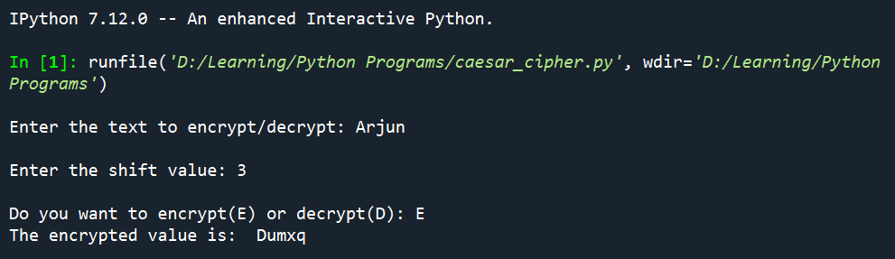

Figure 1: Caesar Cipher Encryption Output

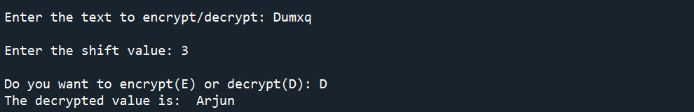

Figure 2: Caesar Cipher Decryption Output

## **Outcome of Practical**

Successfully implemented encryption and decryption of Caesar cipher.

# Implement Monoalphabetic Cipher and Polyalphabetic Cipher Encryption-Decryption

## **Aim**

To write a Python program to implement the encryption and decryption using monoalphabetic and polyalphabetic cipher.

## **Explanation**

**Monoalphabetic Cipher:**

A mono-alphabetic cipher (aka simple substitution cipher) is a substitution cipher where each letter of the plain text is replaced with another letter of the alphabet. It uses a fixed key which consist of the 26 letters of a “shuffled alphabet”.

To put it mathematically, we can now have any permutation or combination of the 26 alphabets, which means (26 x 25 x 24 x 23 x … 2) or 4 x 1026 possibilities! This is extremely hard to crack. It might take years to try out these many combinations even with the most modern computers.

**Polyalphabetic Cipher:**

Improve security using multiple cipher alphabets make cryptanalysis harder with more alphabets to guess and flatter frequency distribution use a key to select which alphabet is used for each letter of the message use each alphabet in turn repeat from start after end of key is reached

Two types:

1. Vignere Cipher
2. Vernam Cipher
3. *Vignere Cipher*

Simplest polyalphabetic substitution cipher effectively multiple

caesar ciphers key is multiple

letters long K = k1 k2 ... kd

In this algorithm, 26 Caesar ciphers make up the mono-alphabetic substitution rules. There is a shifting mechanism, from a count of 0 to 25. For each plain-text letter, we have a corresponding substitution, which we call the key letter. For instance, the key value is e for a letter with shift as 3.

The first letter of the key is added to the first letter of the plaintext, mod 26, the second letters are

added, and so on through the first m letters of the plaintext.

For the next m letters of the plaintext, the key letters are repeated. This process continues until all of

the plaintext sequence is encrypted. A general equation of the encryption process is

Ci = (pi + ki mod m) mod 26

decryption is a generalization of Equation

pi = (Ci - ki mod m) mod 26

1. *Vernam Cipher*

Developed by AT&T engineer , Gillbert vernam in 1918.

System works on binary data

System is

Ci = pi XOR ki

pi =ith binary digit of plaintext ki = ith binary digit of key

Ci = ith binary digit of ciphertext

Exclusive or (XOR) operation

Pi = Ci XOR ki

## **Code**

**Monoalphabetic Cipher**

key='phqgiumeaylnofdxjkrcvstzwb'

alphabet={"A":0,"B":1,"C":2,"D":3,"E":4,"F":5,"G":6,"H":7,"I":8,"J":9,"K":10,"L":11,"M":12,"N":13,"O":14,"P":15,"Q":16,"R":17,"S":18,"T":19,"U":20,"V":21,"W":22,"X":23,"Y":24,"Z":25}

alpha = list(alphabet.keys())

order_number = list(alphabet.values())

def encryption(plain_text):

cypher=''

for letter in plain_text:

position=alphabet[letter.upper()]

cypher+=key[position]

print("The cipher text is: ",cypher)

def decryption(cipher_text):

plain=''

for letter in cipher_text:

pos=key.index(letter)

plain+=alpha[pos]

print("The plain text value is: ", plain.lower())

input_text=input("Enter the text to encrypt/decrypt: ")

while True:

mode=input("Do you want to encrypt(E) or decrypt(D): ")

if mode.upper()=='E':

encryption(input_text)

break

elif mode.upper()=='D':

decryption(input_text)

break

else:

print("Enter the proper value (E/D)")

**Vignere Cipher**

import math

def vignereCipherEncryption(input_text,keyword):

cipher=''

for i in range(0,len(input_text)):

text_index=alphabet.index(input_text[i])

key_index=alphabet.index(key[i])

cipher_index=(text_index+key_index)%26

cipher+=alphabet[cipher_index]

print("The cipher text is: ", cipher)

def vignereCipherDecryption(input_text,keyword):

plain=''

for i in range(0,len(input_text)):

text_index=alphabet.index(input_text[i])

key_index=alphabet.index(key[i])

cipher_index=(text_index-key_index)%26

plain+=alphabet[cipher_index]

print("The plain text is: ", plain)

plain=input('Enter the input text: ')

keyword=input("Enter the keyword: ")

alphabet='abcdefghijklmnopqrstuvwxyz'

text_length=len(plain)

keyword_length=len(keyword)

key_size=math.ceil(text_length/keyword_length)

key=keyword.lower()*key_size

while True:

mode=input("Do you want to encrypt(E) or decrypt(D): ")

if mode.upper()=='E':

vignereCipherEncryption(plain,keyword)

break

elif mode.upper()=='D':

vignereCipherDecryption(plain,keyword)

break

else:

print("Enter the proper value (E/D)")

## **Output**

**Monoalphabetic Cipher**

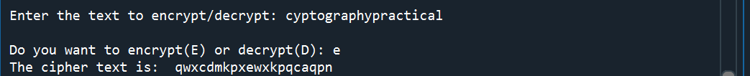

Figure 3: Monoalphabetic Encryption

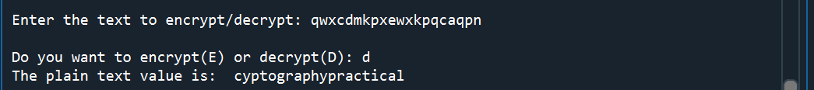

Figure 4: Monoalphabetic Decryption

**Vignere Cipher**

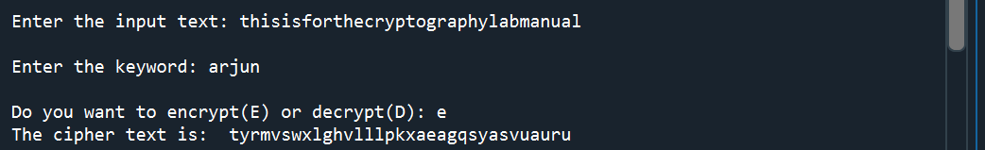

Figure 5: Vignere Encryption

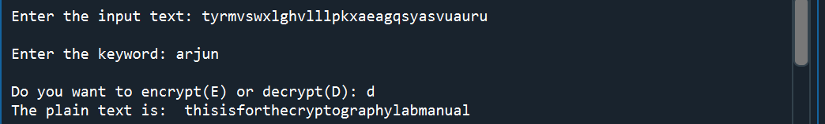

Figure 6: Vignere Decryption

## **Outcome of Practical**

Successfully implemented encryption and decryption of monoalphabetic cipher and Vignere cipher.

# Implement Playfair Cipher Encryption-Decryption

## **Aim**

To perform encryption and decryption of Playfair cipher using cryptool.

## **Explanation**

The Playfair cipher, also called Playfair square, is a cryptographic technique used for manual encryption of data. This scheme was invented by Charles Wheatstone in 1854. However, eventually the scheme came to be known by the name of Lord Playfair, who was Wheatstone’s friend. Playfair made this scheme popular, and hence his name was used.

Plaintext is encrypted two letters at a time

1. if a pair is a repeated letter, insert filler like 'X’

2. if both letters fall in the same row, replace each with letter to right (wrapping back to start from end)

3. if both letters fall in the same column, replace each with the letter below it (again wrapping to top from bottom)

4. otherwise each letter is replaced by the letter in the same row and in the column of the other letter of the pair

The Playfair cipher starts with creating a key table. The key table is a 5×5 grid of letters that will act as the key for encrypting your plaintext. Each of the 25 letters must be unique and one letter of the alphabet is omitted from the table (as there are 25 spots and 26 letters in the alphabet).

To encrypt a message, one would break the message into digrams (groups of 2 letters) such that, for example, "HelloWorld" becomes "HE LL OW OR LD", and map them out on the key table. The two letters of the diagram are considered as the opposite corners of a rectangle in the key table. Note the relative position of the corners of this rectangle. Then apply the following 4 rules, in order, to each pair of letters in the plaintext:

1. If both letters are the same (or only one letter is left), add an "X" after the first letter

2. If the letters appear on the same row of your table, replace them with the letters to their immediate right respectively

3. If the letters appear on the same column of your table, replace them with the letters immediately below respectively

4. If the letters are not on the same row or column, replace them with the letters on the same row respectively but at the other pair of corners of the rectangle defined by the original pair.

## **Tool Used**

**CrypTool** is an open-source project that focuses on the free e-learning software CrypTool illustrating cryptographic and cryptanalytic concepts. According to "Hakin9", CrypTool is worldwide the most widespread e-learning software in the field of cryptology.

CrypTool implements more than 400 algorithms. Users can adjust these with own parameters. To introduce users to the field of cryptography, the organization created multiple graphical interface software containing an online documentation, analytic tools and algorithms. They contain most classical ciphers, as well as modern symmetric and asymmetric cryptography including RSA, ECC, digital signatures, hybrid encryption, homomorphic encryption, and Diffie–Hellman key exchange. Methods from the area of quantum cryptography (like BB84 key exchange protocol) and the area of post-quantum cryptography (like McEliece, WOTS, Merkle-Signature-Scheme, XMSS, XMSS_MT, and SPHINCS) are implemented. In addition to the algorithms, solvers (analyzers) are included, especially for classical ciphers. Other methods (for instance Huffman code, AES, Keccak, MSS) are visualized.

In addition it contains: didactical games (like Number Shark, Divider Game, or Zudo-Ku) and interactive tutorials about primes, elementary number theory, and lattice-based cryptography.

## **Screenshot of the output**

Select the Playfair encryption.

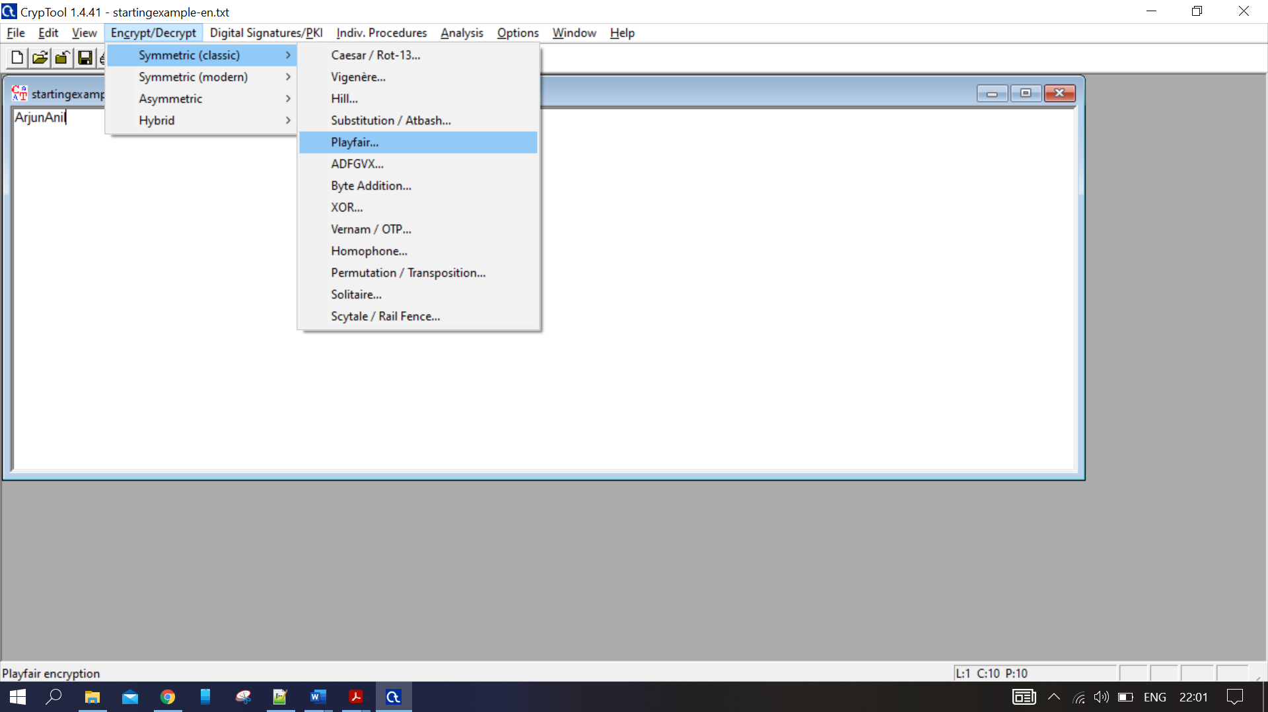

Figure 7: Playfair Encryption

Provide the key and select the matrix size. Then press Encrypt.

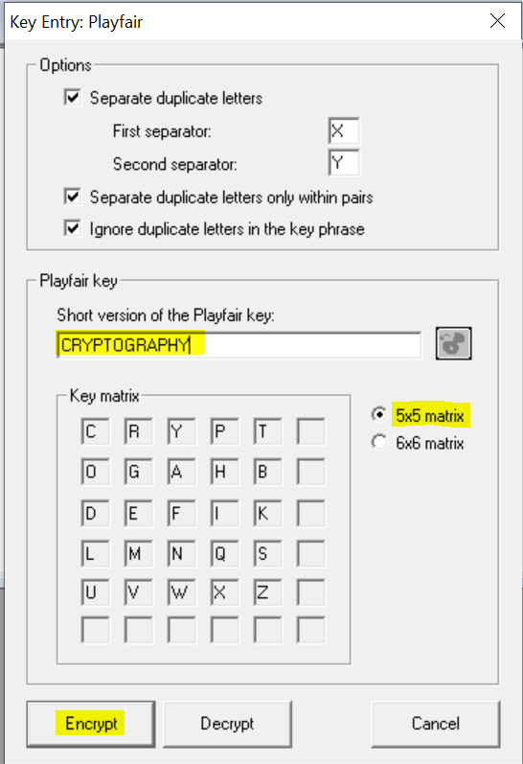

Figure 8: Playfair Encryption

The plain text is split as below and is encrypted.

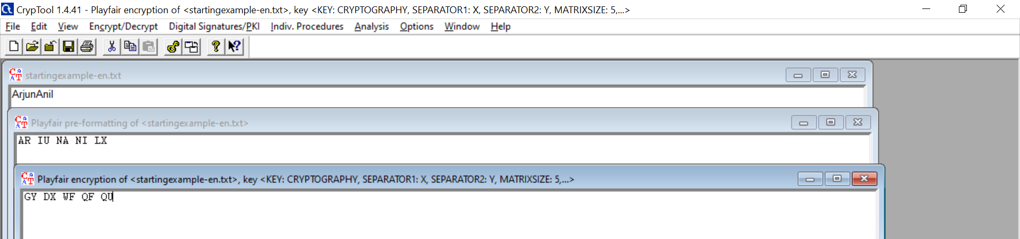

Figure 9: Encryption

For the decryption, copy the cipher text and follow the same steps as encryption. The key and matrix size should be same as that provided for encryption.

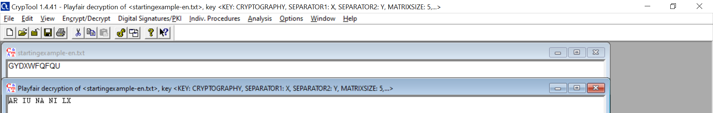

Figure 10: Decryption

As I and J are considered as one and the total length is odd, we got the output as ARIUNANILX, our plain text was ARJUNANIL.

## **Outcome of Practical**

Successfully performed encryption and decryption of Playfair cipher.

# Encrypt File Using Different Cryptographic Algorithm.

## **Aim**

To encrypt and decrypt a file using Cryptool using algorithm like Vernam cipher and perform Digital Signature.

## **Explanation**

***Vernam Cipher***

Vernam Cipher is a method of encrypting alphabetic text. It is one of the Transposition techniques for converting a plain text into a cipher text. In this mechanism we assign a number to each character of the Plain-Text, like (a = 0, b = 1, c = 2, … z = 25).

Method to take key:

In Vernam cipher algorithm, we take a key to encrypt the plain text which length should be equal to the length of the plain text.

Encryption Algorithm:

1. Assign a number to each character of the plain-text and the key according to alphabetical order.
2. Add both the number (Corresponding plain-text character number and Key character number).
3. Subtract the number from 26 if the added number is greater than 26, if it isn’t then leave it.

Example:

Plain-Text: RAMSWARUPK

Key: RANCHOBABA

Now according to our encryption algorithm we assign a number to each character of our plain-text and key.

PT: R A M S W A R U P K

NO: 17 0 12 18 22 0 17 20 15 10

KEY: R A N C H O B A B A

NO: 17 0 13 2 7 14 1 0 1 0

Now add the number of Plain-Text and Key and after doing the addition and subtraction operation (if required), we will get the corresponding Cipher-Text character number.

CT-NO: 34 0 25 20 29 14 18 20 16 10

In this case, there are two numbers which are greater than the 26 so we have to subtract 26 from them and after applying the subtraction operation the new Cipher text character numbers are as follow:

CT-NO: 8 0 25 20 3 14 18 20 16 10

New Cipher-Text is after getting the corresponding character from the number.

CIPHER-TEXT: I A Z U D O S U Q K

Note:

For the Decryption apply the just reverse process of encryption.

***Digital Signature***

A digital signature is a mathematical technique used to validate the authenticity and integrity of a message, software or digital document. It's the digital equivalent of a handwritten signature or stamped seal, but it offers far more inherent security. A digital signature is intended to solve the problem of tampering and impersonation in digital communications.

Digital signatures can provide evidence of origin, identity and status of electronic documents, transactions or digital messages. Signers can also use them to acknowledge informed consent.

In many countries, including the United States, digital signatures are considered legally binding in the same way as traditional handwritten document signatures.

How do digital signatures work?

Digital signatures are based on public key cryptography, also known as asymmetric cryptography. Using a public key algorithm, such as RSA (Rivest-Shamir-Adleman), two keys are generated, creating a mathematically linked pair of keys, one private and one public.

Digital signatures work through public key cryptography's two mutually authenticating cryptographic keys. The individual who creates the digital signature uses a private key to encrypt signature-related data, while the only way to decrypt that data is with the signer's public key.

If the recipient can't open the document with the signer's public key, that's a sign there's a problem with the document or the signature. This is how digital signatures are authenticated.

Digital signature technology requires all parties trust that the individual creating the signature has kept the private key secret. If someone else has access to the private signing key, that party could create fraudulent digital signatures in the name of the private key holder.

What are the benefits of digital signatures?

Security is the main benefit of digital signatures. Security capabilities embedded in digital signatures ensure a document is not altered and signatures are legitimate. Security features and methods used in digital signatures include the following:

* Personal identification numbers (PINs), passwords and codes. Used to authenticate and verify a signer's identity and approve their signature. Email, username and password are the most common methods used.
* Asymmetric cryptography. Employs a public key algorithm that includes private and public key encryption and authentication.
* Checksum. A long string of letters and numbers that represents the sum of the correct digits in a piece of digital data, against which comparisons can be made to detect errors or changes. A checksum acts as a data fingerprint.
* Cyclic redundancy check (CRC). An error-detecting code and verification feature used in digital networks and storage devices to detect changes to raw data.
* Certificate authority (CA) validation. CAs issue digital signatures and act as trusted third parties by accepting, authenticating, issuing and maintaining digital certificates. The use of CAs helps avoid the creation of fake digital certificates.
* Trust service provider (TSP) validation. A TSP is a person or legal entity that performs validation of a digital signature on a company's behalf and offers signature validation reports.

Other benefits to using digital signatures include the following:

* Timestamping. By providing the data and time of a digital signature, timestamping is useful when timing is critical, such as for stock trades, lottery ticket issuance and legal proceedings.
* Globally accepted and legally compliant. The public key infrastructure (PKI) standard ensures vendor-generated keys are made and stored securely. Because of the international standard, a growing number of countries are accepting digital signatures as legally binding.
* Time savings. Digital signatures simplify the time-consuming processes of physical document signing, storage and exchange, enabling businesses to quickly access and sign documents.
* Cost savings. Organizations can go paperless and save money previously spent on the physical resources and on the time, personnel and office space used to manage and transport them.
* Positive environmental impact. Reducing paper use also cuts down on the physical waste generated by paper and the negative environmental impact of transporting paper documents.
* Traceability. Digital signatures create an audit trail that makes internal record-keeping easier for business. With everything recorded and stored digitally, there are fewer opportunities for a manual signee or record-keeper to make a mistake or misplace something.

## **Tool Used**

**CrypTool** is an open-source project that focuses on the free e-learning software CrypTool illustrating cryptographic and cryptanalytic concepts. According to "Hakin9", CrypTool is worldwide the most widespread e-learning software in the field of cryptology.

CrypTool implements more than 400 algorithms. Users can adjust these with own parameters. To introduce users to the field of cryptography, the organization created multiple graphical interface software containing an online documentation, analytic tools and algorithms. They contain most classical ciphers, as well as modern symmetric and asymmetric cryptography including RSA, ECC, digital signatures, hybrid encryption, homomorphic encryption, and Diffie–Hellman key exchange. Methods from the area of quantum cryptography (like BB84 key exchange protocol) and the area of post-quantum cryptography (like McEliece, WOTS, Merkle-Signature-Scheme, XMSS, XMSS_MT, and SPHINCS) are implemented. In addition to the algorithms, solvers (analyzers) are included, especially for classical ciphers. Other methods (for instance Huffman code, AES, Keccak, MSS) are visualized.

In addition it contains: didactical games (like Number Shark, Divider Game, or Zudo-Ku) and interactive tutorials about primes, elementary number theory, and lattice-based cryptography.

## **Screenshot of Output**

Select the vernam cipher

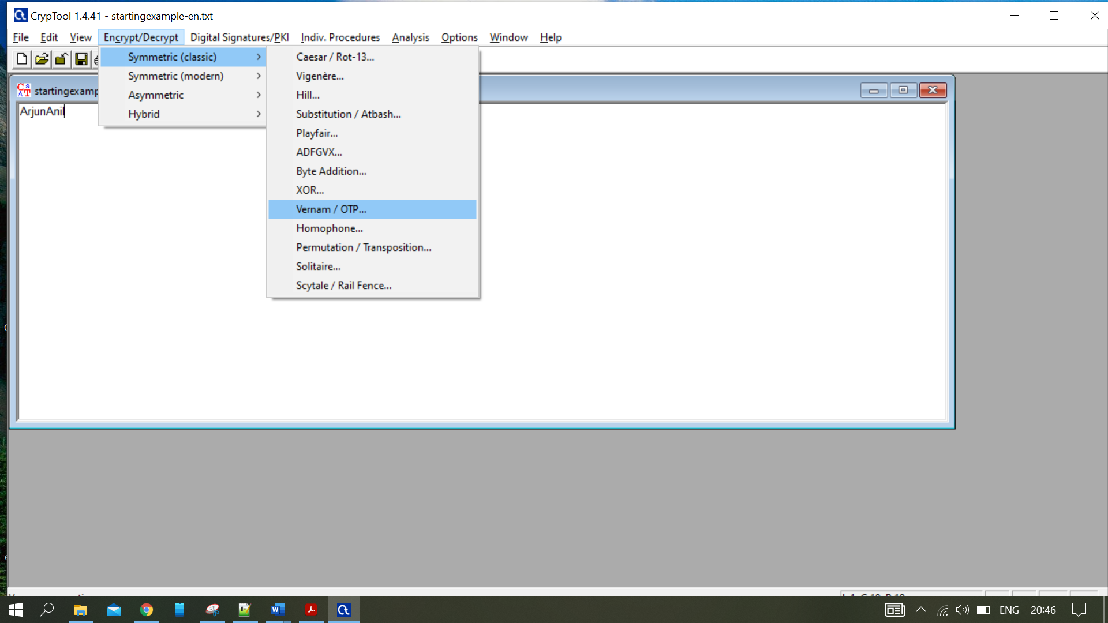

Figure 11: Select Vernam Cipher

Select a key file for the decryption and encrypt.

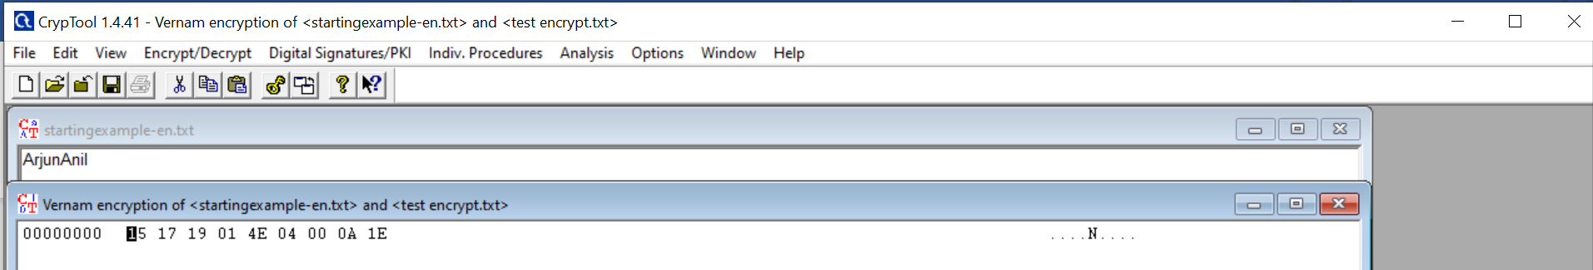

Figure 12: Encryption

For Decryption, copy the cipher text and follow the first step and select the same key file. The decryption is as below.

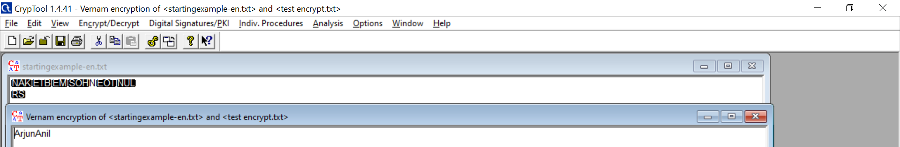

Figure 13: Vernam Decryption

***Digital Signature***

Select Sign Document Option as below:

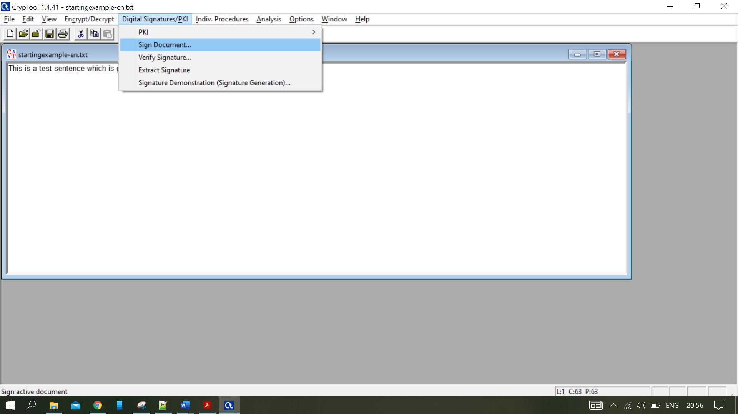

Figure 14: Sign Document

Select the Key, enter the pin and click sign.

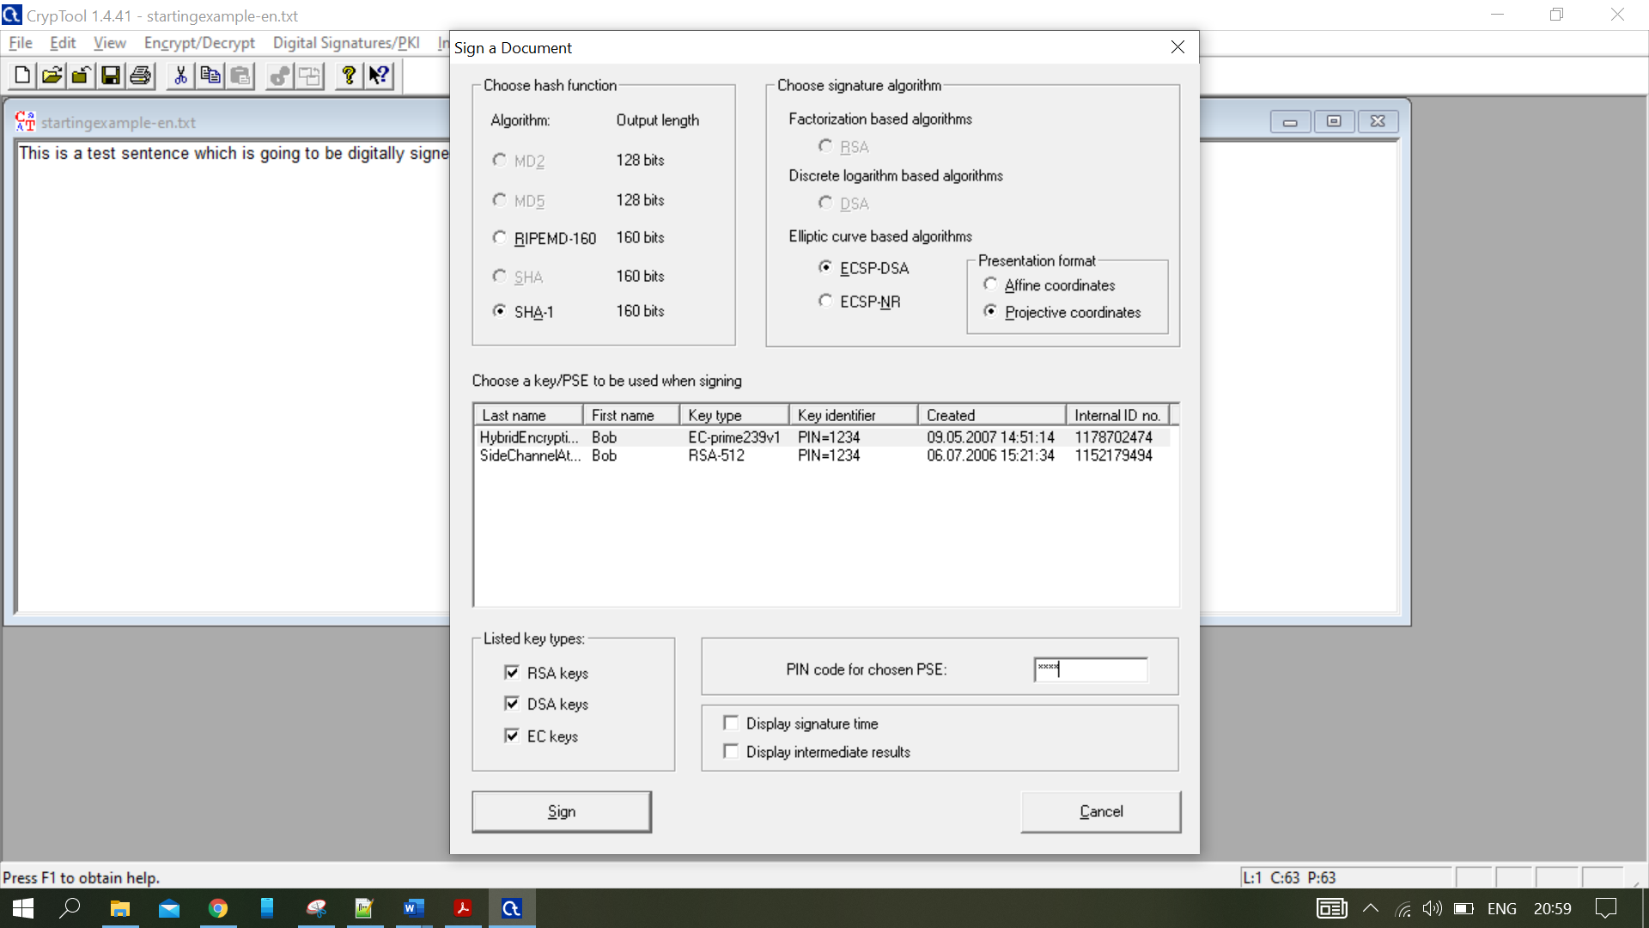

Figure 15: Sign

Highlighted part is the text a message and rest is the key generated.

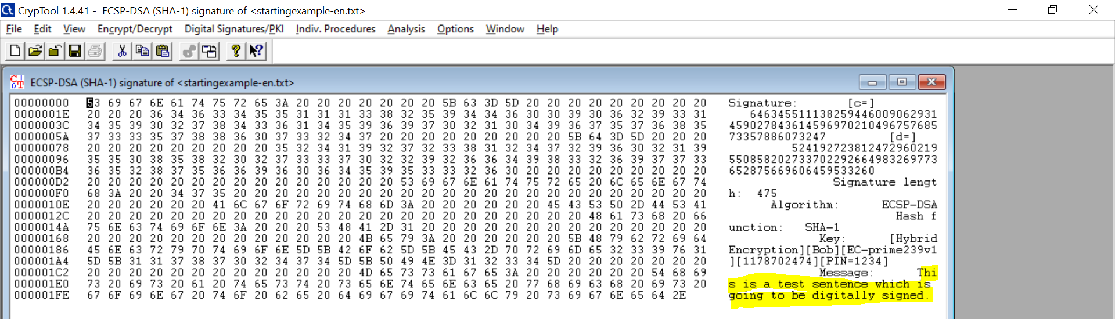

Figure 16: Generated Key

***Signing a document***

Open the document using cryptool

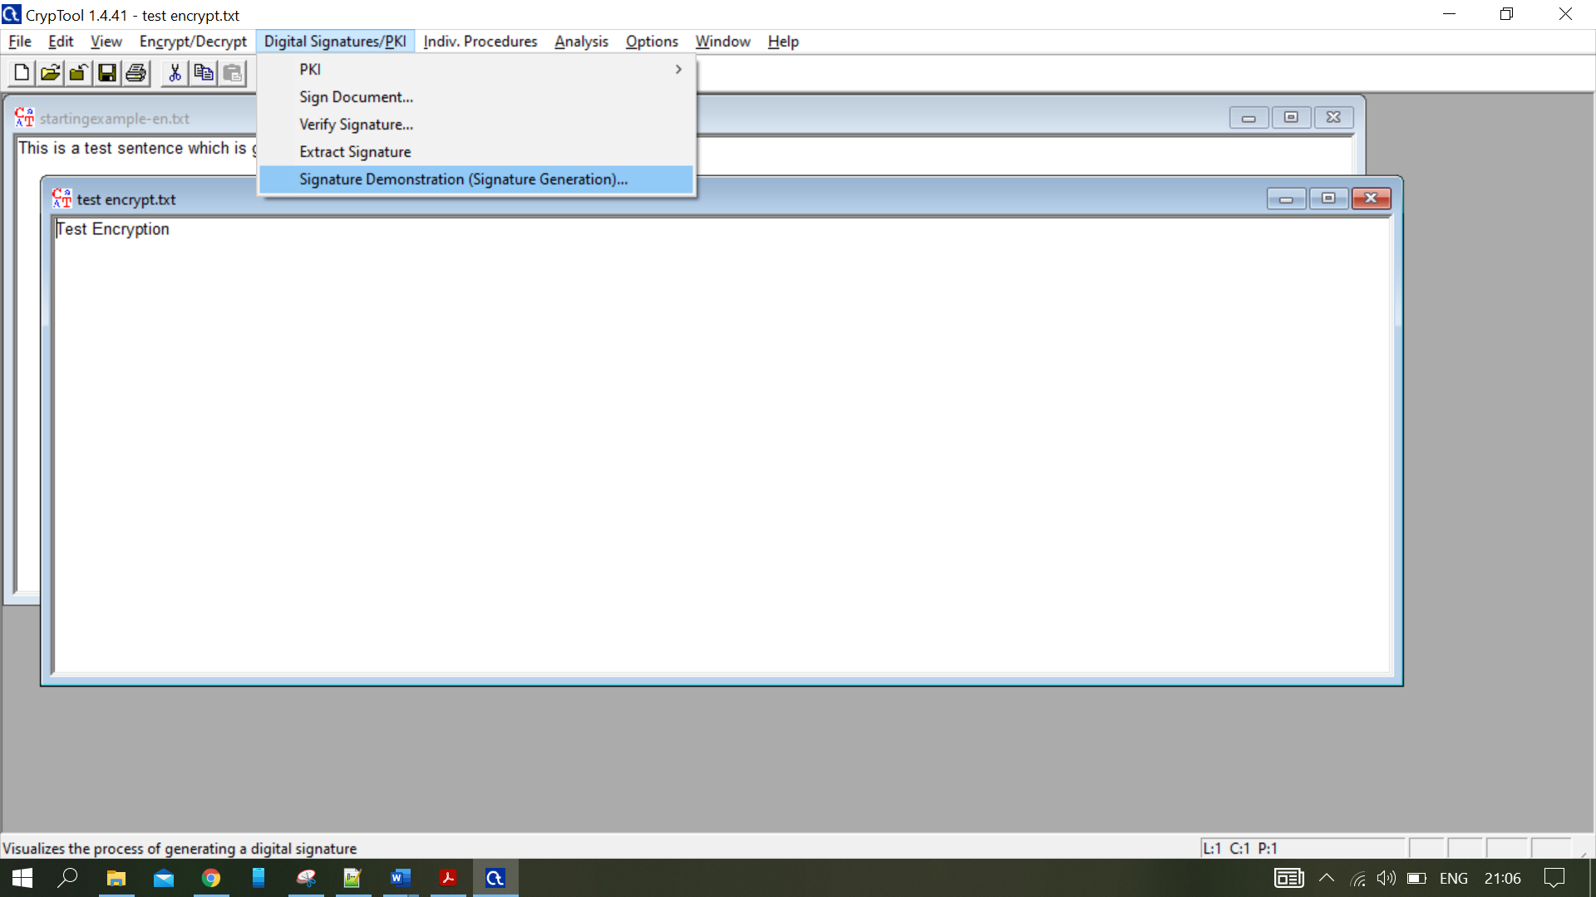

Figure 17: Open the Document.

Open the document and select hash function.

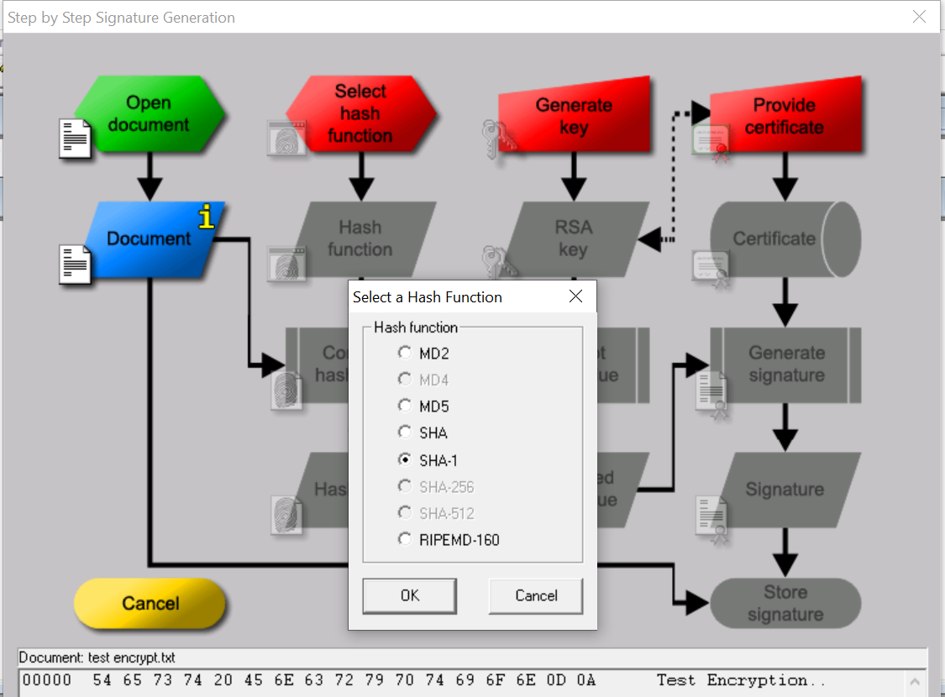

Figure 18: Select Hash Function

Compute the hash value.

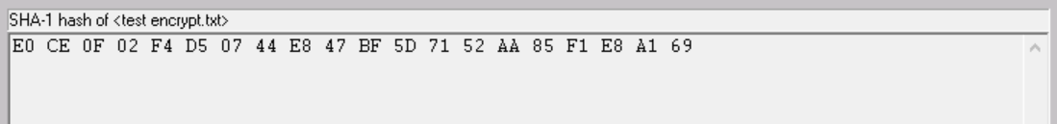

Figure 19: Hash Value

Generate the Key. Generate Prime number-> Apply prime number and then press Store Key.

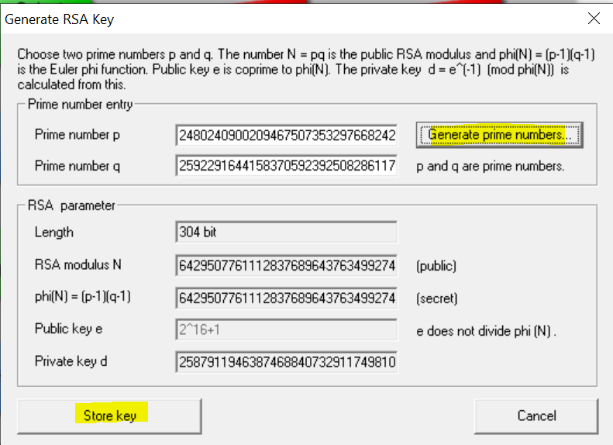

Figure 20: Generate Key.

Provide the details, click Create certificate and PSE.

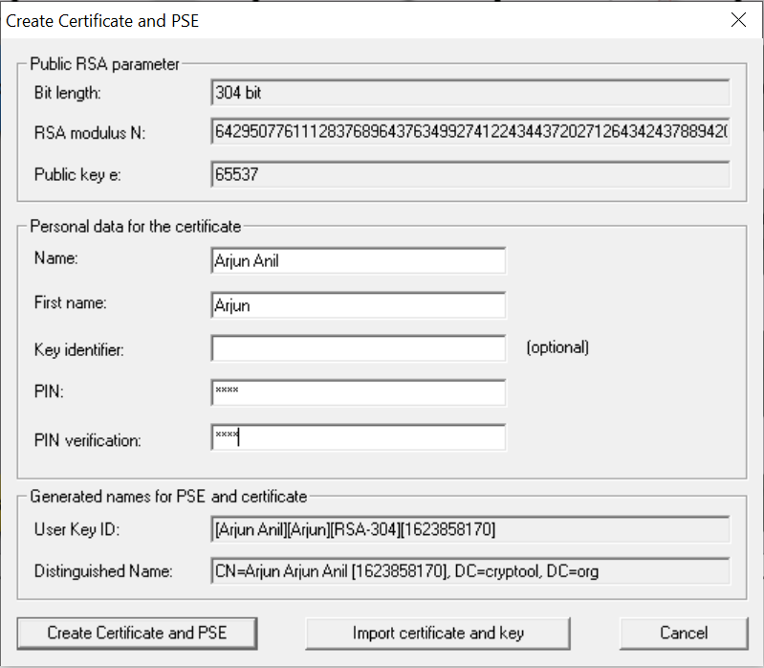

Figure 21: Create Certificate.

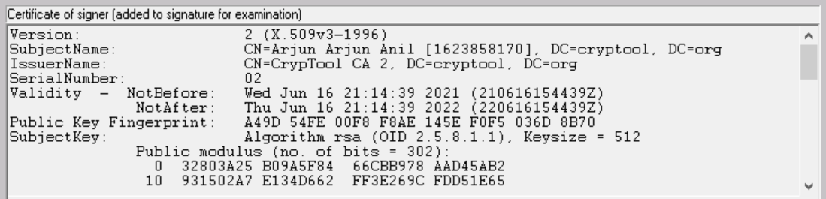

Figure 22: Certificate

Store the Signature.

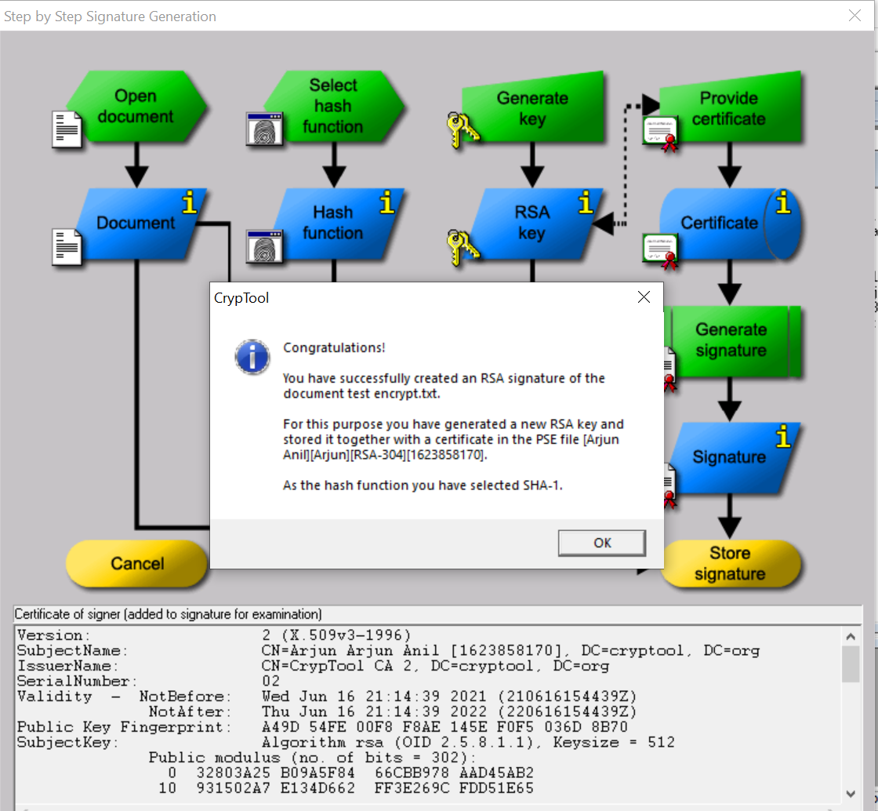

Figure 23: Store the Signature.

Signature

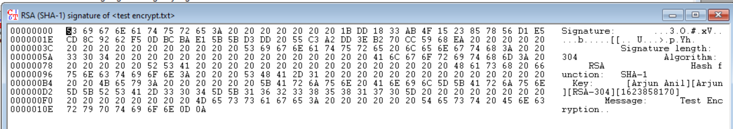

Figure 24: Signature

## **Outcome of the Practical**

Encrypted the text using cryptool and digitally signed a file.

# Implement Diffi-Hellmen Key exchange Method

## **Aim**

To write a Python program to implement Diffi-Hellman key exchange method.

## **Explanation**

The idea behind the Diffie–Hellman algorithm is quite simple but beautiful. Think about the final shared symmetric key between Alice and Bob to be made up of three parts: g, x, and y. As shown in figure.

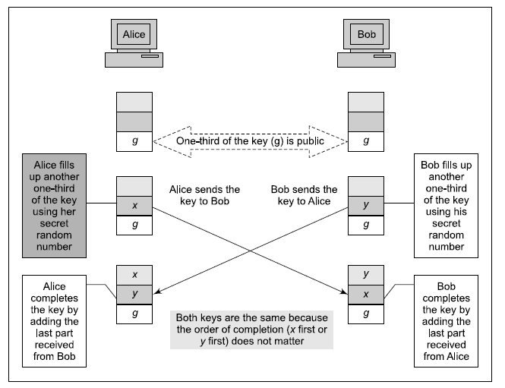

Figure 25: Diffi Hellman

The first part of the key (g) is a public number, known to everyone. The other two parts of the key (i.e.x and y) must be made available by Alice and Bob. Alice adds the second part (x), while Bob adds the third (y). When Alice receives the two-thirds completed key from Bob, she adds the one-third remaining part (i.e. x). This completes Alice’s key. Similarly, when Bob receives the two-thirds completed key from Alice, he adds the one-third remaining part (i.e. y). This completes Bob’s key. Note that although Alice’s key is made up using a sequence of g-y-x, and Bob’s key is made up using a sequence of g-x-y, the two keys are the same because gxy = gyx. Importantly, although the eventual two keys are the same, Alice cannot find Bob’s part (i.e. y) because the computation is done using modulus n. Similarly, Bob cannot derive Alice’s part (i.e. x).

## **Code**

a=7

q=23

xa=int(input("enter the private number for A: "))

xb=int(input("enter the private number for B: "))

ya=(a**xa)%q

yb=(a**xb)%q

print("The Public number of A is: ",ya)

print("The Public number of A is: ",yb)

ka=(yb**xa)%q

kb=(ya**xb)%q

if ka==kb:

print('the key is:',kb)

## **Output**

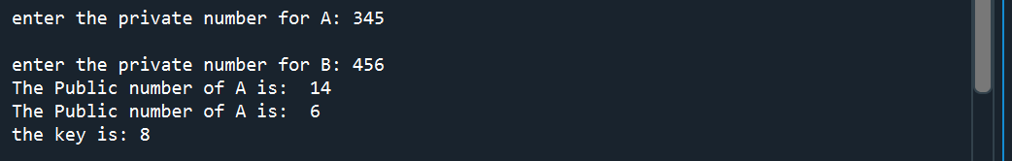

Figure 26: Output

## **Outcome of Practical**

Successfully implemented Diffi-Hellman key exchange method using Python.

# Implement RSA encryption-decryption algorithm.

## **Aim**

To implement RSA encryption and decryption algorithm using Python.

## **Explanation**

RSA (Rivest–Shamir–Adleman) is an algorithm used by modern computers to encrypt and decrypt messages. It is an asymmetric cryptographic algorithm. Asymmetric means that there are two different keys. This is also called public key cryptography, because one of the keys can be given to anyone. The other key must be kept private. The algorithm is based on the fact that finding the factors of a large composite number is difficult: when the factors are prime numbers, the problem is called prime factorization. It is also a key pair (public and private key) generator.

RSA involves use of public and private key for its operation. The keys are generated using the following steps: -

* + Two prime numbers are selected as p and q
  + n = pq which is the modulus of both the keys.
  + Calculate totient = (p-1)(q-1)
  + Choose e such that e > 1 and coprime to totient which means GCD (e, totient) must be equal to 1, e is the public key.
  + Choose d such that it satisfies the equation de = 1 + k (totient), d is the private key not known to everyone.
  + Cipher text is calculated using the equation c = m^e mod n where m is the message.
  + With the help of c and d we decrypt message using equation m = c^d mod n where d is the private key.

## **Code**

import math

p=17

q=11

print(f"The selected prime numbers are {p}(p) and {q}(q)")

n=p*q

print("The value of n (p*q) is: ",n)

#calculate totient value

t=(p-1)*(q-1)

for i in range(4,t):

if math.gcd(i,t)==1:

e=i

break

else:

continue

print("The value of e is: ", e)

#calculate the value of d de(modt)=1, taking the value of k as 2

for i in range(1,t):

if (i*e)%t==1:

d=i

break

while True:

val=input("Do you want to encrypt or decrypt (E/D): ")

if val.upper()=='D':

m=int(input("Enter the Plain Text value: "))

c=(m**e)%n

print('The cipher text value is: ', c)

break

elif val.upper()=='E':

c=int(input("Enter the value of cipher text: "))

m=(c**d)%n

print("The plain text value is: ", m)

break

else:

print("Enter the correct value (E/D)")

## **Output**

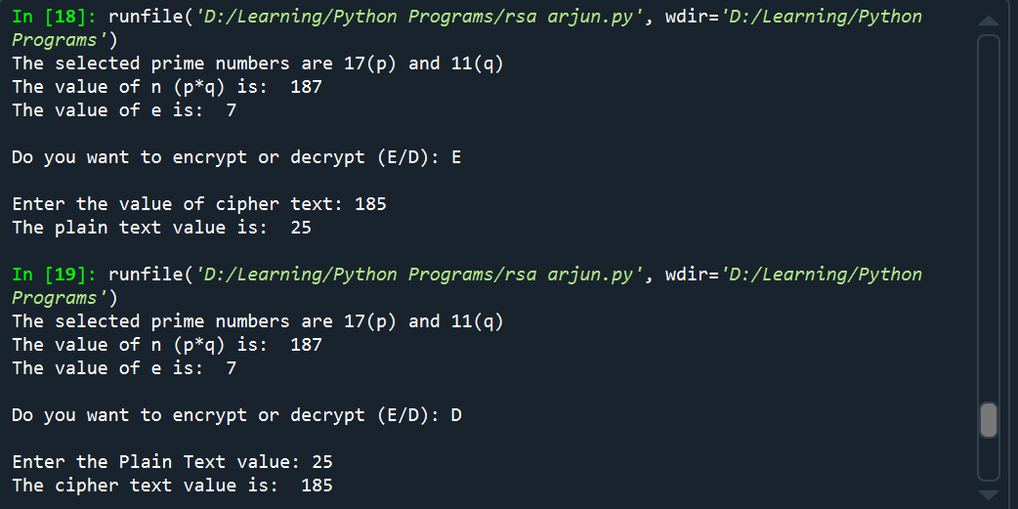

Figure 27: RSA Output

## **Outcome of the Practical**

Implemented the RSA encryption and decryption using Python.

# Calculate Hash for a text or a file using MD5 or SHA Algorithms

## **Aim**

To calculate the hash value of a text using MD5 or SHA algorithms.

## **Explanation**

Hashing is the process of converting a given key into another value. A hash function is used to generate the new value according to a mathematical algorithm. The result of a hash function is known as a hash value or simply, a hash.

*Message Digest Algorithm 5*

Message Digest Algorithm 5 (MD5) is a cryptographic hash algorithm that can be used to create a 128-bit string value from an arbitrary length string. Although there has been insecurities identified with MD5, it is still widely used. MD5 is most commonly used to verify the integrity of files. However, it is also used in other security protocols and applications such as SSH, SSL, and IPSec. Some applications strengthen the MD5 algorithm by adding a salt value to the plaintext or by applying the hash function multiple times.

*Secure Hash Algorithm*

Secure Hash Algorithm is the name of a series of hash algorithms. SHA-1 creates a 160-bit hash value. SHA-2 includes SHA-224, SHA-256, SHA-384, and SHA-512, named after the length of the message digest each creates.

## **Tool Used**

**CrypTool** is an open-source project that focuses on the free e-learning software CrypTool illustrating cryptographic and cryptanalytic concepts. According to "Hakin9", CrypTool is worldwide the most widespread e-learning software in the field of cryptology.

CrypTool implements more than 400 algorithms. Users can adjust these with own parameters. To introduce users to the field of cryptography, the organization created multiple graphical interface software containing an online documentation, analytic tools and algorithms. They contain most classical ciphers, as well as modern symmetric and asymmetric cryptography including RSA, ECC, digital signatures, hybrid encryption, homomorphic encryption, and Diffie–Hellman key exchange. Methods from the area of quantum cryptography (like BB84 key exchange protocol) and the area of post-quantum cryptography (like McEliece, WOTS, Merkle-Signature-Scheme, XMSS, XMSS_MT, and SPHINCS) are implemented. In addition to the algorithms, solvers (analyzers) are included, especially for classical ciphers. Other methods (for instance Huffman code, AES, Keccak, MSS) are visualized.

In addition it contains: didactical games (like Number Shark, Divider Game, or Zudo-Ku) and interactive tutorials about primes, elementary number theory, and lattice-based cryptography.

## **Screenshot of Output**

MD5

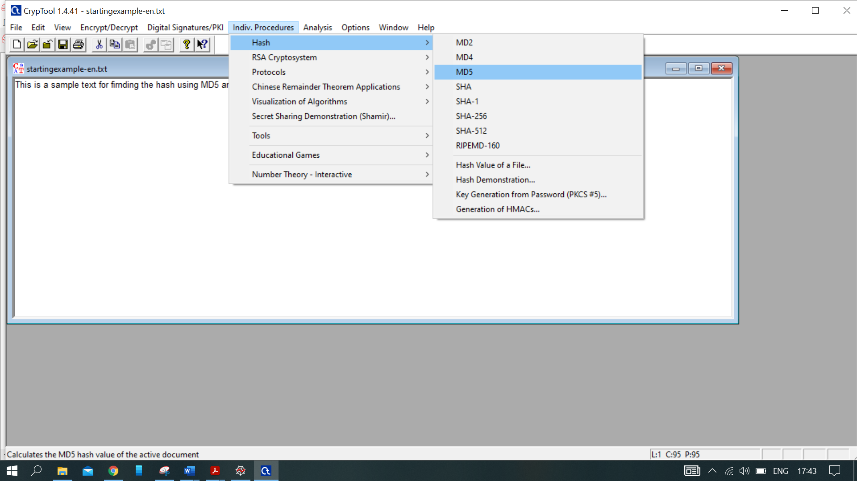

Figure 28: MD5 Hashing Selection

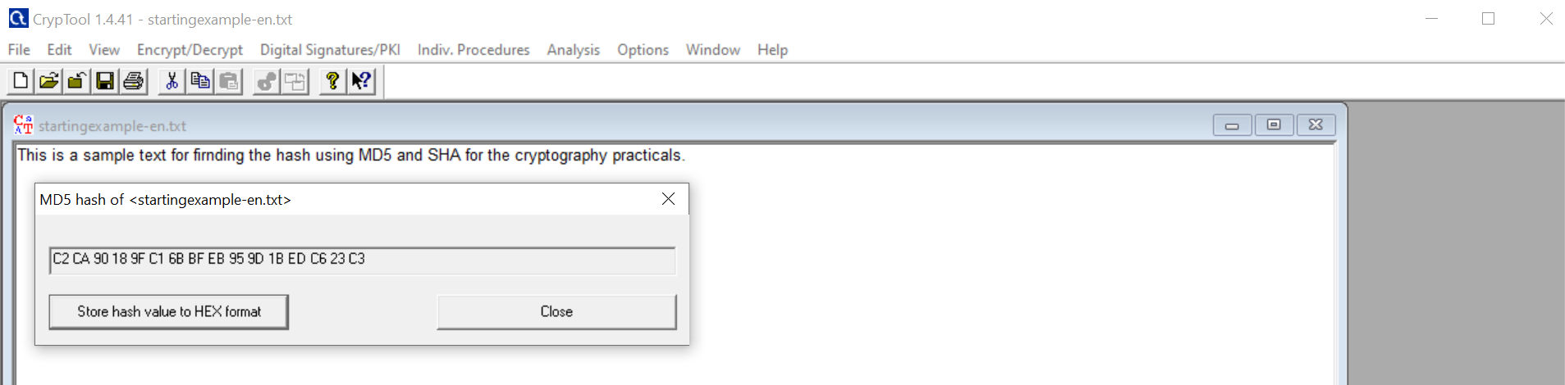

Figure 29: MD5 Hashing Output

SHA

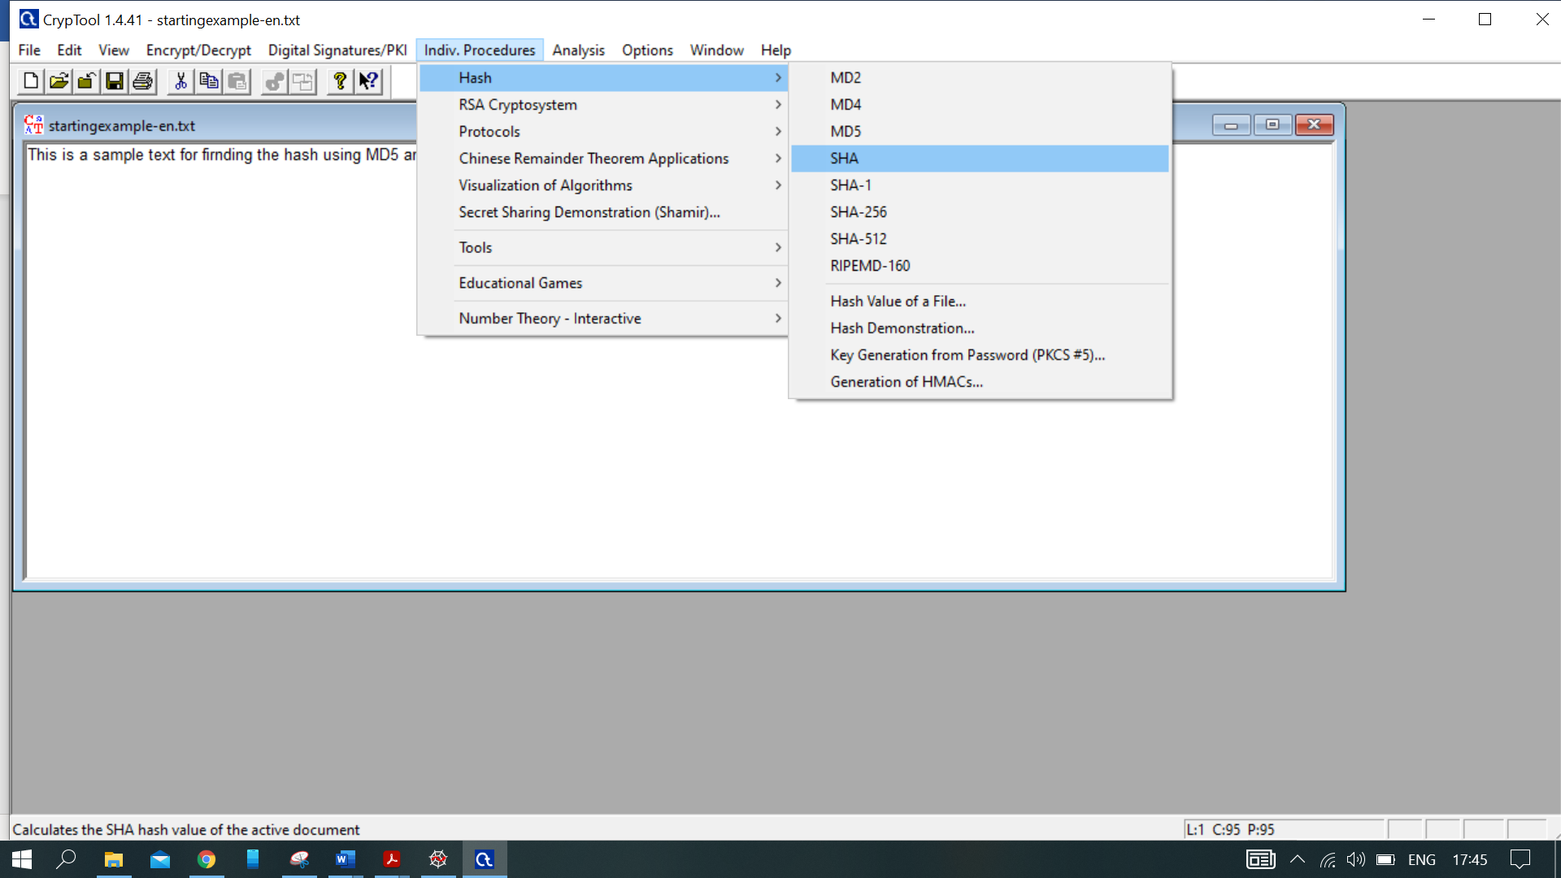

Figure 30: SHA Hashing Selection

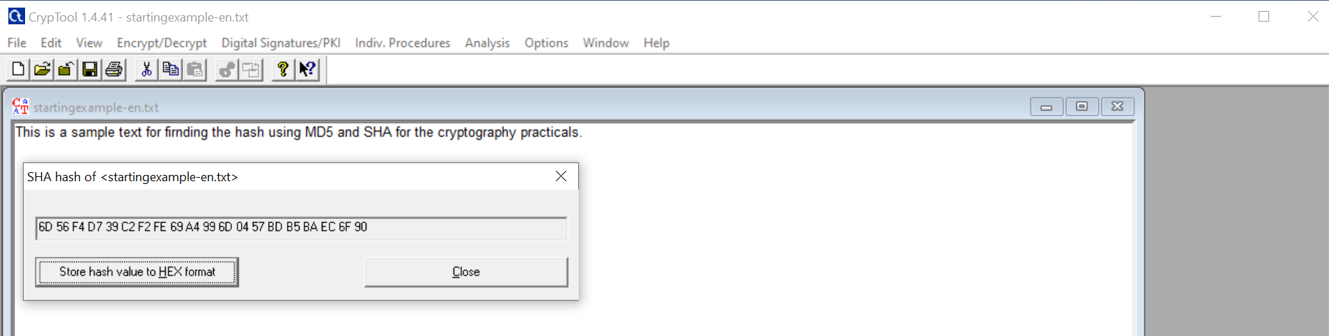

Figure 31: SHA Hashing Output

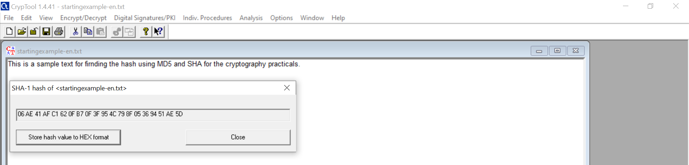

Figure 32: SHA1 Hashing Output

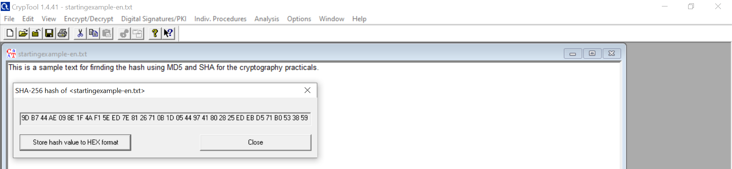

Figure 33: SHA256 Hashing Output

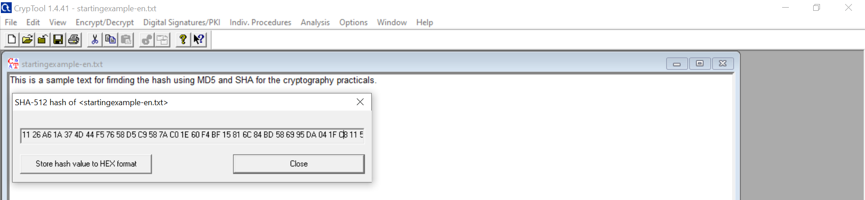

Figure 34: SHA512 Hashing Output

## **Outcome of Practical**

Calculated the hash values of a text using MD5, SHA, SHA-1, SHA-256 and SHA-512.

# Encrypt a file using Veracrypt and decrypt it.

## **Aim**

To encrypt and decrypt a file using Veracrypt.

## **Explanation**

Encryption is the process of converting normal message (plaintext) into meaningless message (Ciphertext). Whereas Decryption is the process of converting meaningless message (Ciphertext) into its original form (Plaintext).

In cryptography, encryption is the process of encoding information. This process converts the original representation of the information, known as plaintext, into an alternative form known as ciphertext. Ideally, only authorized parties can decipher a ciphertext back to plaintext and access the original information.

## **Tool Used**

VeraCrypt is a source-available freeware utility used for on-the-fly encryption (OTFE). It can create a virtual encrypted disk within a file or encrypt a partition or (in Windows) the entire storage device with pre-boot authentication.

Individual ciphers supported by VeraCrypt are AES, Serpent, Twofish, Camellia, and Kuznyechik. The Magma cipher was removed in version 1.19 in response to a security audit. Additionally, ten different combinations of cascaded algorithms are available: AES–Twofish, AES–Twofish–Serpent, Camellia–Kuznyechik, Camellia–Serpent, Kuznyechik–AES, Kuznyechik–Serpent–Camellia, Kuznyechik–Twofish, Serpent–AES, Serpent–Twofish–AES, and Twofish–Serpent. The cryptographic hash functions available for use in VeraCrypt are RIPEMD-160, SHA-256, SHA-512, Streebog and Whirlpool.

## **Screenshot of Output**

*Encryption*

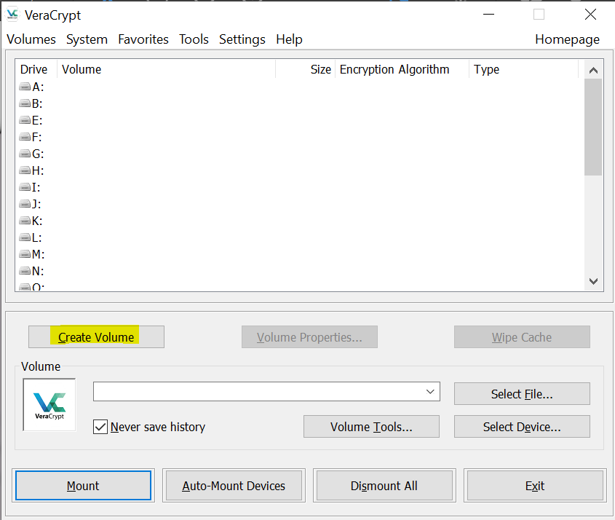

Figure 35: VeraCrypt Encryption 1

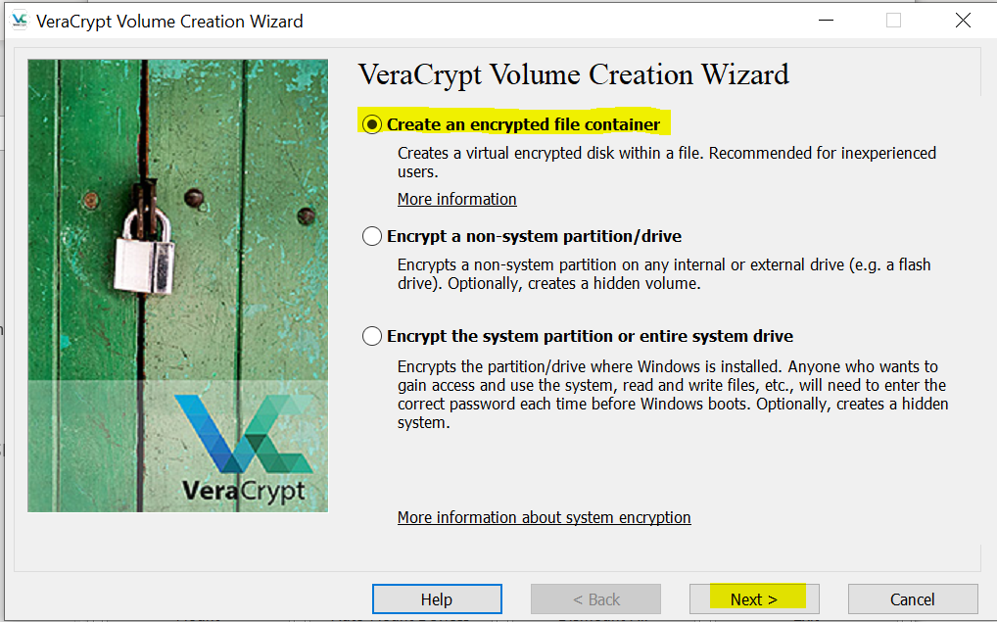

Figure 36: VeraCrypt Encryption 2

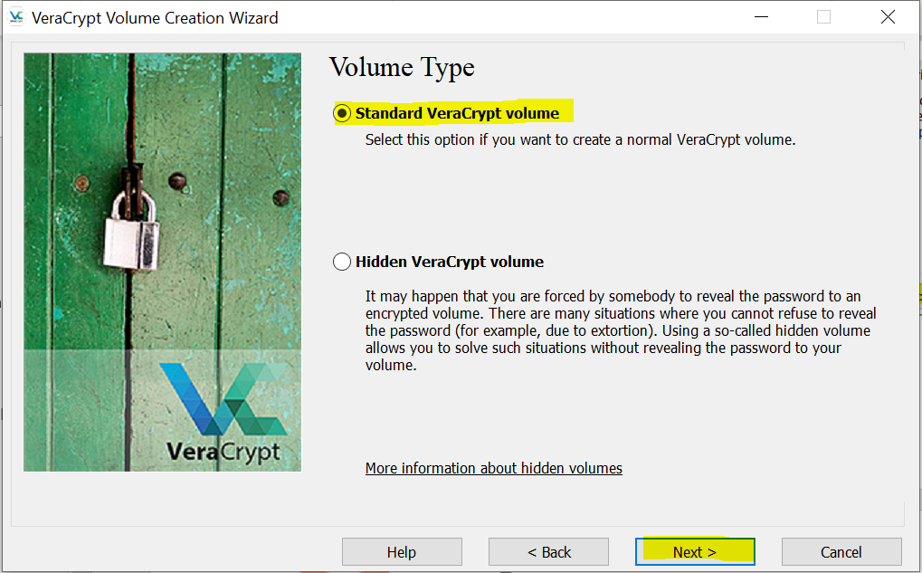

Figure 37: VeraCrypt Encryption 3

Select the file location.

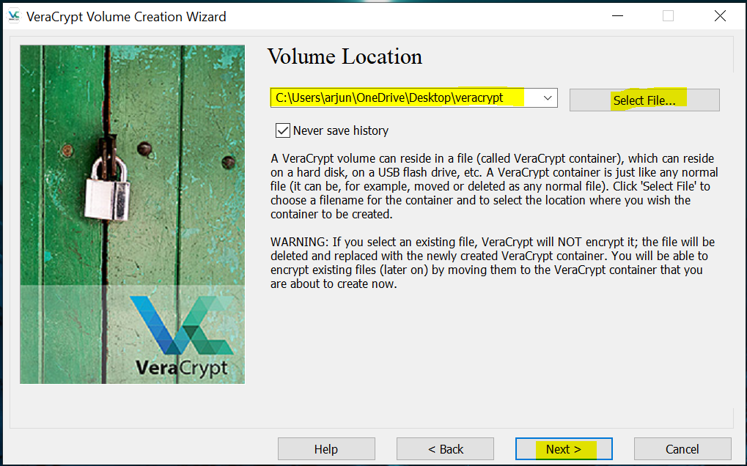

Figure 38: VeraCrypt Encryption 4

Select Encryption and Hash algorithm from dropdown and click next.

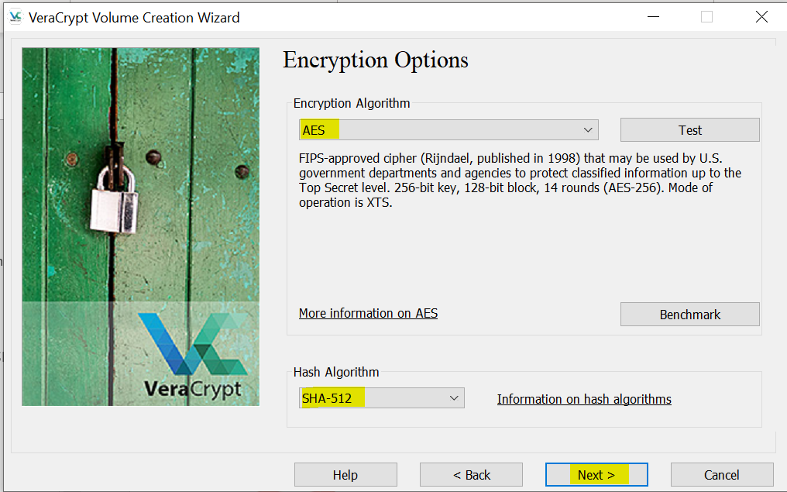

Figure 39: Veracrypt Encryption 5

Select the required size for encrypted volume and click Next.

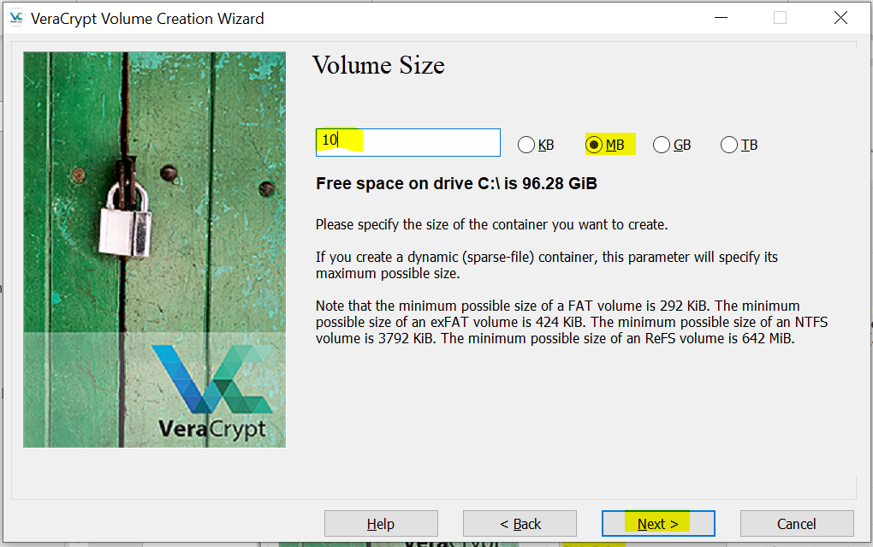

Figure 40: Veracrypt Encryption 6

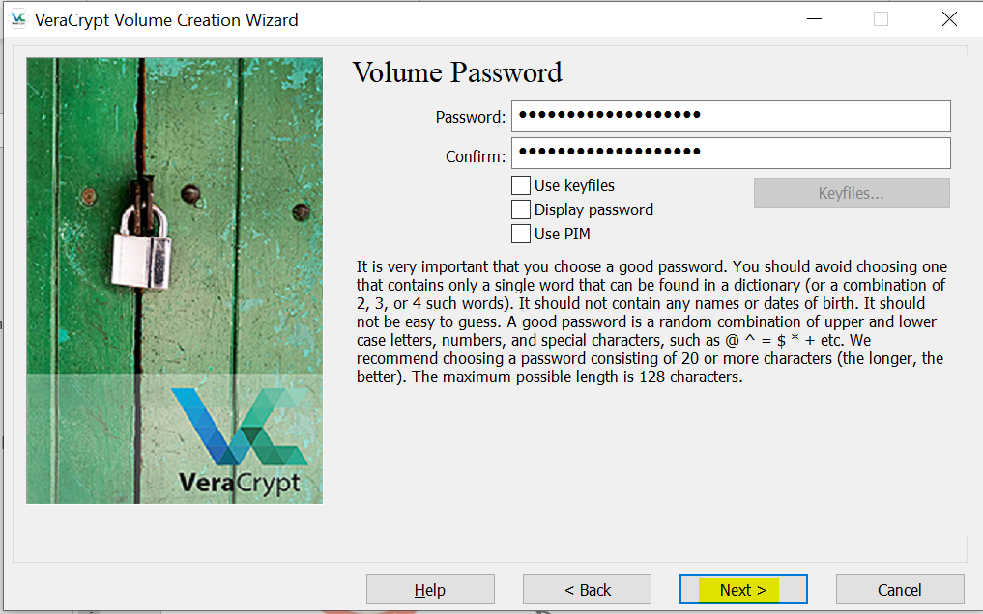

Figure 41: Veracrypt Encryption 7

Move the mouse to collect randomness and make the bar green and click Format.

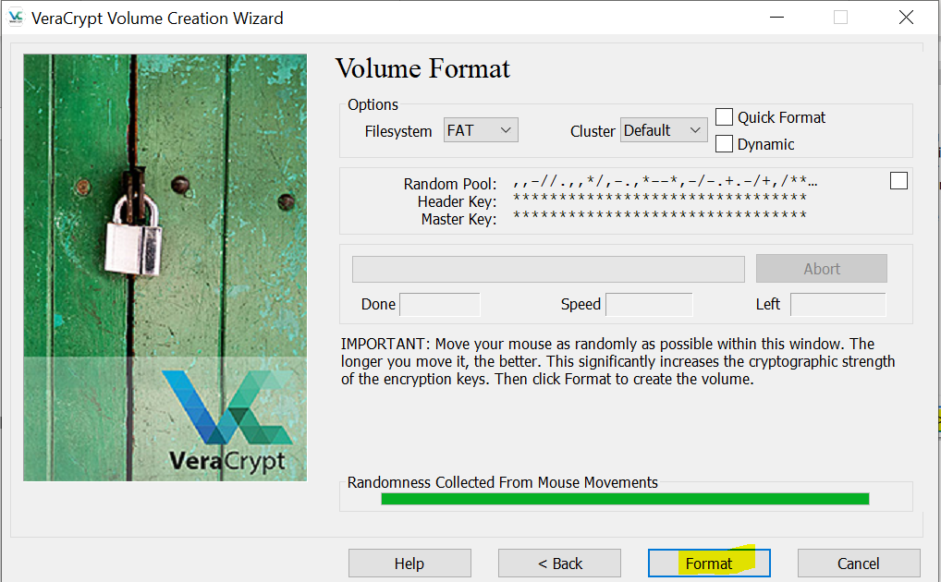

Figure 42: VeraCrypt Encryption 7

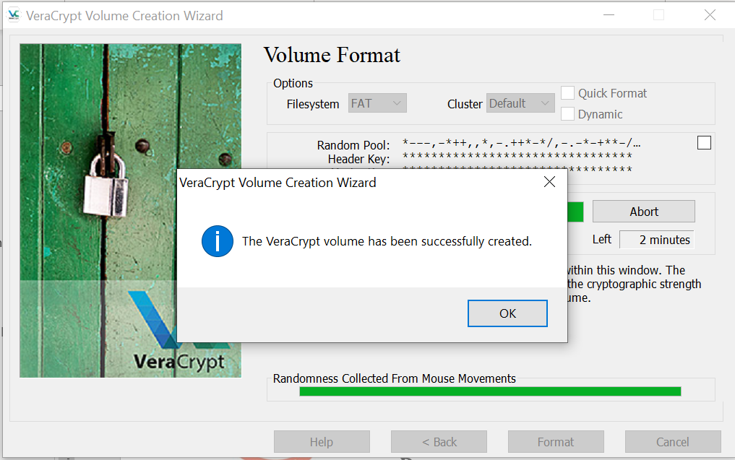

Figure 43: VeraCrypt Encryption 8

Select File->Select the location in which the encrypted volume is saved and click Mount

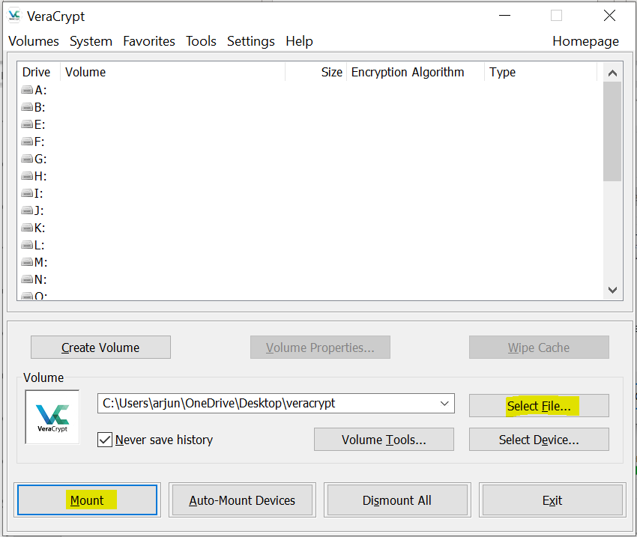

Figure 44: Veracrypt Encryption 9

Provide the password and click OK.

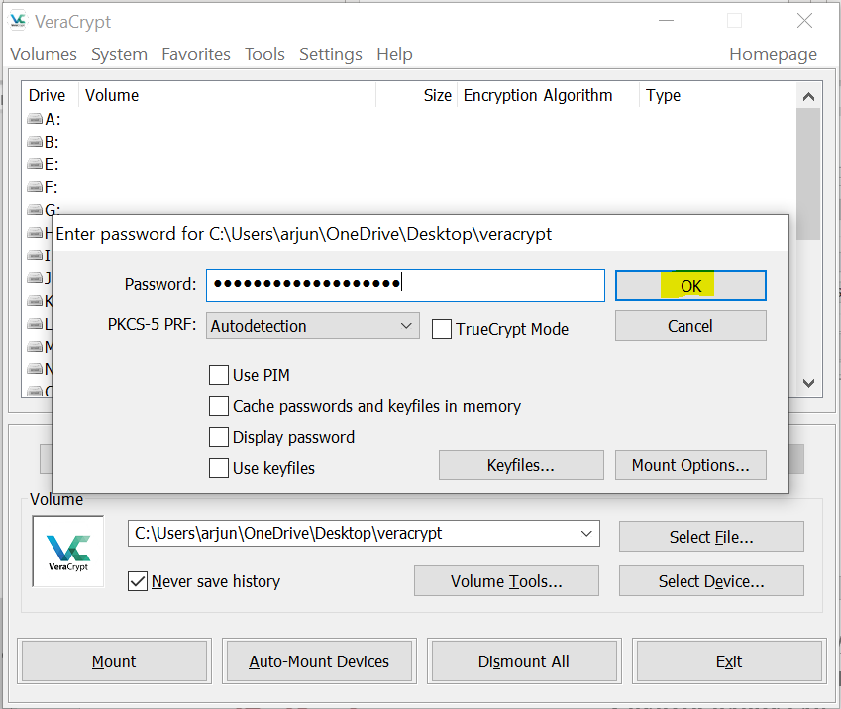

Figure 45: Veracrypt Encryption 10

Veracrypt encrypted disk is mounted.

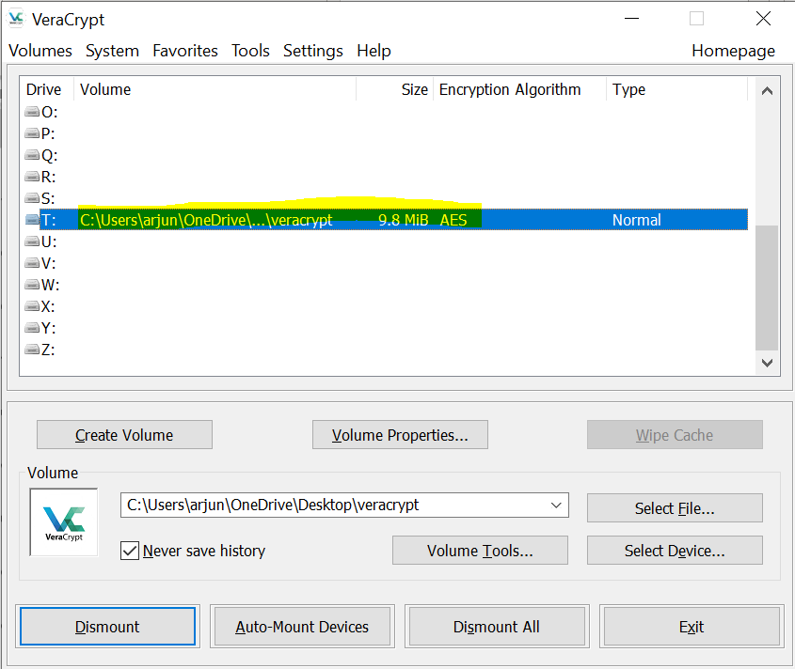

Figure 46: Veracrypt Encryption 11

Right click on the mounted section and then click open. A folder will be opened, copy the file to be encrypted in that location.

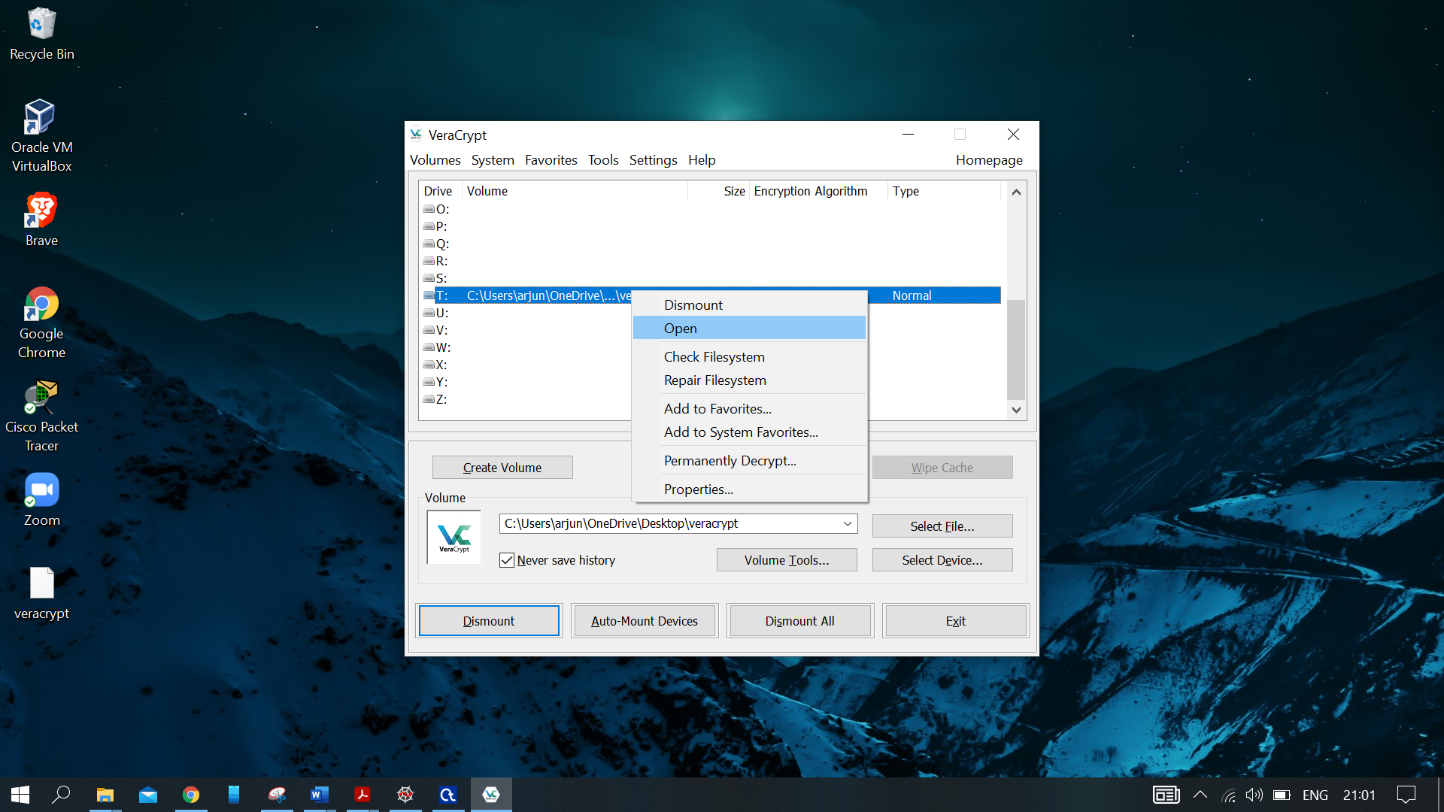

Figure 47: Veracrypt Encryption 12

After copying the file to that location select this drive and click Dismount.

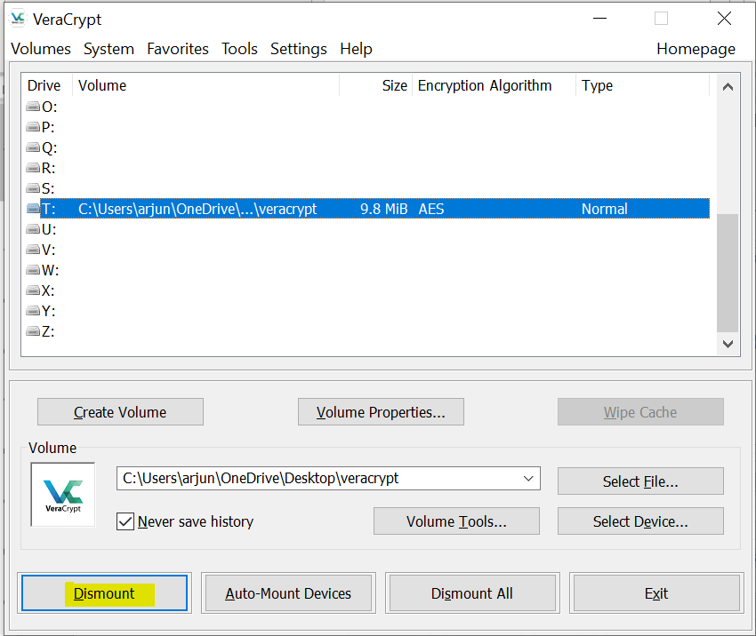

Figure 48: Veracrypt Encryption 13

Now the file is encrypted, in order to decrypt, we will have to mount this volume again and right click and then open.

*Decryption*

Select File->Select the location in which the encrypted volume is saved and click Mount.



Figure 49:Veracrypt Decryption1

Provide the password and click OK.



Figure 50: Veracrypt Decryption 2

Veracrypt encrypted disk is mounted.



Figure 51: Veracrypt Decryption 3

Right click on the mounted section and then click open. A folder will be opened, open the encrypted file.

## **Outcome of the Practical**

Performed encryption and decryption of a file using VeraCrypt.

# Use Ciphershed for Encryption and Decryption

## **Aim**

To encrypt and decrypt a file using Ciphershed.

## **Explanation**

Encryption is the process of converting normal message (plaintext) into meaningless message (Ciphertext). Whereas Decryption is the process of converting meaningless message (Ciphertext) into its original form (Plaintext).

In cryptography, encryption is the process of encoding information. This process converts the original representation of the information, known as plaintext, into an alternative form known as ciphertext. Ideally, only authorized parties can decipher a ciphertext back to plaintext and access the original information.

## **Tool Used**

**CipherShed** is free (as in free-of-charge and free-speech) encryption software for keeping your data secure and private. It started as a fork of the now-discontinued TrueCrypt Project. Learn more about how CipherShed works and the project behind it.

CipherShed is cross-platform; It is available for Windows, Mac OS X and GNU/Linux. Although, as packages for OS X and Linux do not exist, yet, users of those platforms will need to compile CipherShed.

The CipherShed project is open-source, meaning the program source code is available for anyone to view. We encourage everyone to examine and audit our code, as well as encourage new ideas and improvements.

## **Screenshot of Output**

Click on Create Volume.

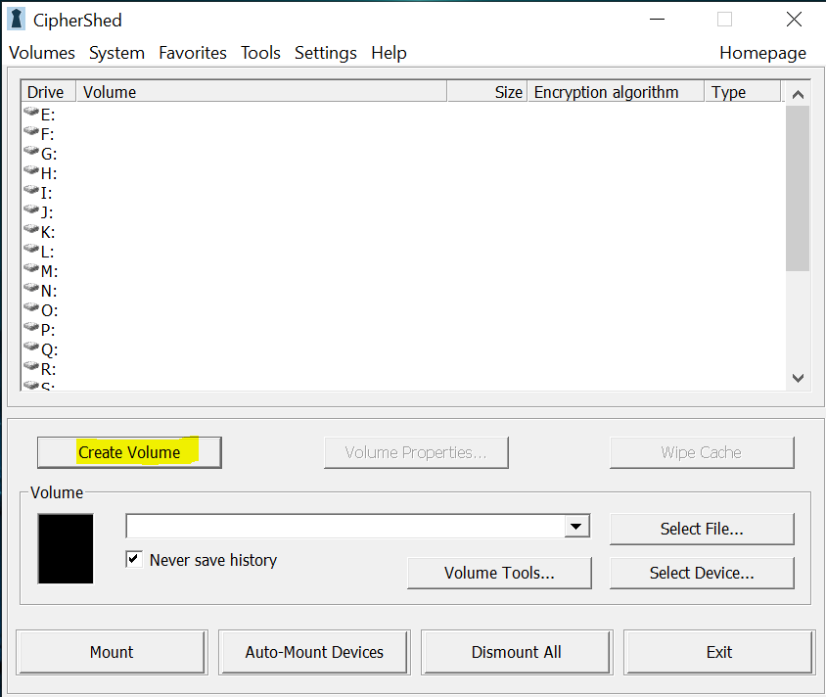

Figure 52: Cipher Shed 1

Select the option Create an encrypted file container and click next.

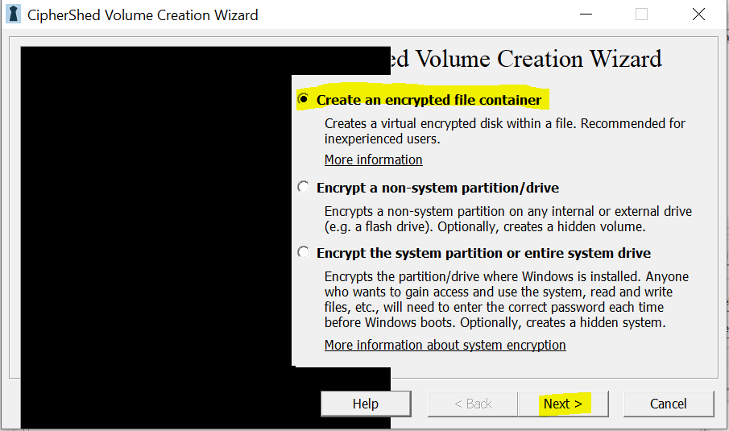

Figure 53: Ciphershed 2

Select Standard ciphershed volume and click Next.

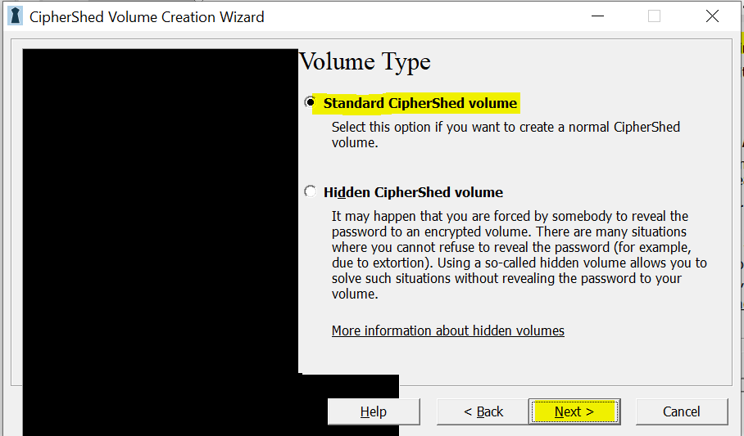

Figure 54: Ciphershed 3

Click on select file and select the location where you want the encrypted volume to be saved and then click Next.

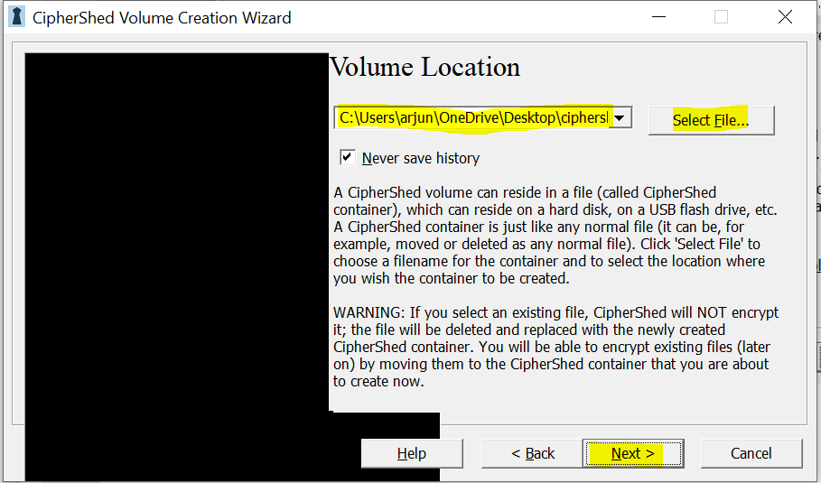

Figure 55: Ciphershed 4

Select the encryption and hashing algorithm and then click Next.

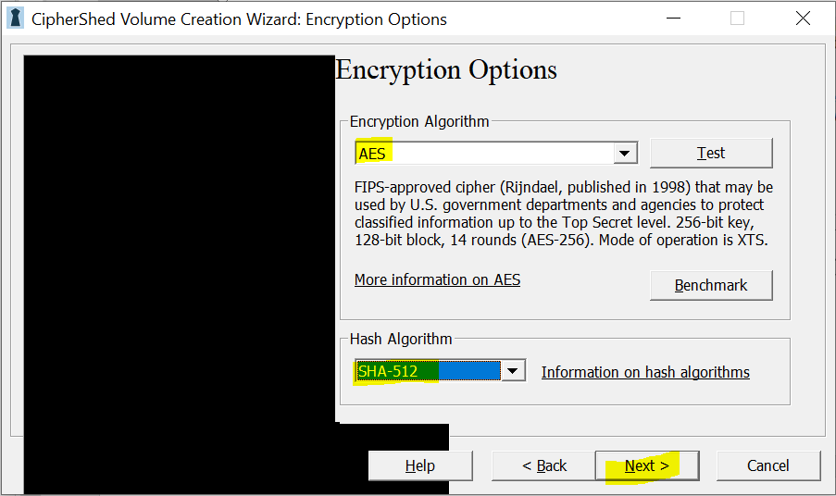

Figure 56: Ciphershed 5

Select the required size for the encrypted volume.

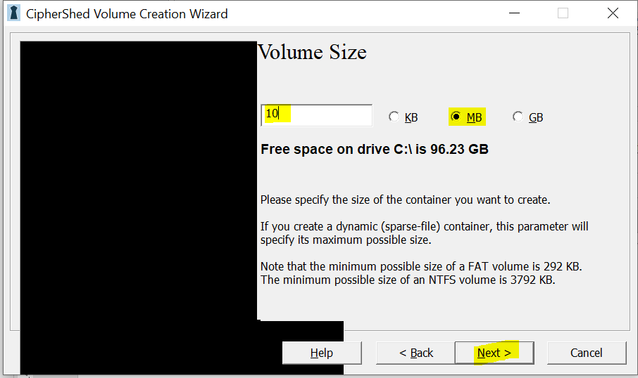

Figure 57: Ciphershed 6

Enter a strong password and click next, if the password you are using is weak, then there is no point in all these encryptions.

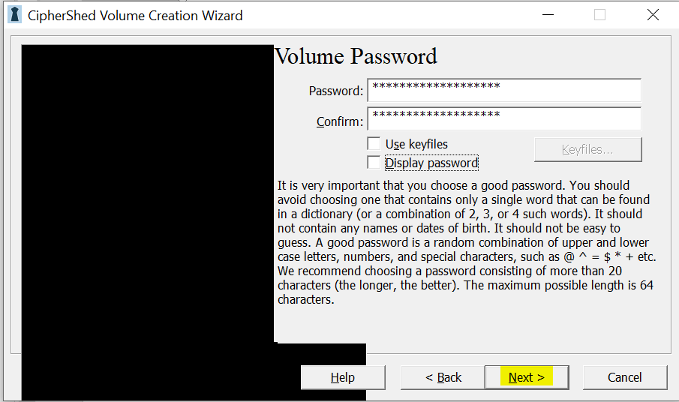

Figure 58: Ciphershed 7

Select file system as NTFS, as it is used in Windows and click Format.

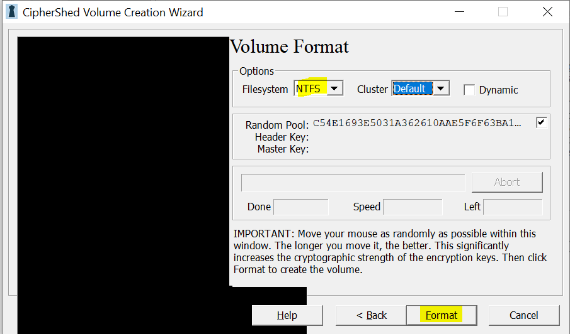

Figure 59: Ciphershed 8

We have successfully created the cipher shed volume. Now we can encrypt and decrypt the files using this volume.

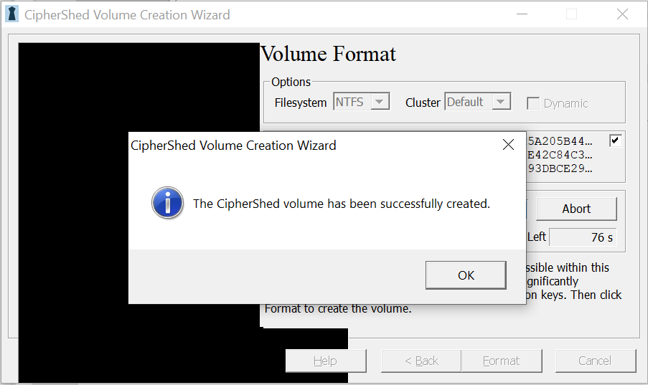

Figure 60: Ciphershed 9

For the encryption and decryption, the steps are same. First we have to mount the created volume. For that click on any drive name and Select file-> select the volume file and click mount.

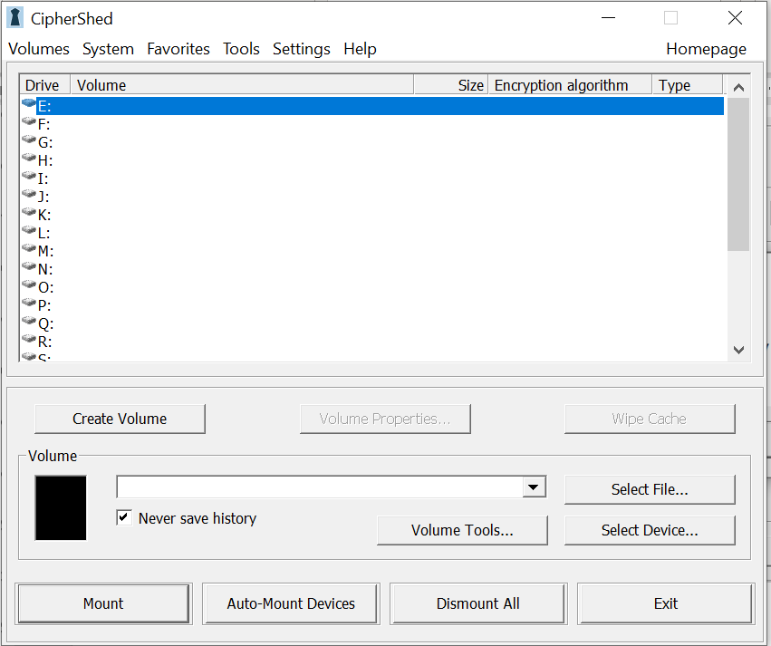

Figure 61: Ciphershed 10

Provide the password of the encrypted volume and click OK.

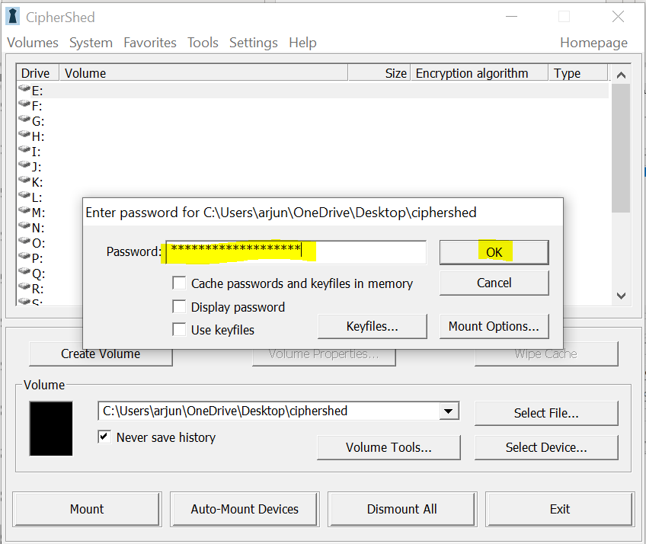

Figure 62: Ciphershed 11

After mounting, right click on the mounted volume and click open, this will open a folder and copy the file required on to this location.

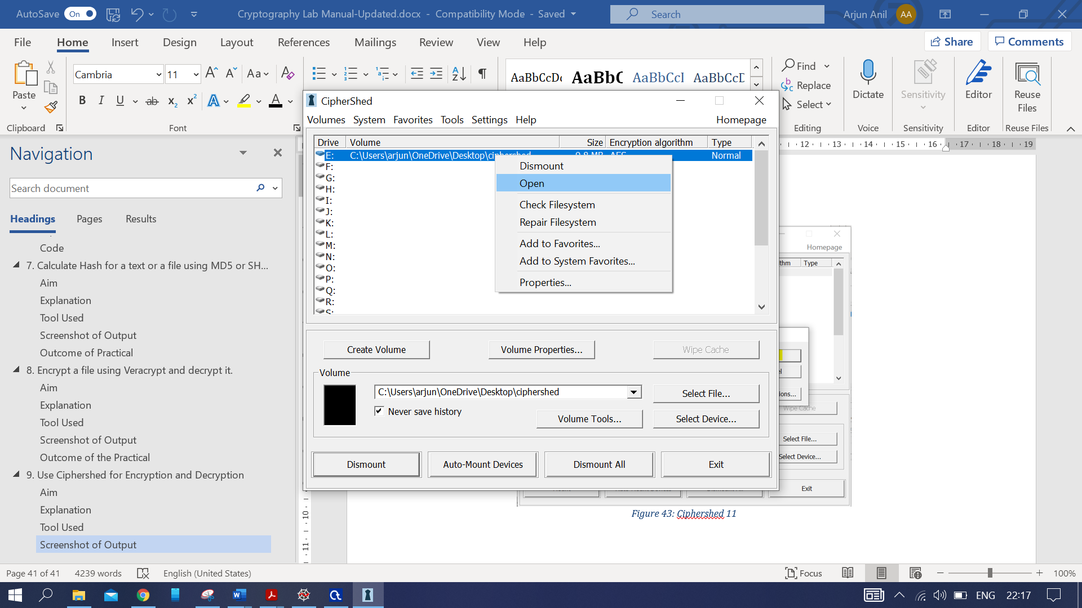

Figure 63: Cipher shed 12

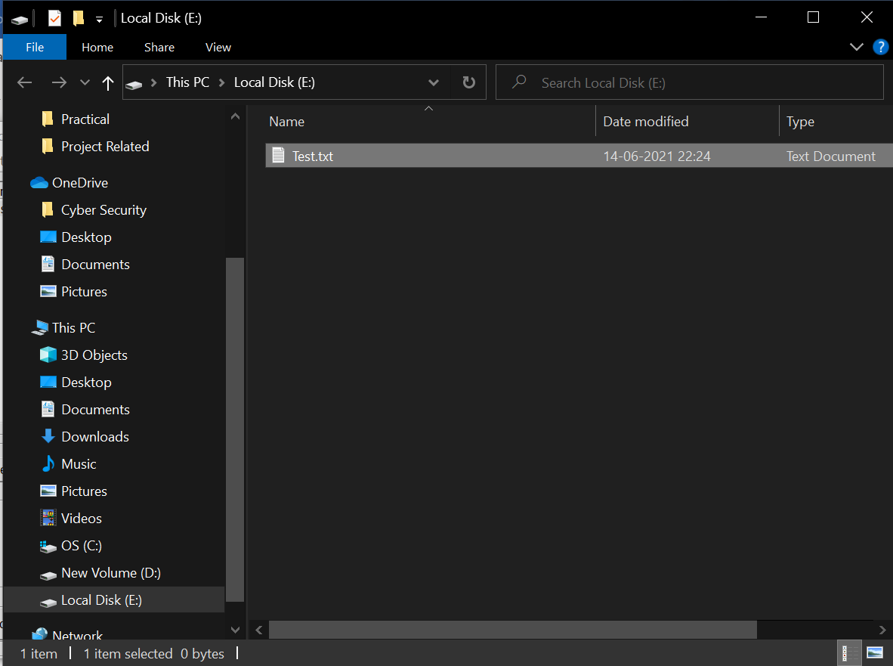

Figure 64: Ciphershed 13

After copying the file, unmount the volume so that others will not be able to access the file. As long as the volume is mounted it is accessible to others using the computer.

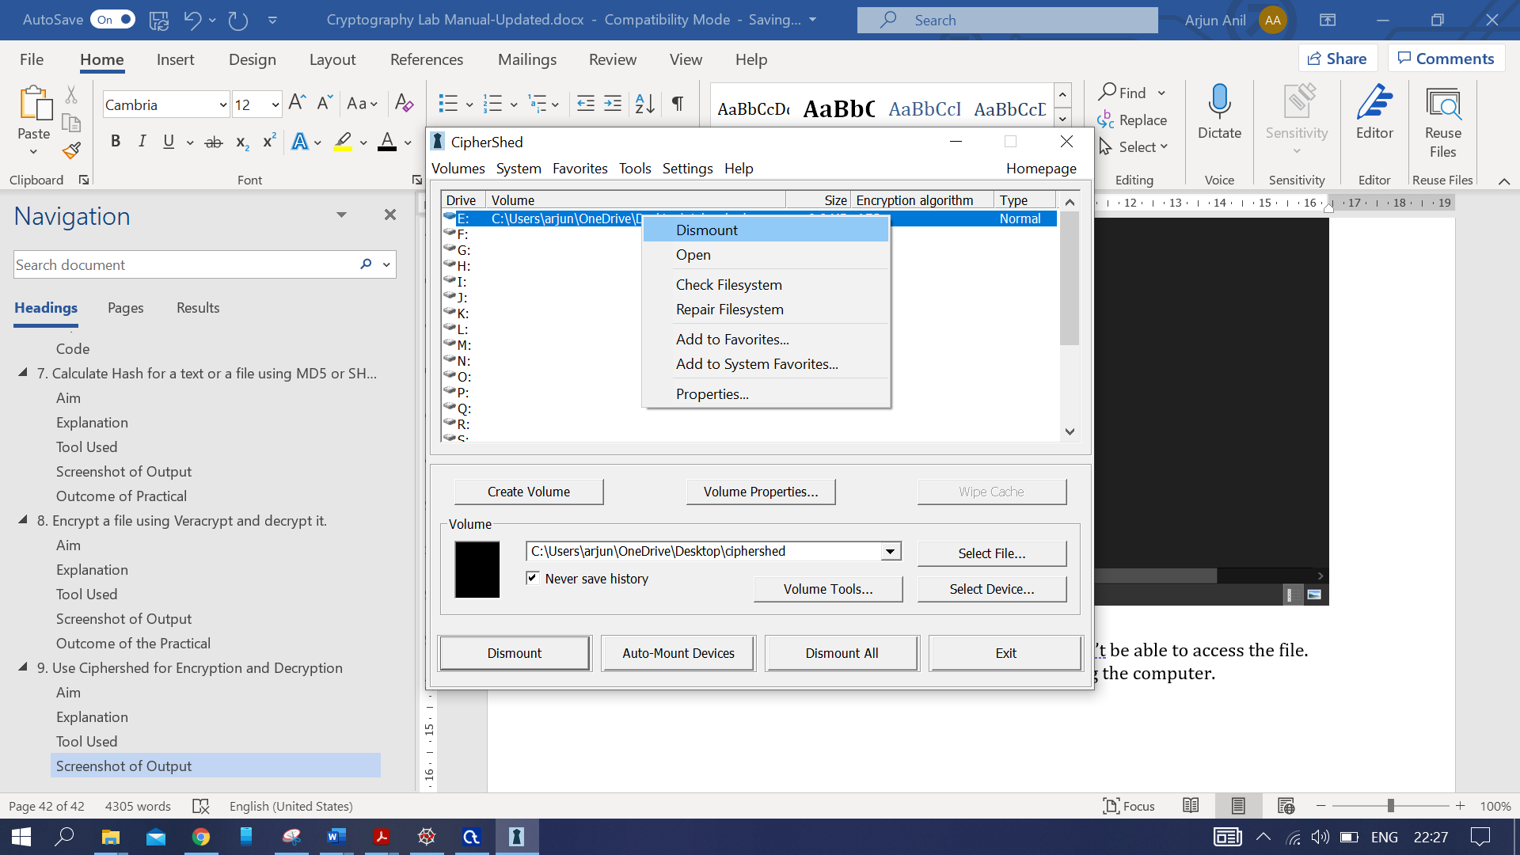

Figure 65: Ciphershed 14

The encrypted file and be decrypted by following the same steps as done for copying the file.

Mount the volume-> Provide password-> Open the Volume -> Access the file.

## **Outcome of the Practical**

Encrypted and decrypted the file using Ciphershed.

# Perform Various Encryption-Decryption Techniques with Cryptool- DES, AES, RC4 and HMAC

## **Aim**

To perform encryption and decryption techniques with Cryptool such as DES, AES and RC4.

## **Explanation**

***DES***

The DES (Data Encryption Standard) algorithm is a symmetric-key block cipher created in the early 1970s by an IBM team and adopted by the National Institute of Standards and Technology (NIST). The algorithm takes the plain text in 64-bit blocks and converts them into ciphertext using 48-bit keys.

Since it’s a symmetric-key algorithm, it employs the same key in both encrypting and decrypting the data. If it were an asymmetrical algorithm, it would use different keys for encryption and decryption.

DES Algorithm Steps

To put it in simple terms, DES takes 64-bit plain text and turns it into a 64-bit ciphertext. And since we’re talking about asymmetric algorithms, the same key is used when it’s time to decrypt the text.

The algorithm process breaks down into the following steps:

1. The process begins with the 64-bit plain text block getting handed over to an initial permutation (IP) function.
2. The initial permutation (IP) is then performed on the plain text.
3. Next, the initial permutation (IP) creates two halves of the permuted block, referred to as Left Plain Text (LPT) and Right Plain Text (RPT).
4. Each LPT and RPT goes through 16 rounds of the encryption process.
5. Finally, the LPT and RPT are rejoined, and a Final Permutation (FP) is performed on the newly combined block.
6. The result of this process produces the desired 64-bit ciphertext.

The encryption process step (step 4, above) is further broken down into five stages:

1. Key transformation
2. Expansion permutation
3. S-Box permutation
4. P-Box permutation
5. XOR and swap

For decryption, we use the same algorithm, and we reverse the order of the 16 round keys.

Next, to better understand what DES is, let us learn the various modes of operation for DES.

DES Modes of Operation

Data encryption experts using DES have five different modes of operation to choose from.

* Electronic Codebook (ECB). Each 64-bit block is encrypted and decrypted independently.
* Cipher Block Chaining (CBC). Each 64-bit block depends on the previous one and uses an Initialization Vector (IV)
* Cipher Feedback (CFB). The preceding ciphertext becomes the input for the encryption algorithm, producing pseudorandom output, which in turn is XORed with plaintext, building the next ciphertext unit.
* Output Feedback (OFB). Much like CFB, except that the encryption algorithm input is the output from the preceding DES.

***AES***

The more popular and widely adopted symmetric encryption algorithm likely to be encountered nowadays is the Advanced Encryption Standard (AES). It is found at least six time faster than triple DES.

A replacement for DES was needed as its key size was too small. With increasing computing power, it was considered vulnerable against exhaustive key search attack. Triple DES was designed to overcome this drawback, but it was found slow.

The features of AES are as follows −

* Symmetric key symmetric block cipher
* 128-bit data, 128/192/256-bit keys
* Stronger and faster than Triple-DES
* Provide full specification and design details.

Operation of AES

AES is an iterative rather than Feistel cipher. It is based on ‘substitution–permutation network’. It comprises of a series of linked operations, some of which involve replacing inputs by specific outputs (substitutions) and others involve shuffling bits around (permutations).

Interestingly, AES performs all its computations on bytes rather than bits. Hence, AES treats the 128 bits of a plaintext block as 16 bytes. These 16 bytes are arranged in four columns and four rows for processing as a matrix −

Unlike DES, the number of rounds in AES is variable and depends on the length of the key. AES uses 10 rounds for 128-bit keys, 12 rounds for 192-bit keys and 14 rounds for 256-bit keys. Each of these rounds uses a different 128-bit round key, which is calculated from the original AES key.

The schematic of AES structure is given in the following illustration −

AES Structure

Encryption Process

Here, we restrict to description of a typical round of AES encryption. Each round comprise of four sub-processes. The first round process is depicted below −

First Round Process

Byte Substitution (SubBytes)

The 16 input bytes are substituted by looking up a fixed table (S-box) given in design. The result is in a matrix of four rows and four columns.

Shiftrows

Each of the four rows of the matrix is shifted to the left. Any entries that ‘fall off’ are re-inserted on the right side of row. Shift is carried out as follows −

* First row is not shifted.
* Second row is shifted one (byte) position to the left.
* Third row is shifted two positions to the left.
* Fourth row is shifted three positions to the left.
* The result is a new matrix consisting of the same 16 bytes but shifted with respect to each other.

MixColumns

Each column of four bytes is now transformed using a special mathematical function. This function takes as input the four bytes of one column and outputs four completely new bytes, which replace the original column. The result is another new matrix consisting of 16 new bytes. It should be noted that this step is not performed in the last round.

Addroundkey

The 16 bytes of the matrix are now considered as 128 bits and are XORed to the 128 bits of the round key. If this is the last round, then the output is the ciphertext. Otherwise, the resulting 128 bits are interpreted as 16 bytes, and we begin another similar round.

Decryption Process

The process of decryption of an AES ciphertext is like the encryption process in the reverse order. Each round consists of the four processes conducted in the reverse order −

* Add round key
* Mix columns
* Shift rows
* Byte substitution

Since sub-processes in each round are in reverse manner, unlike for a Feistel Cipher, the encryption and decryption algorithms need to be separately implemented, although they are very closely related.

AES Analysis

In present day cryptography, AES is widely adopted and supported in both hardware and software. Till date, no practical cryptanalytic attacks against AES have been discovered. Additionally, AES has built-in flexibility of key length, which allows a degree of ‘future-proofing’ against progress in the ability to perform exhaustive key searches.

However, just as for DES, the AES security is assured only if it is correctly implemented, and good key management is employed.

***RC4***

In cryptography, RC4 (Rivest Cipher 4 also known as ARC4 or ARCFOUR meaning Alleged RC4, see below) is a stream cipher. While it is remarkable for its simplicity and speed in software, multiple vulnerabilities have been discovered in RC4, rendering it insecure. It is especially vulnerable when the beginning of the output keystream is not discarded, or when nonrandom or related keys are used. Particularly problematic uses of RC4 have led to very insecure protocols such as WEP.

RC4 generates a pseudorandom stream of bits (a keystream). As with any stream cipher, these can be used for encryption by combining it with the plaintext using bit-wise exclusive-or; decryption is performed the same way (since exclusive-or with given data is an involution). This is similar to the one-time pad except that generated pseudorandom bits, rather than a prepared stream, are used.

To generate the keystream, the cipher makes use of a secret internal state which consists of two parts:

1. A permutation of all 256 possible bytes (denoted "S" below).
2. Two 8-bit index-pointers (denoted "i" and "j").

The permutation is initialized with a variable length key, typically between 40 and 2048 bits, using the key-scheduling algorithm (KSA). Once this has been completed, the stream of bits is generated using the pseudo-random generation algorithm (PRGA).

***HMAC***

HMAC algorithm stands for Hashed or Hash based Message Authentication Code. It is a result of work done on developing a MAC derived from cryptographic hash functions. HMAC is a great resistant towards cryptanalysis attacks as it uses the hashing concept twice. HMAC consists of twin benefits of Hashing and MAC, and thus is more secure than any other authentication codes. RFC 2104 has issued HMAC, and HMAC has been made compulsory to implement in IP security. The FIPS 198 NIST standard has also issued HMAC.

Objectives –

As the Hash Function, HMAC is also aimed to be one way, i.e., easy to generate output from input but complex the other way round.

It aims at being less effected by collisions than the hash functions.

HMAC reuses the algorithms like MD5 and SHA-1 and checks to replace the embedded hash functions with more secure hash functions, in case found.

HMAC tries to handle the Keys in more simple manner.

HMAC algorithm –

The working of HMAC starts with taking a message M containing blocks of length b bits. An input signature is padded to the left of the message and the whole is given as input to a hash function which gives us a temporary message digest MD’. MD’ again is appended to an output signature and the whole is applied a hash function again, the result is our final message digest MD.

Here is a simple structure of HMAC:

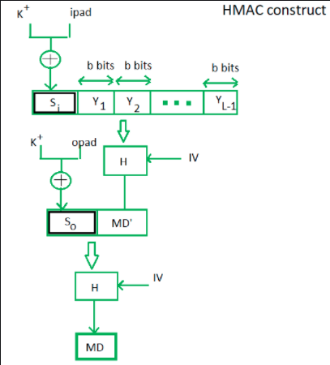

Figure 66: HMAC Construct (Source: <https://www.geeksforgeeks.org/hmac-algorithm-in-computer-network/>)

Here, H stands for hashing function,

M is original message.

Si and So, are input and output signatures respectively,

Yi is the ith block in original message M, where i ranges from [1, L)

L = the count of blocks in M

K is the secret key used for hashing.

IV is an initial vector (some constant)

The generation of input signature and output signature Si and So respectively.

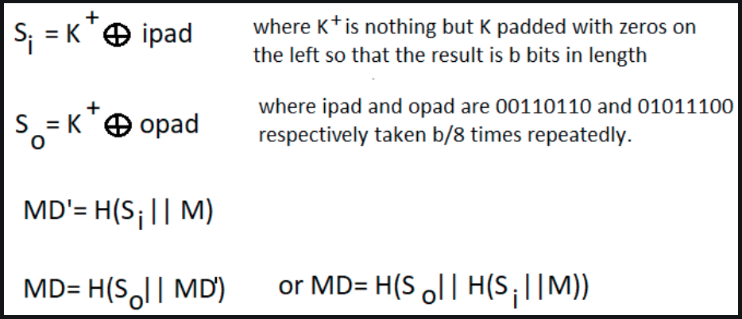

Figure 67: HMAC (Source: <https://www.geeksforgeeks.org/hmac-algorithm-in-computer-network/>)

To a normal hash function HMAC adds a compression instance to the processing. This structural implementation holds efficiency for shorter MAC values.

## **Tool Used**

**CrypTool** is an open-source project that focuses on the free e-learning software CrypTool illustrating cryptogram phic and cryptanalytic concepts. According to "Hakin9", CrypTool is worldwide the most widespread e-learning software in the field of cryptology.

CrypTool implements more than 400 algorithms. Users can adjust these with own parameters. To introduce users to the field of cryptography, the organization created multiple graphical interface software containing an online documentation, analytic tools, and algorithms. They contain most classical ciphers, as well as modern symmetric and asymmetric cryptography including RSA, ECC, digital signatures, hybrid encryption, homomorphic encryption, and Diffie–Hellman key exchange. Methods from the area of quantum cryptography (like BB84 key exchange protocol) and the area of post-quantum cryptography (like McEliece, WOTS, Merkle-Signature-Scheme, XMSS, XMSS_MT, and SPHINCS) are implemented. In addition to the algorithms, solvers (analyzers) are included, especially for classical ciphers. Other methods (for instance Huffman code, AES, Keccak, MSS) are visualized.

In addition, it contains: didactical games (like Number Shark, Divider Game, or Zudo-Ku) and interactive tutorials about primes, elementary number theory, and lattice-based cryptography.

## **Screenshot of Output**

DES Encryption

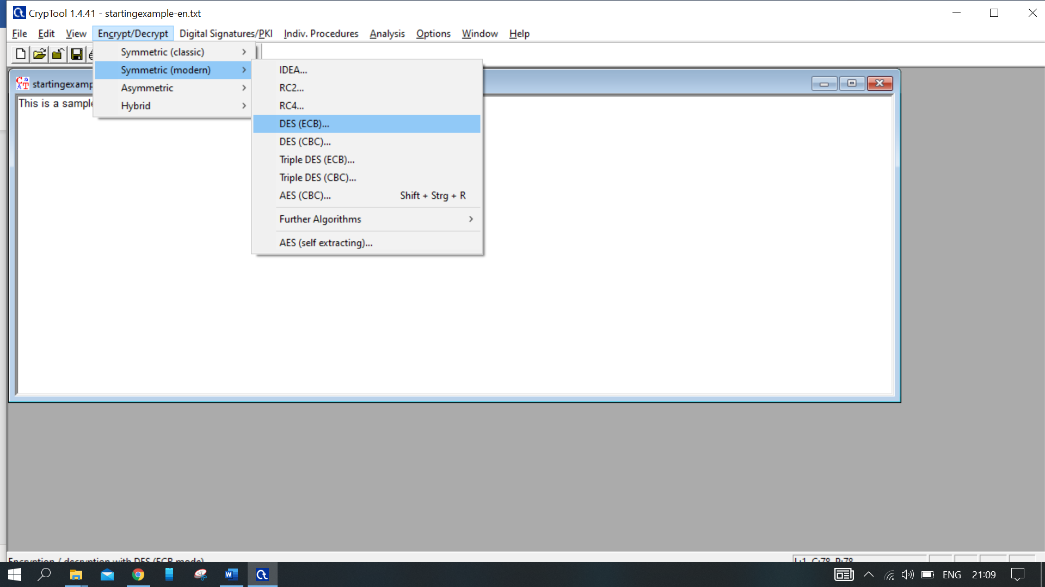

Figure 68: DES Encryption-1

Enter a value for the key, as this is a symmetric key encryption, keep this key in mind for decryption.

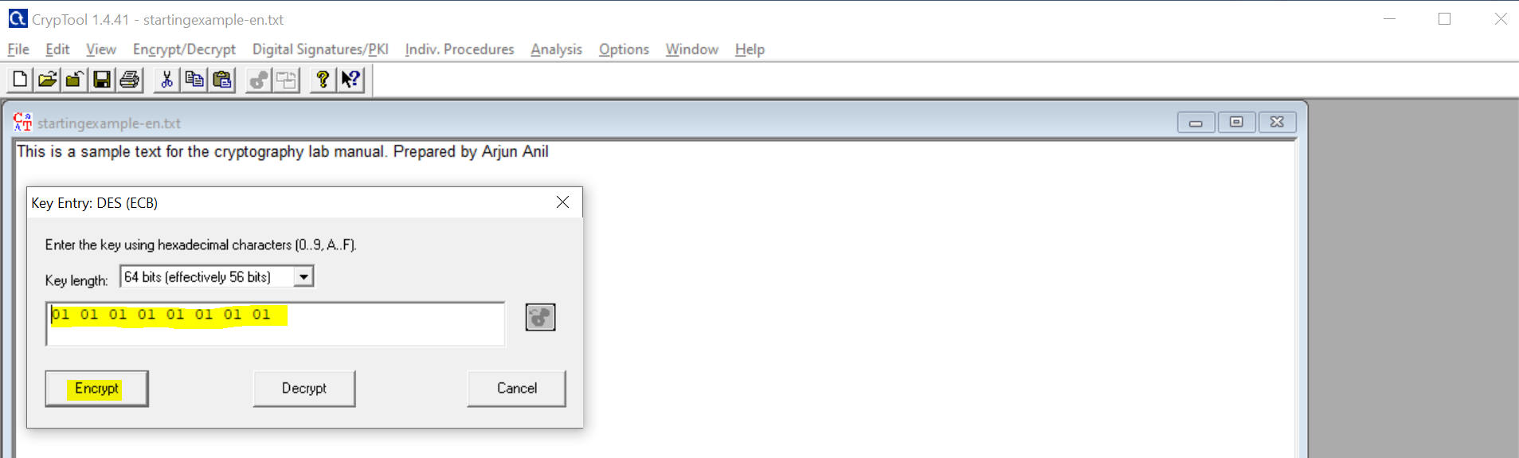

Figure 69: DES Encryption-2

The Encrypted Output.

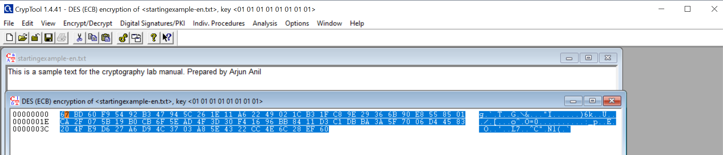

Figure 70: DES Encryption-3

DES Decryption

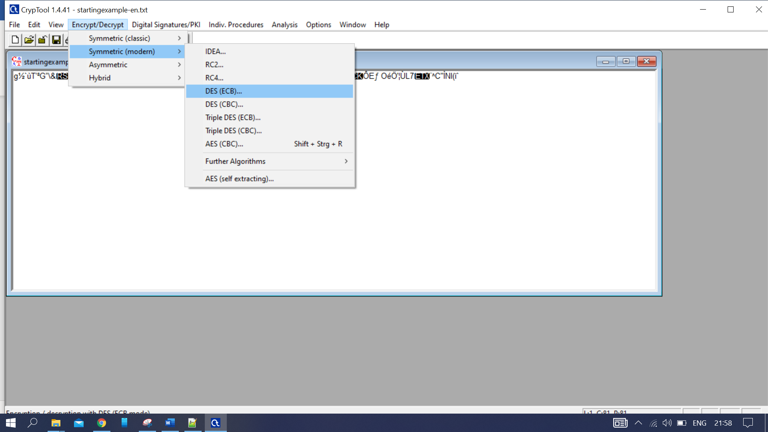

Figure 71: DES Decryption-1

Decrypt the previously encrypted code, provide the same key used and press decrypt.

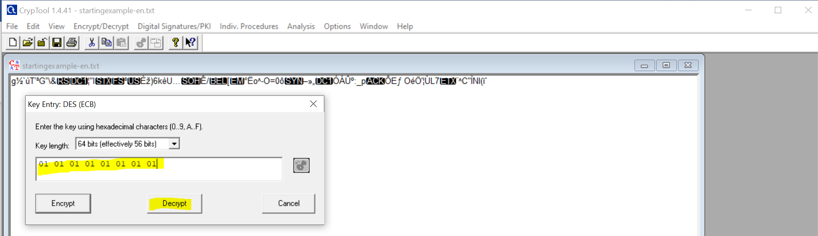

Figure 72: DES Decryption-2

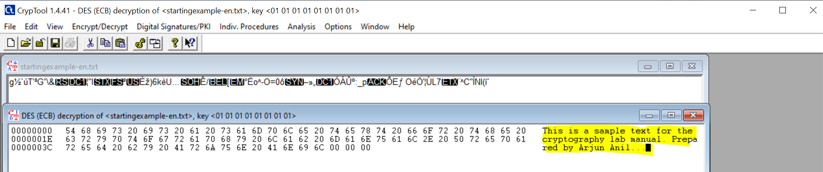

Figure 73: DES Decryption-3

For the detailed steps for DES you can follow the below steps for animation.

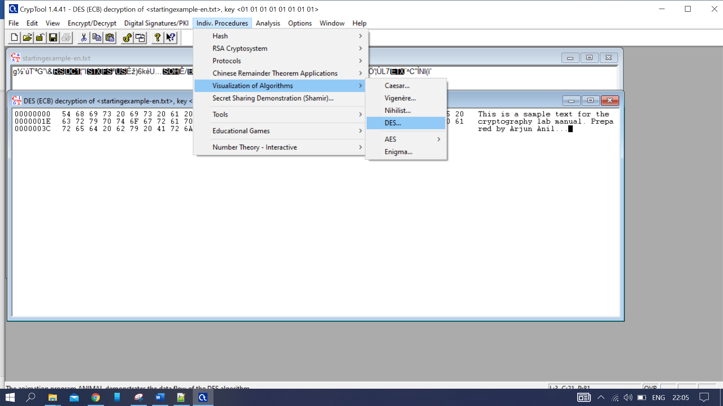

Figure 74: DES

**AES Encryption**

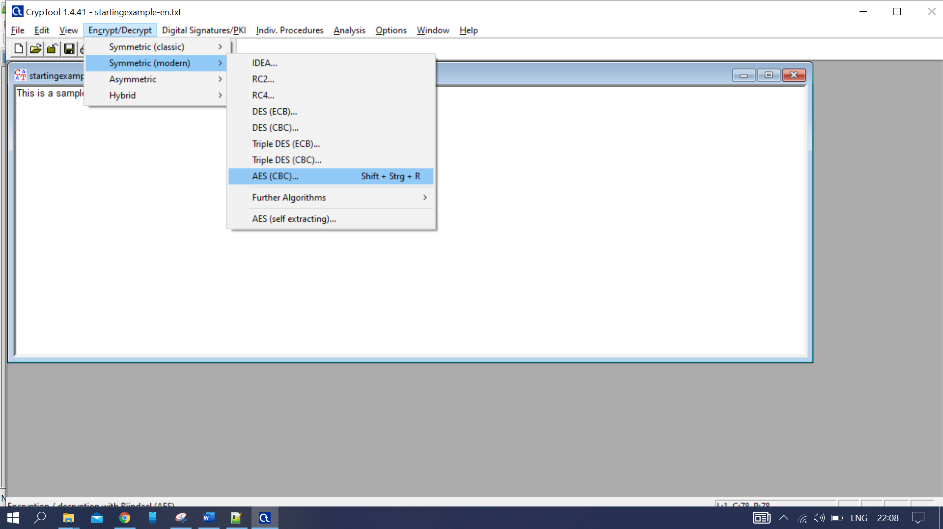

Figure 75: AES Encryption-1

Select the key size you require, update the key and press encrypt.

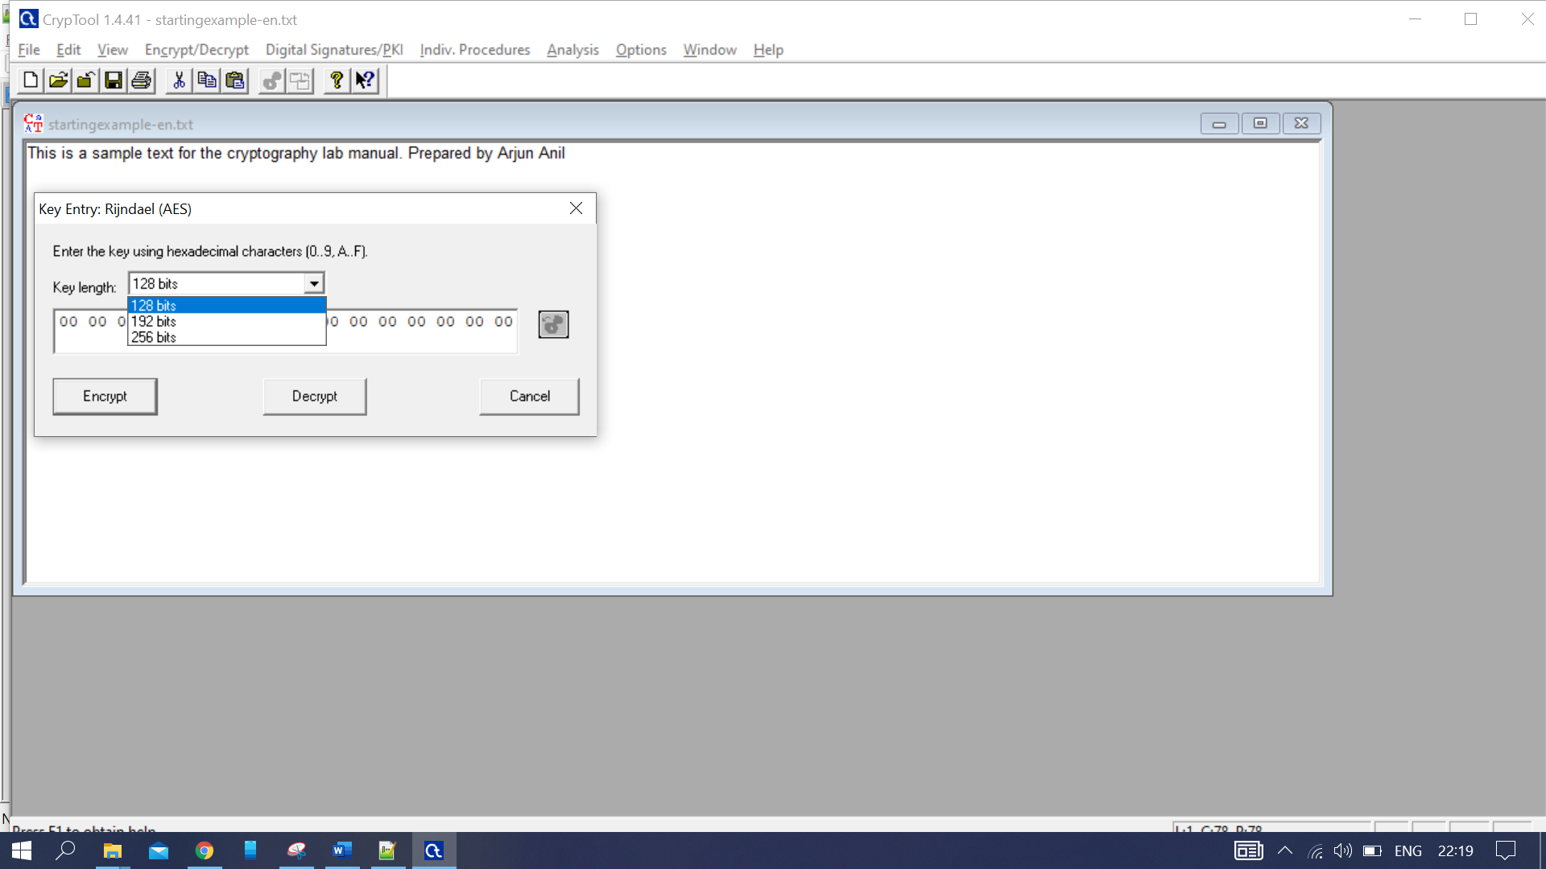

Figure 76: AES Encryption-2

Highlighted part is the encrypted value.

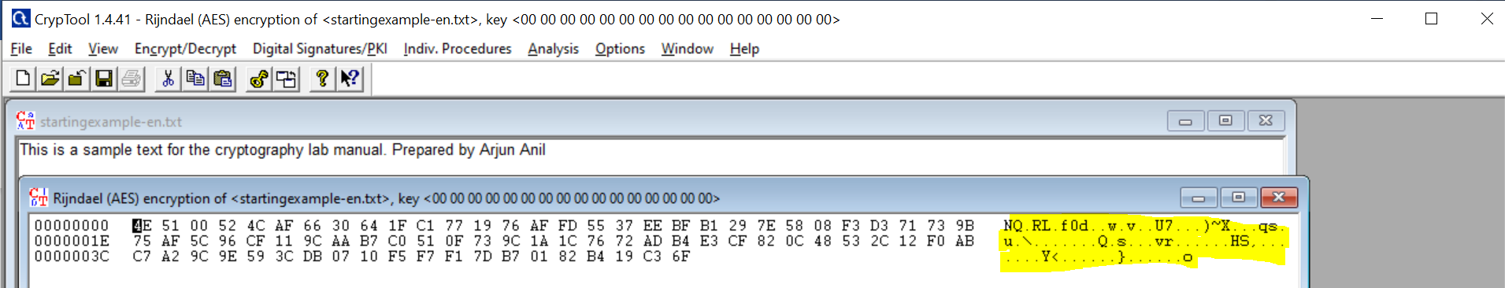

Figure 77: AES Encryption-3

AES Decryption

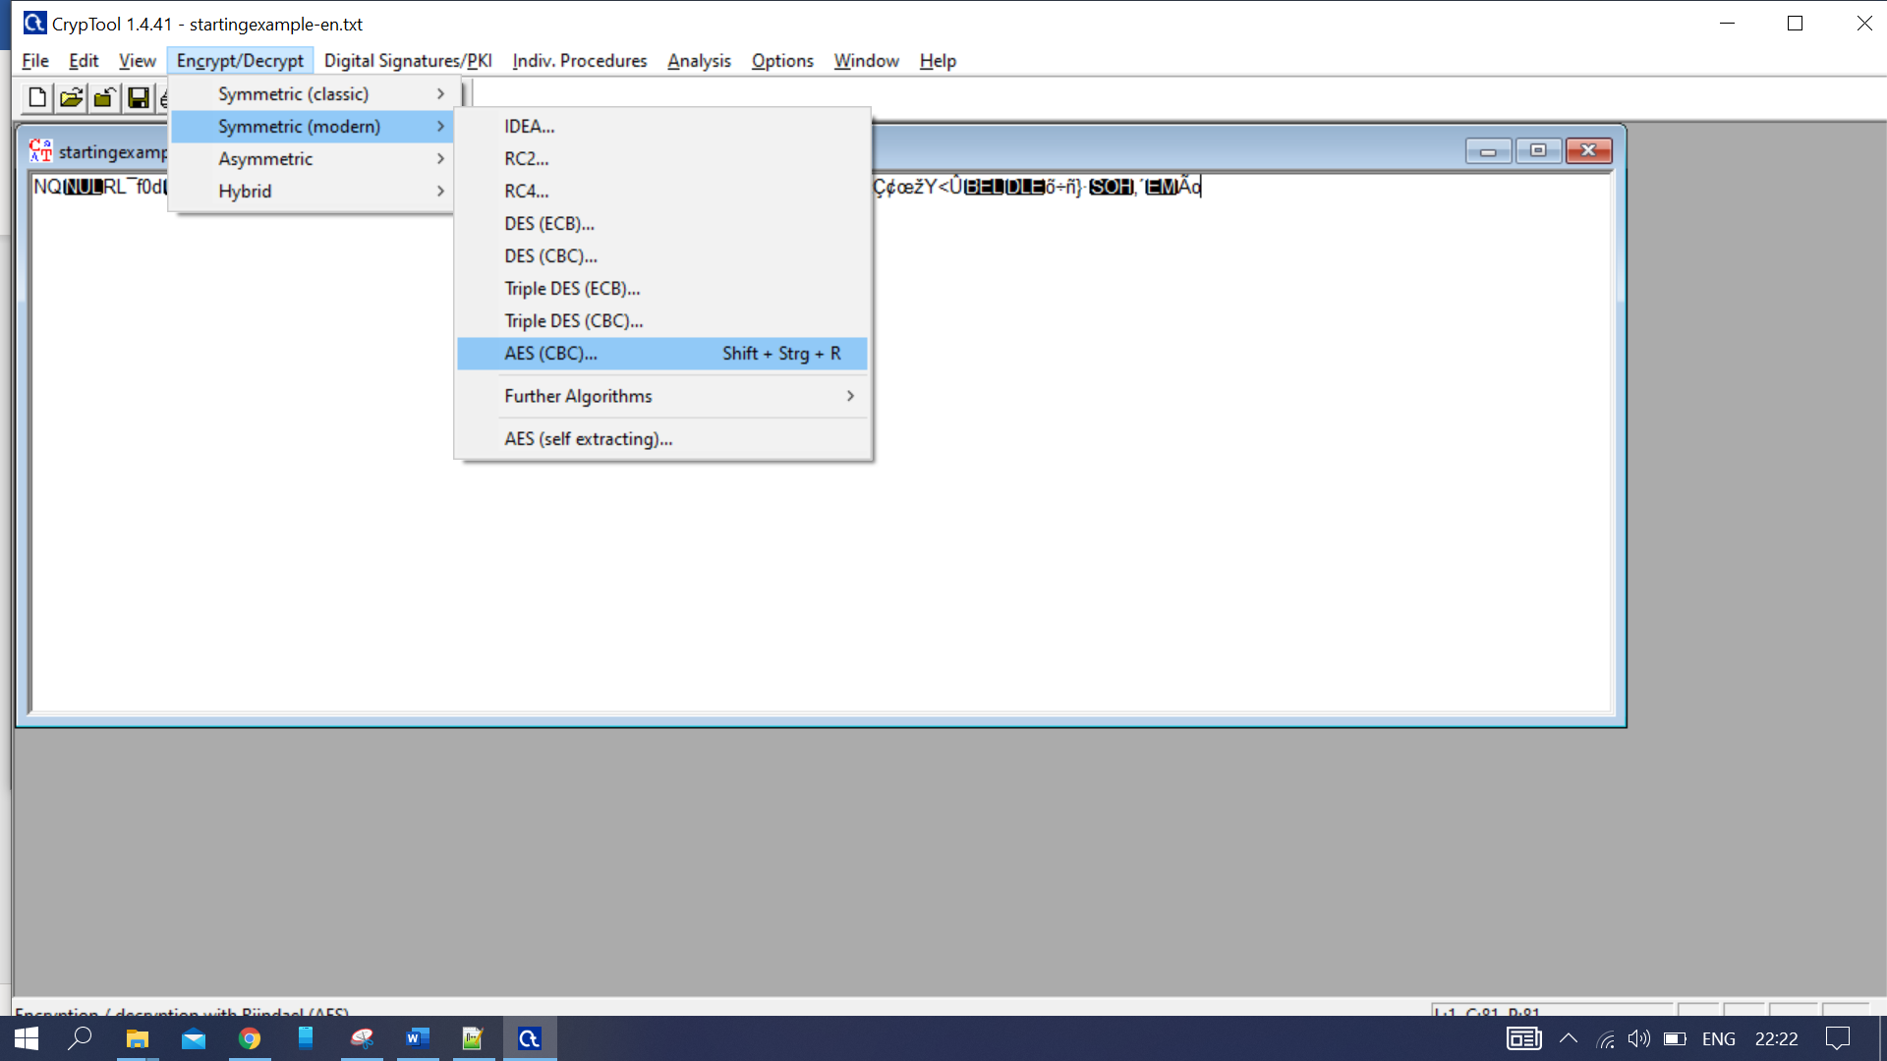

Figure 78:AES Decryption-1

Enter the same key and key length as selected for encryption and press Decrypt.

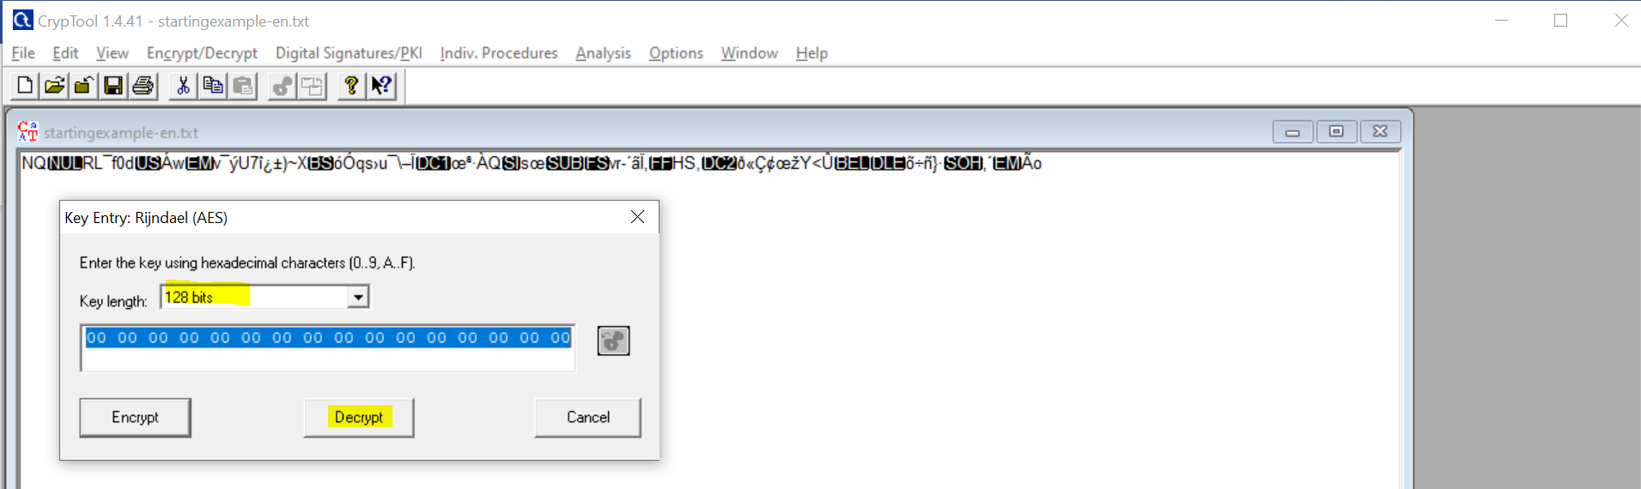

Figure 79: AES Decryption-2

Decrypted Value

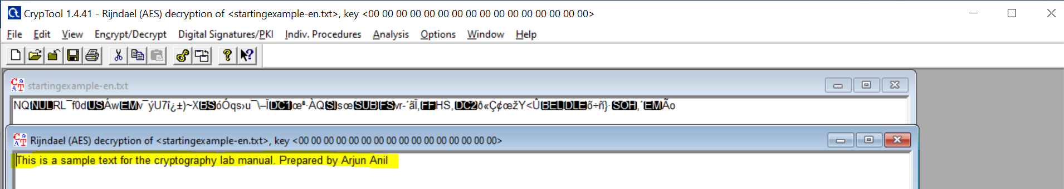

Figure 80: AES Decryption-3

**RC4 Encryption**

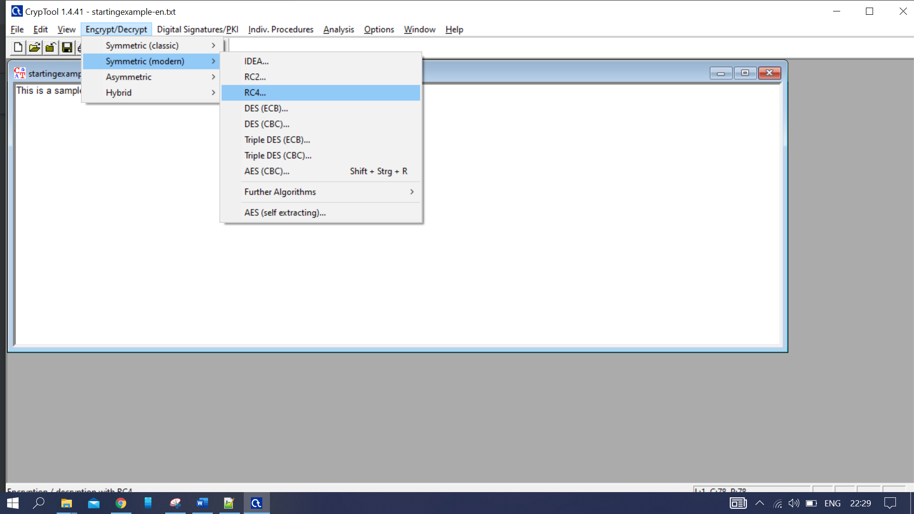

Figure 81: RC4 Encryption-1

Select the bit size you want and update the key and press Encrypt.

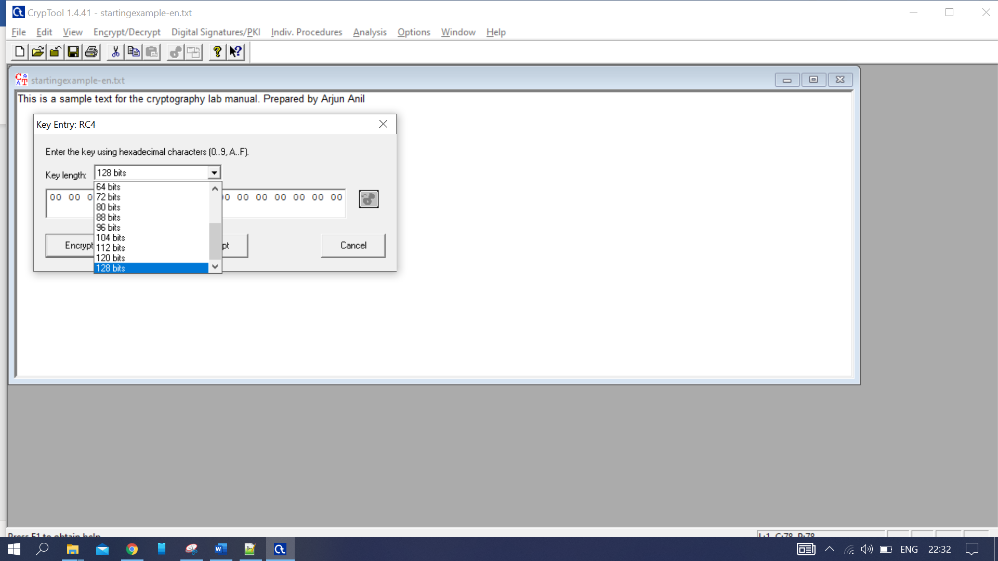

Figure 82: RC4 Encryption-2

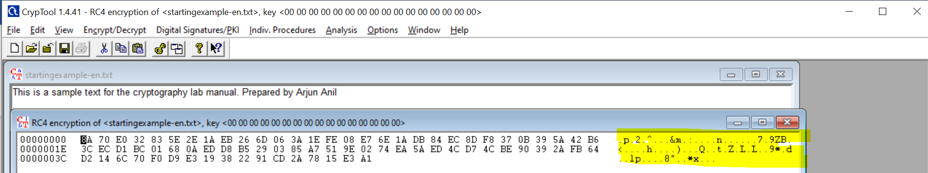

Figure 83: RC4 Encryption-4

**RC4 Decryption**

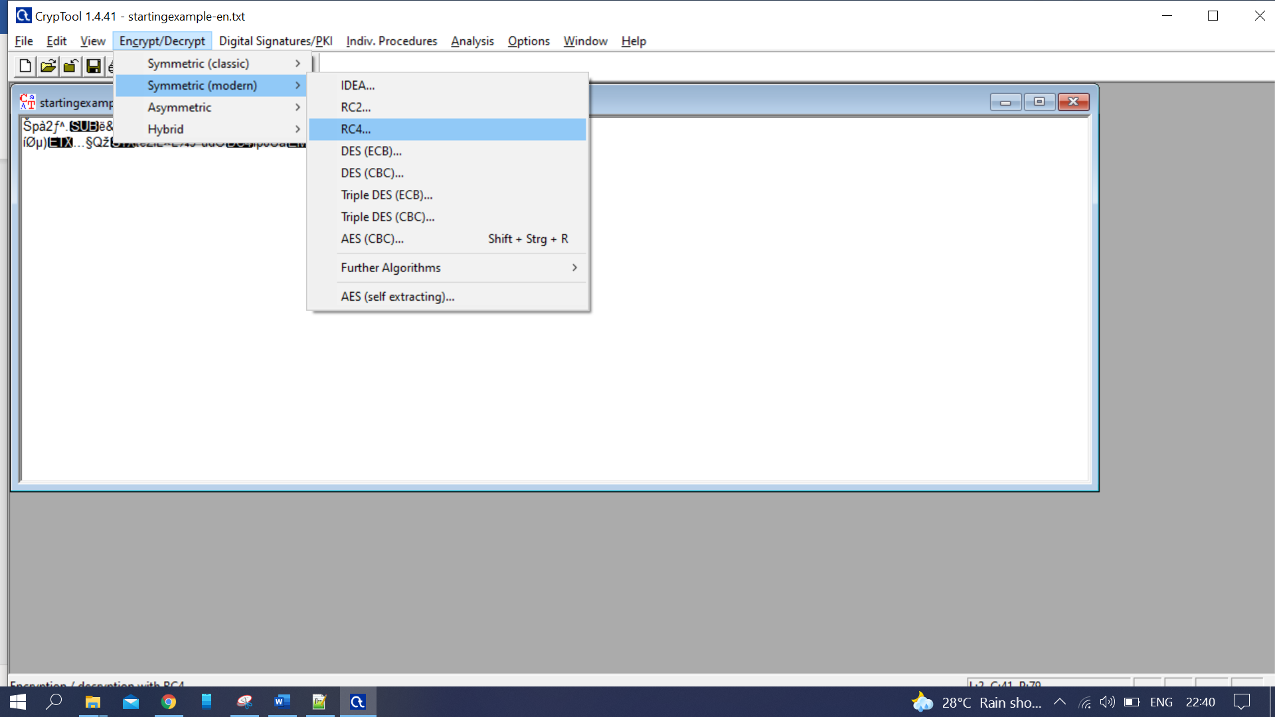

Figure 84: RC4 Decryption-1

Select the same key length and key used for encryption and press Decrypt.

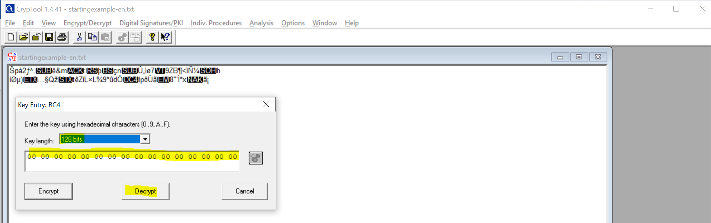

Figure 85: RC4 Decryption-2

It was getting decrypted as below:

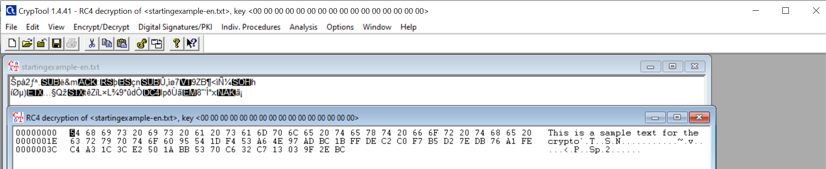

Figure 86: RC4 Decryption-3

***HMAC***

Select HMAC as below:

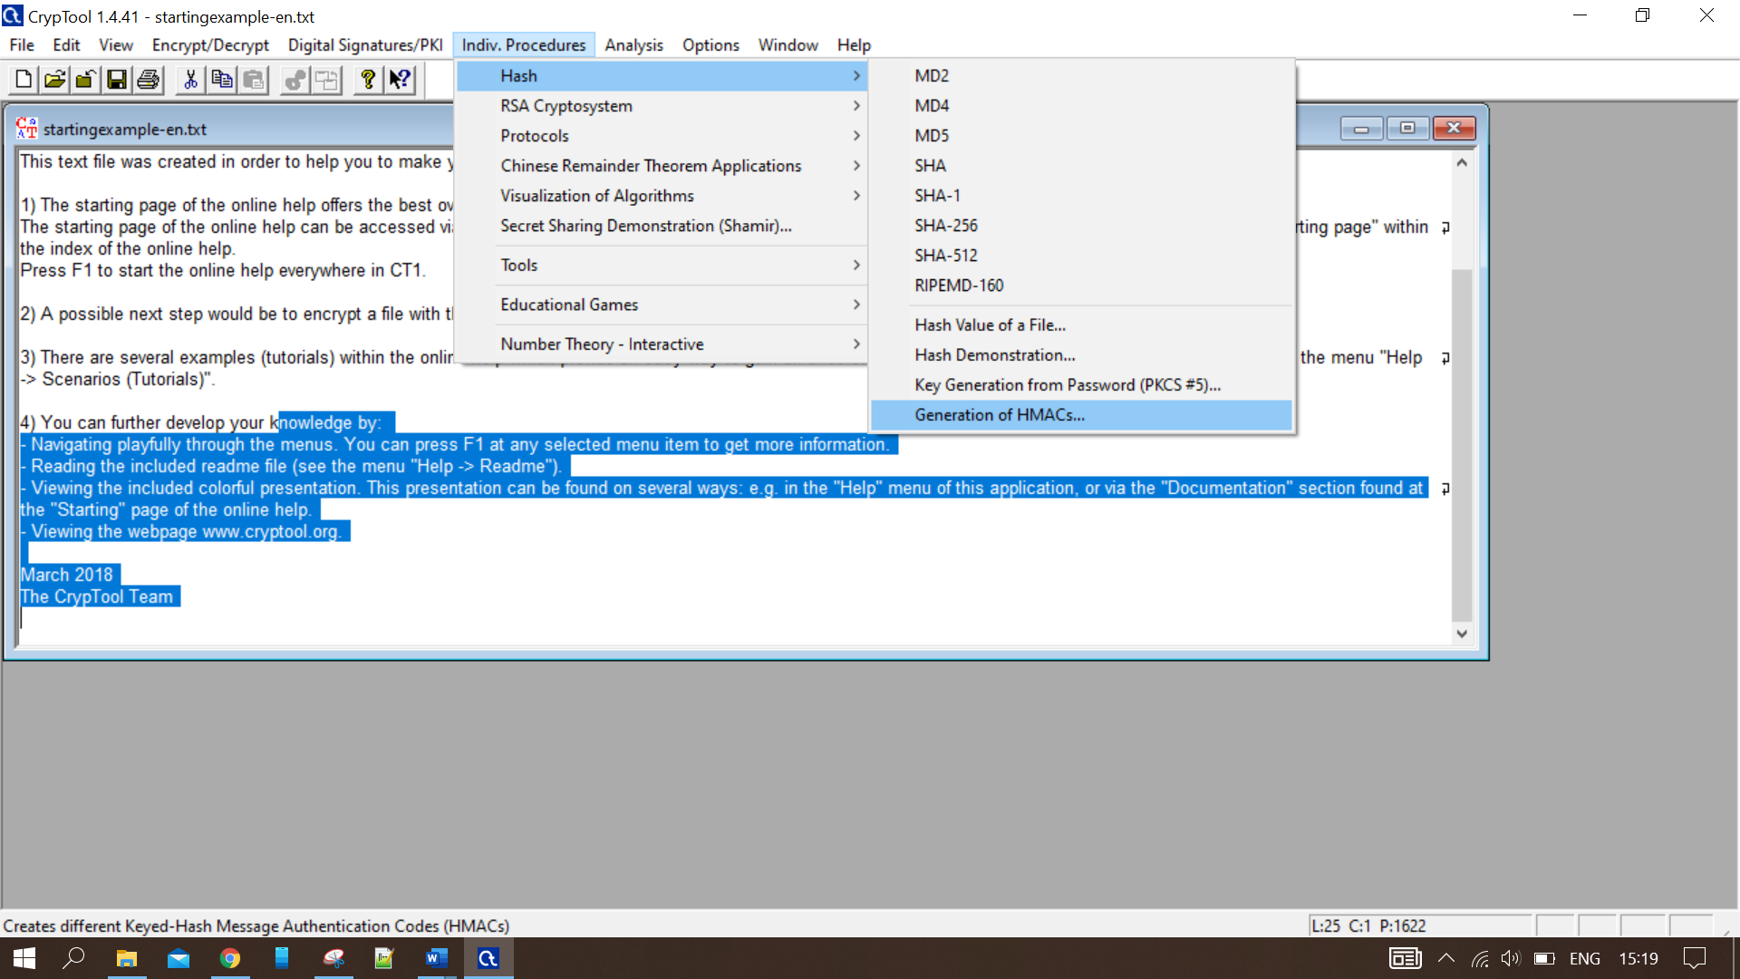

Figure 87: Select HMAC.

Enter the text to convert and update the key the HMC will be generated at the bottom.

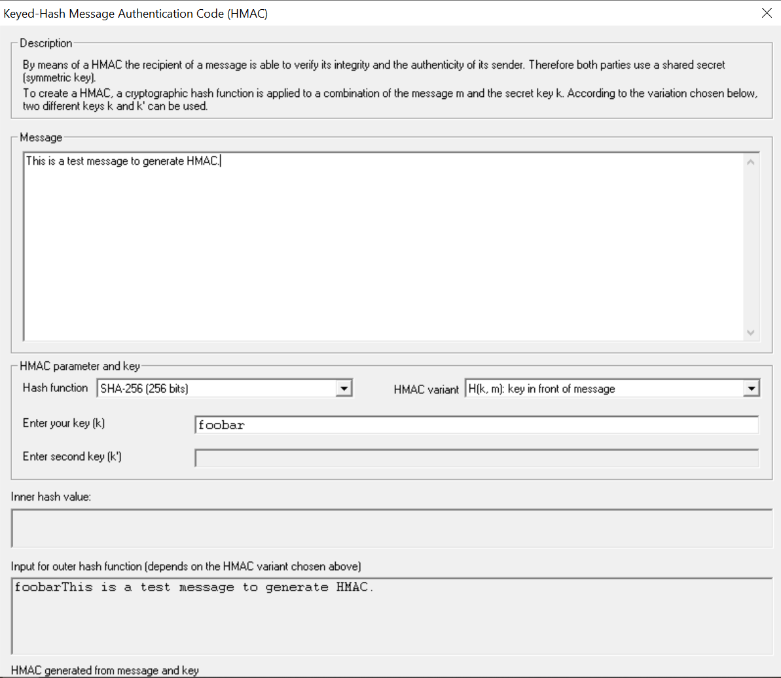

Figure 88:HMAC

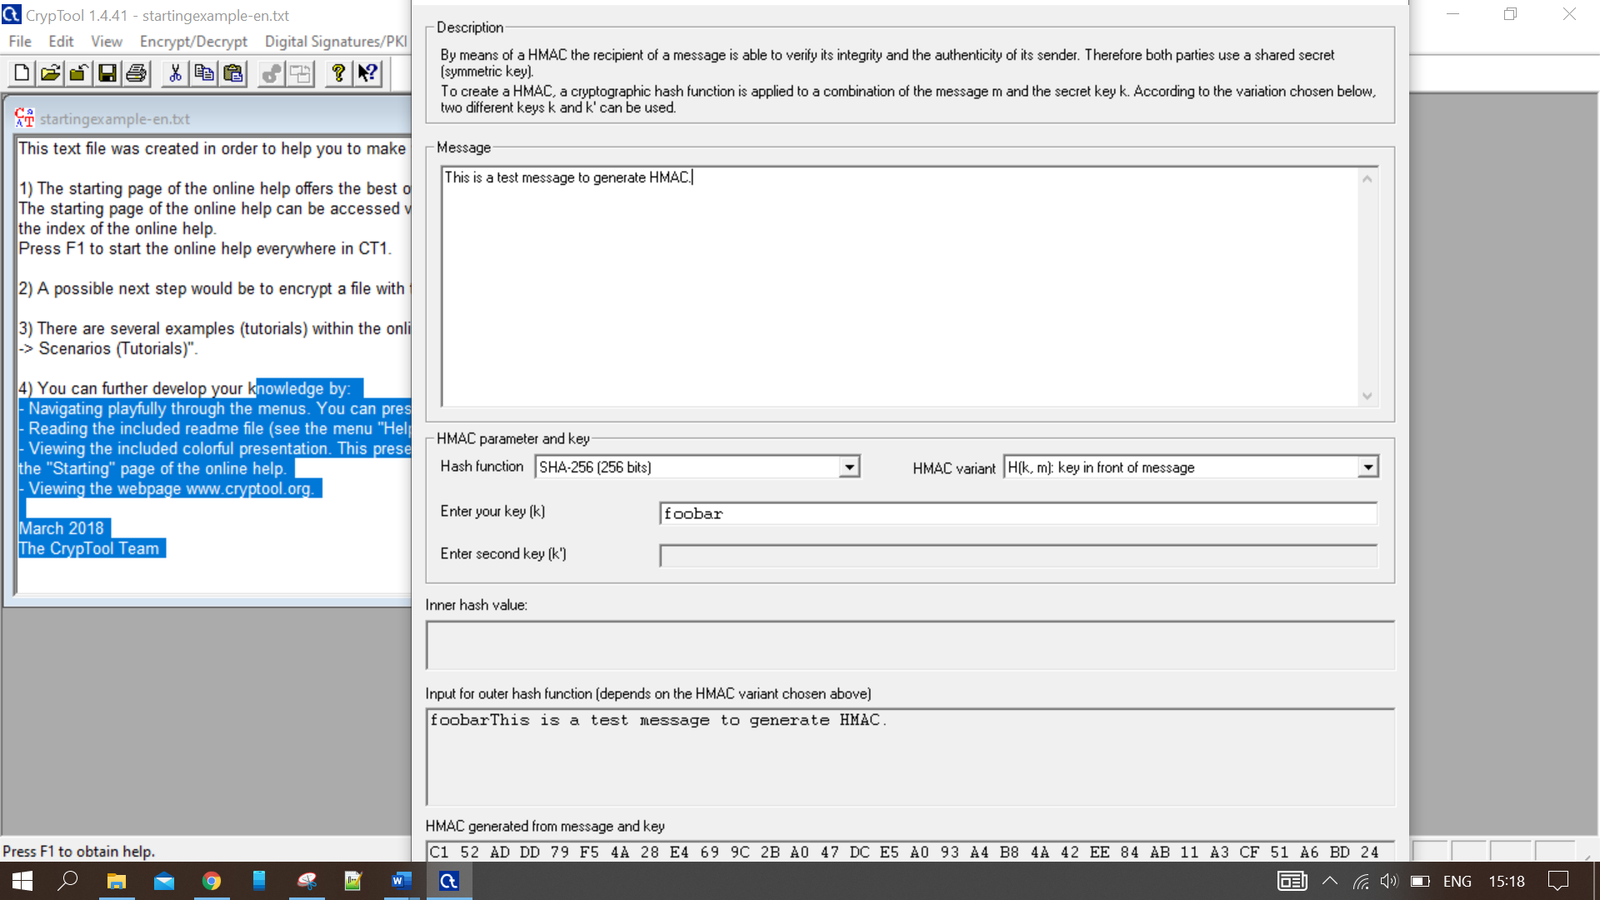

Figure 89: Generated HMAC value

## **Outcome of the Practical**

Encrypted and decrypted a sample text with cryptool for the DES, AES and RC4 algorithms and HMAC.

# Generate Certificate using Openssl

## **Aim**

To generate certificate using Openssl.

## **Explanation**

OpenSSL is a software library for applications that secure communications over computer networks against eavesdropping or need to identify the party at the other end. It is widely used by Internet servers, including most HTTPS websites.

OpenSSL contains an open-source implementation of the SSL and TLS protocols. The core library, written in the C programming language, implements basic cryptographic functions and provides various utility functions. Wrappers allowing the use of the OpenSSL library in a variety of computer languages are available.

The OpenSSL Software Foundation (OSF) represents the OpenSSL project in most legal capacities including contributor license agreements, managing donations, and so on. OpenSSL Software Services (OSS) also represents the OpenSSL project, for Support Contracts.

***Algorithms***

OpenSSL supports several different cryptographic algorithms:

*Ciphers*

AES, Blowfish, Camellia, Chacha20, Poly1305, SEED, CAST-128, DES, IDEA, RC2, RC4, RC5, Triple DES, GOST 28147-89, SM4

*Cryptographic hash functions*

MD5, MD4, MD2, SHA-1, SHA-2, SHA-3, RIPEMD-160, MDC-2, GOST R 34.11-94, BLAKE2, Whirlpool, SM3

*Public-key cryptography*

RSA, DSA, Diffie–Hellman key exchange, Elliptic curve, X25519, Ed25519, X448, Ed448, GOST R 34.10-2001, SM2

***Licensing***

OpenSSL is double licensed under the OpenSSL License and the SSLeay License, which means that the terms of both licenses apply. The OpenSSL License is Apache License 1.0 and SSLeay License bears some similarity to a 4-clause BSD License.

As the OpenSSL License is Apache License 1.0, but not Apache License 2.0, it requires the phrase "this product includes software developed by the OpenSSL Project for use in the OpenSSL Toolkit" to appear in advertising material and any redistributions (Sections 3 and 6 of the OpenSSL License). Due to this restriction, the OpenSSL License and the Apache License 1.0 are incompatible with the GNU GPL. Some GPL developers have added an OpenSSL exception to their licenses that specifically permits using OpenSSL with their system. GNU Wget and climm both use such exceptions. Some packages (like Deluge) explicitly modify the GPL license by adding an extra section at the beginning of the license documenting the exception. Other packages use the LGPL-licensed GnuTLS and MPL-licensed NSS, which both perform the same task.

## **Procedure and Screenshots**

1. Download and Install Openssl, change directory to: *C:\Program Files\OpenSSL-Win64\bin*

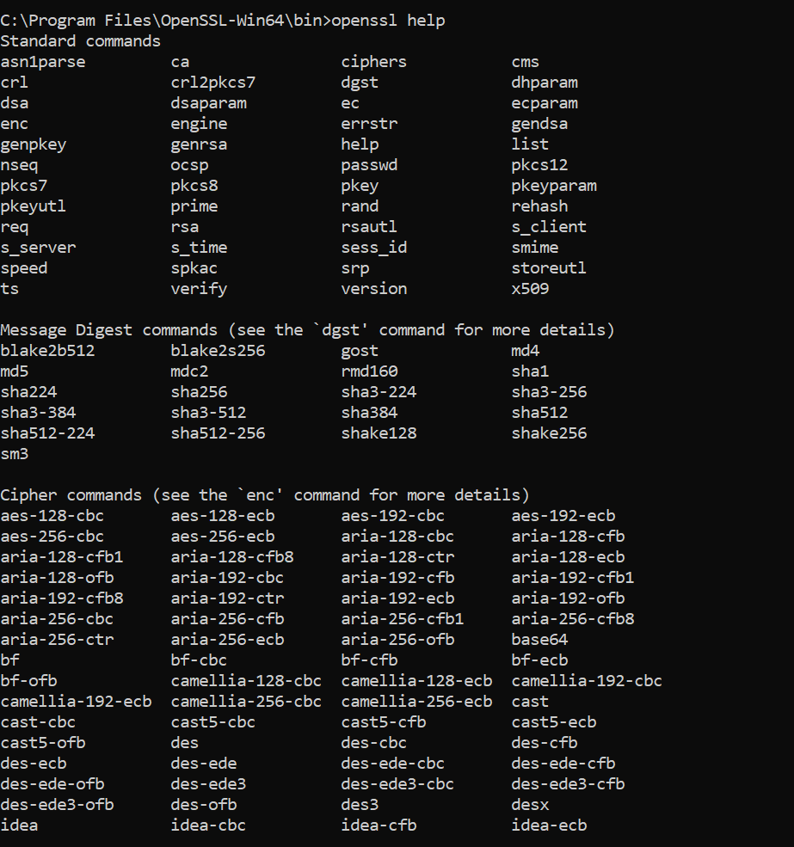

Figure 90: Openssl help command.

1. Generate key using the command: *Openssl genrsa -out test_key.key 2048 (Test_key.key is the key name and 2048 is the key length)*

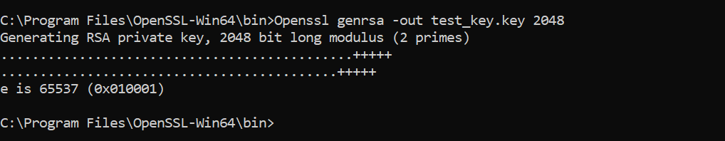

Figure 91: Openssl key generate.

1. Create Certificate Signing Request (CSR): *Openssl req -new -key test_key.key -out test_key.csr*

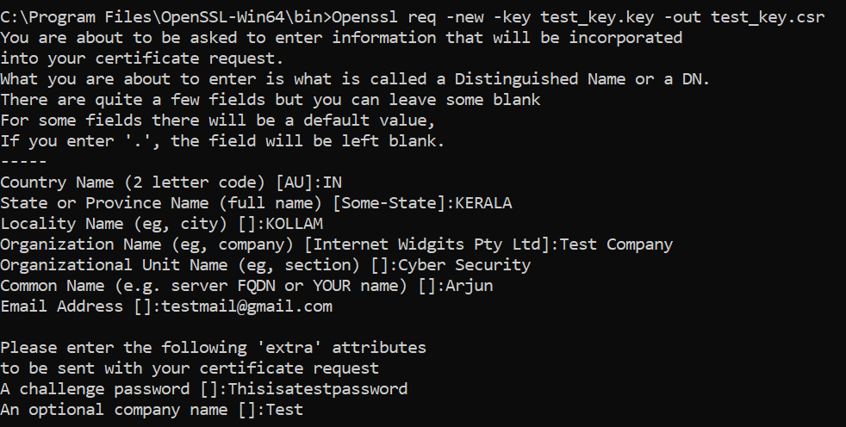

Figure 92: Creating CSR

1. Extract Public key, verify CSR file: *Openssl req -text -in test_key.csr -noout -verify*

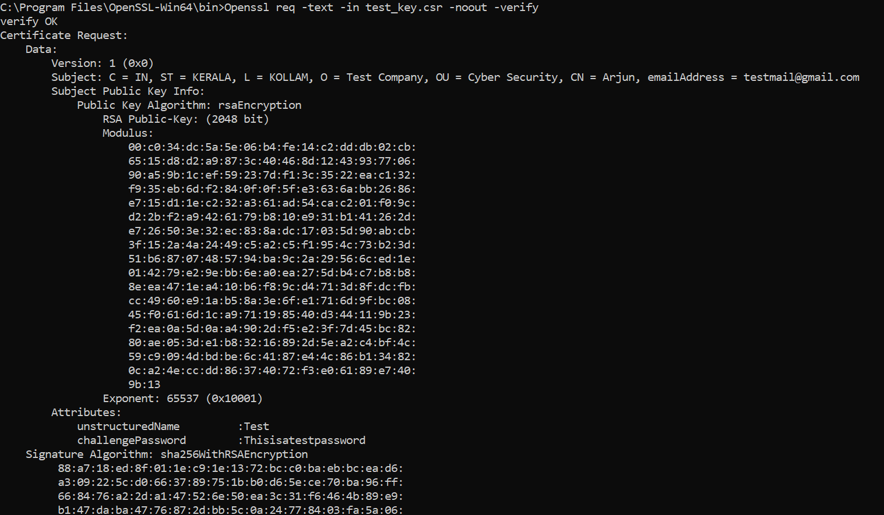

Figure 93: Extract Public Key

1. Sign the certificate: *Openssl x509 -in test_key.csr -out test_cert.crt -req -signkey test_key.key -days 365*



Figure 94: Certificate Signing

1. Generate Public Key: *Openssl rsa -in test_key.key -pubout -out test_key.key*



Figure 95: Generating Public Key

## **Outcome of the Practical**

Generated certificate using Openssl.

# Implement PGP for Email Security

## **Aim**

To implement PGP for email security.

## **Explanation**

Pretty Good Privacy (PGP) is an encryption system used for both sending encrypted emails and encrypting sensitive files. Since its invention back in 1991, PGP has become the de facto standard for email security.

The popularity of PGP is based on two factors. The first is that the system was originally available as freeware, and so spread rapidly among users who wanted an extra level of security for their email messages. The second is that since PGP uses both symmetric encryption and public-key encryption, it allows users who have never met to send encrypted messages to each other without exchanging private encryption keys.

***PGP Encryption working:***

PGP shares some features with other encryption systems you may have heard of, like Kerberos encryption (which is used to authenticate network users) and SSL encryption (which is used to secure websites).

At a basic level, PGP encryption uses a combination of two forms of encryption: symmetric key encryption, and public-key encryption.

To understand how PGP works, it’s useful to look at a diagram:

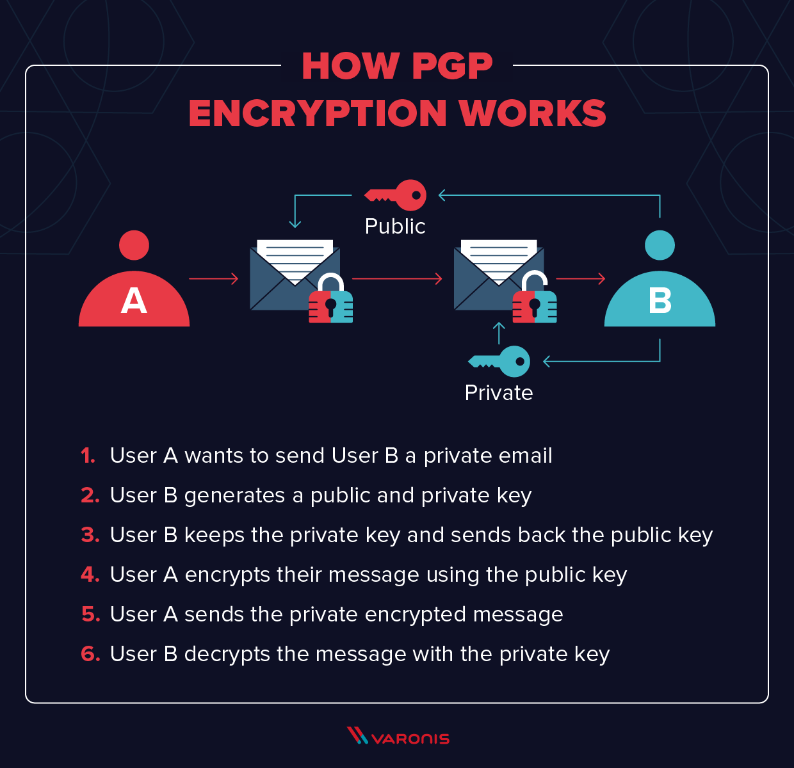

Figure 96: PGP Encryption Working (Source: <https://www.varonis.com/blog/pgp-encryption/>)

The mathematics behind encryption can get complex (though you can take a look at the math if you like), so here we’ll stick to the basic concepts. At the highest level, this is how PGP encryption works:

* First, PGP generates a random session key using one of two (main) algorithms. This key is a huge number that cannot be guessed and is only used once.
* Next, this session key is encrypted. This is done using the public key of the intended recipient of the message. The public key is tied to a particular person’s identity, and anyone can use it to send them a message.
* The sender sends their encrypted PGP session key to the recipient, and they are able to decrypt it using their private key. Using this session key, the recipient is now able to decrypt the actual message.

***Uses of PGP Encryption***

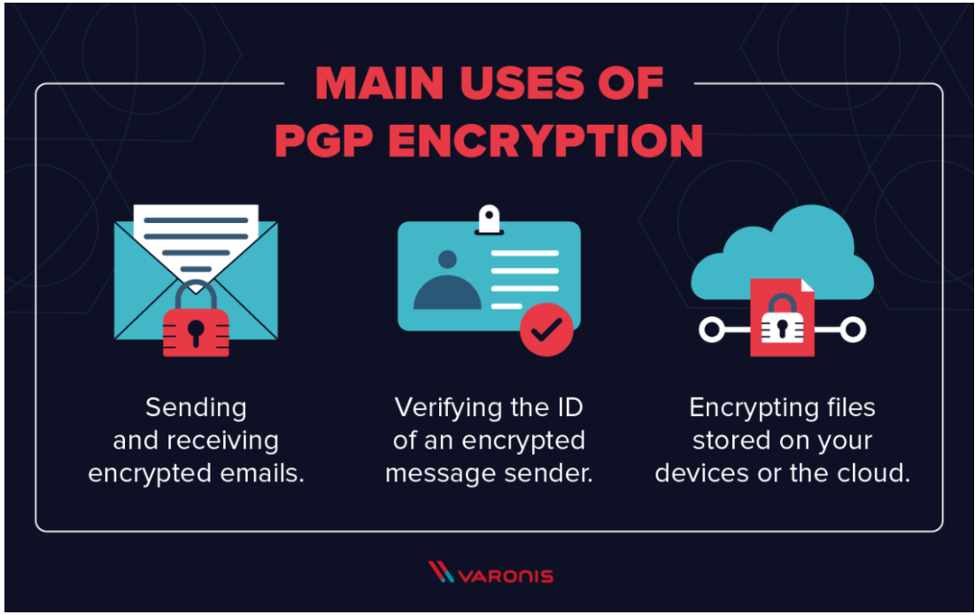

Figure 97: Uses of PGP Encryption (Source: <https://www.varonis.com/blog/pgp-encryption/>)

There are, essentially, three main uses of PGP:

1. Sending and receiving encrypted emails.
2. Verifying the identity of the person who has sent you this message.
3. Encrypting files stored on your devices or in the cloud.

Of these three uses, the first – sending secure email – is by far the dominant application of PGP. But let us take a brief look at all three.

***Encrypting Emails***

As in the example above, most people use PGP to send encrypted emails. In the early years of PGP, it was mainly used by activists, journalists, and other people who deal with sensitive information. The PGP system was originally designed, in fact, by a peace and political activist named Paul Zimmerman, who recently joined Startpage, one of the most popular private search engines.

Today, the popularity of PGP has grown significantly. As more users have realized just how much information corporations and their governments are collecting on them, huge numbers of people now use the standard to keep their private information private.

***Digital Signature Verification***

A related use of PGP is that it can be used for email verification. If a journalist is unsure about the identity of a person sending them a message, for instance, they can use a Digital Signature alongside PGP to verify this.

Digital signatures work by using an algorithm to combine the sender’s key with the data they are sending. This generates a “hash function,” another algorithm that can convert a message to a block of data of fixed size. This is then encrypted using the sender’s private key.

The recipient of the message can then decrypt this data using the sender’s public key. If even one character of the message has been changed in transit, the recipient will know. This can indicate either the sender is not who they say they are, that they have tried to fake a Digital Signature, or that the message has been tampered with.

***Encrypting Files***

A third use of PGP is to encrypt files. Because the algorithm used by PGP – normally the RSA algorithm – is essentially unbreakable, PGP offers a highly secure way of encrypting files at rest, especially when used alongside a Threat Detection and Response Solution. In fact, this algorithm is so secure that it has even been used in high-profile malware such as the CryptoLocker malware.

Back in 2010, Symantec acquired PGP Corp., which held the rights for the PGP system. Since then, Symantec has become the dominant vendor of PGP file-encryption software through such products as Symantec Encryption Desktop and Symantec Encryption Desktop Storage. This software offers PGP encryption for all your files, whilst also hiding the complexities of encryption and decryption processes.

## **Procedure and Screenshots**

1. Open the Kleopatra application: File-> New Key Pair to create a new key pair.

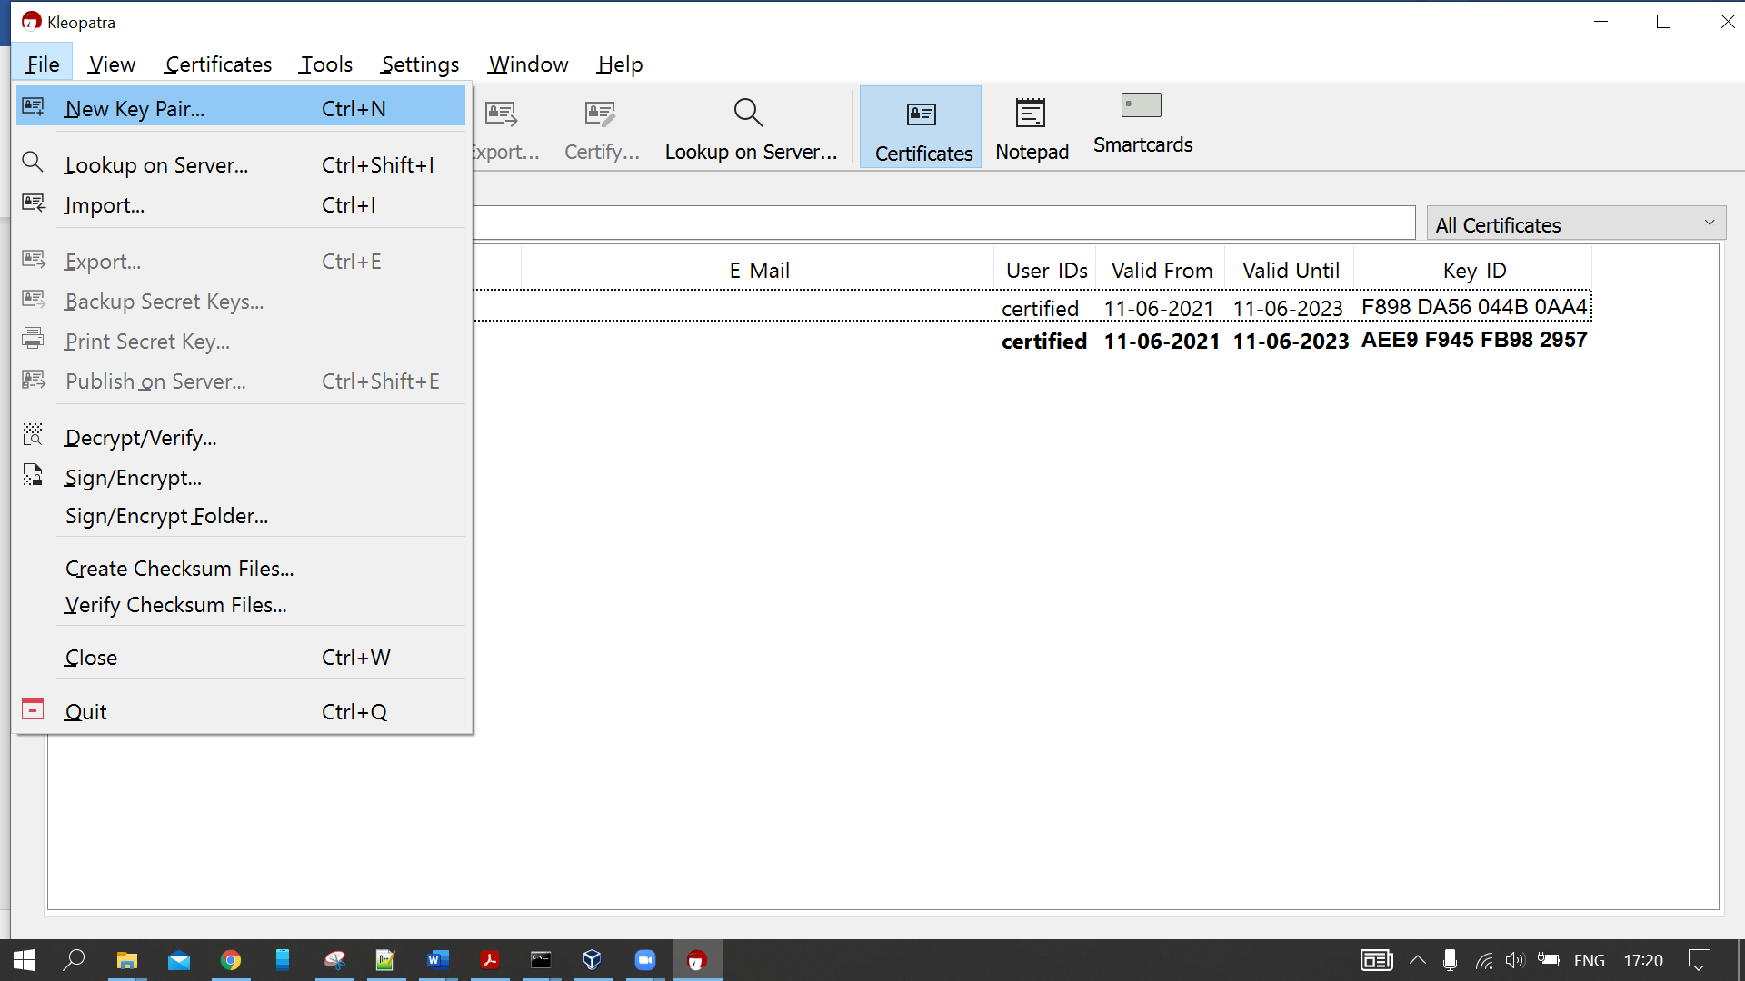

Figure 98: Kleopatra create new key pair.

1. Click on the option you require.

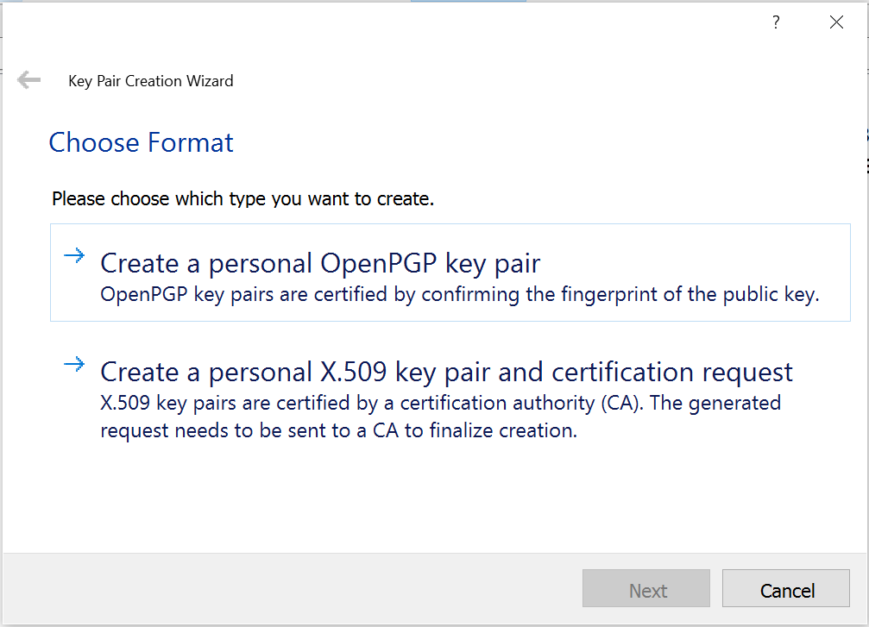

Figure 99: Select format of key pair.

1. Provide the details and click Create.

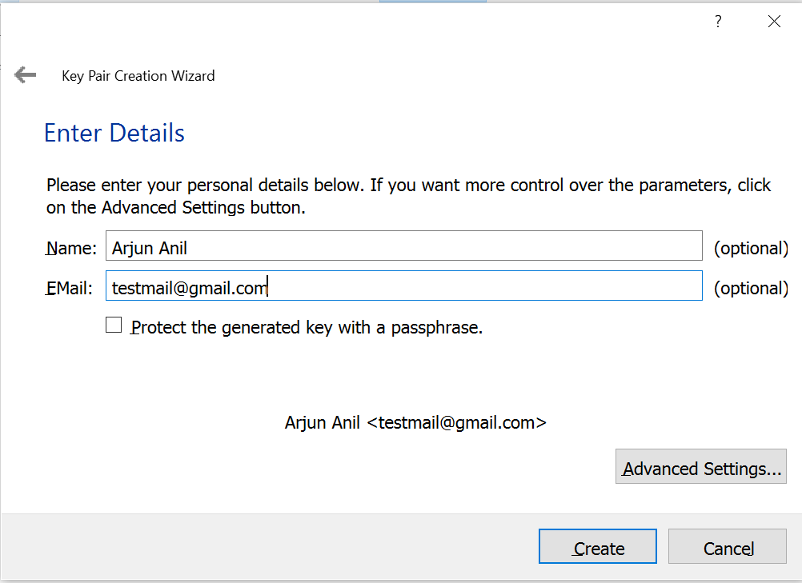

Figure 100: Enter Details.

1. Click Finish.

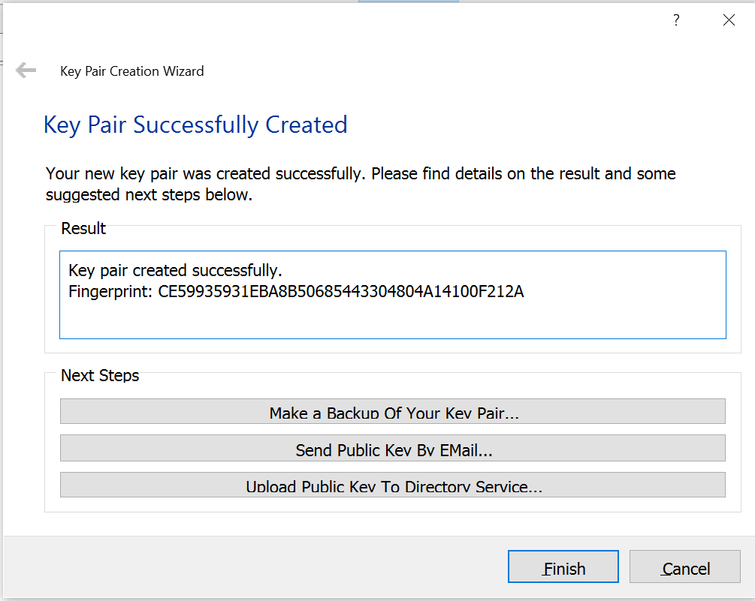

Figure 101: Key Generated.

1. Select the key you have created and click Export. Save that key file in any location and share that with the person you want to have encrypted communication.

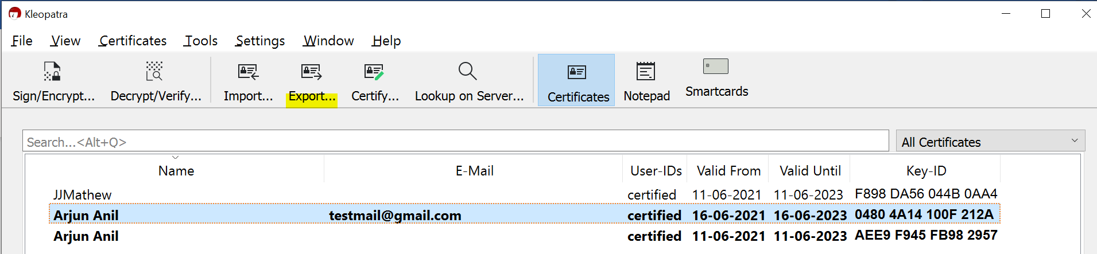

Figure 102: Export Key

1. The person at other end will have to import the shared public key by pressing ‘Import’.

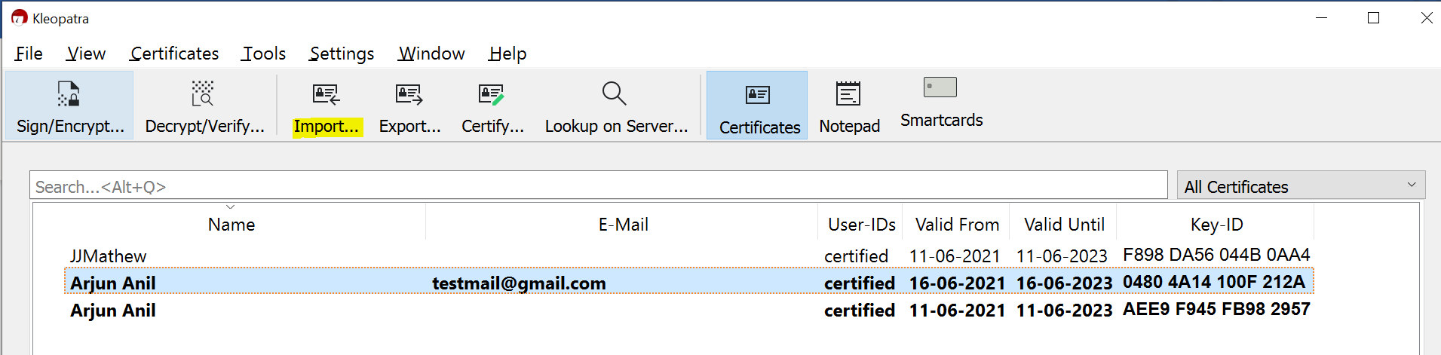

Figure 103: Import Key

1. Click on the public key of other user you have imported and click sign/encrypt.

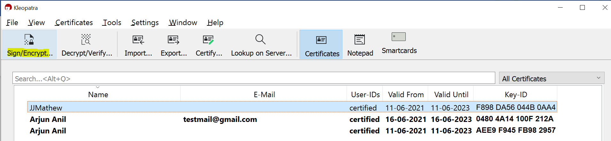

Figure 104:Sign/Encrypt.

1. Select a file and click encrypt.

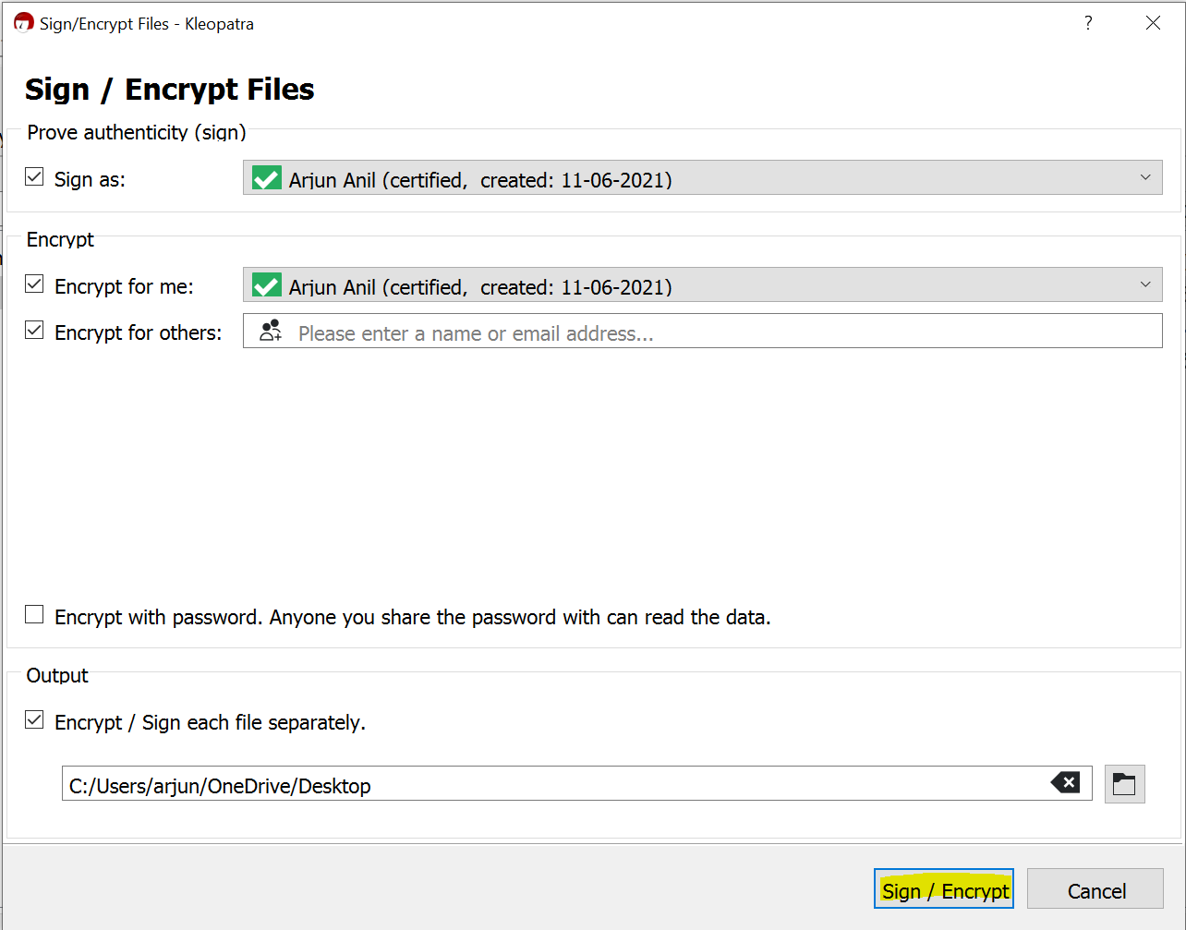

Figure 105: Sign/Encrypt 2

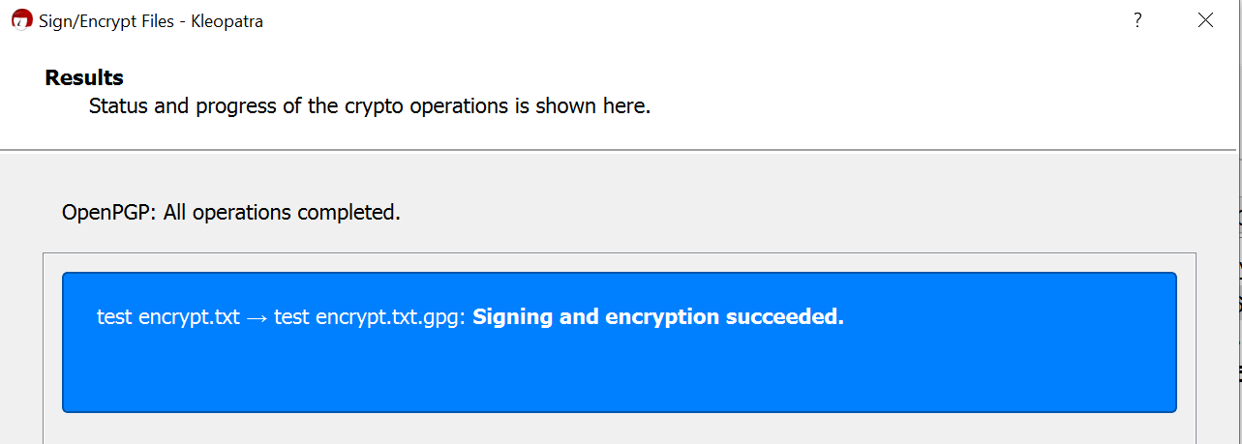

Figure 106: Sign/Encrypt 3

1. Share the encrypted file with the other person and he can select Decrypt/verify and select the file and decrypt it. (The receiver must use the same key which he shared for encryption)

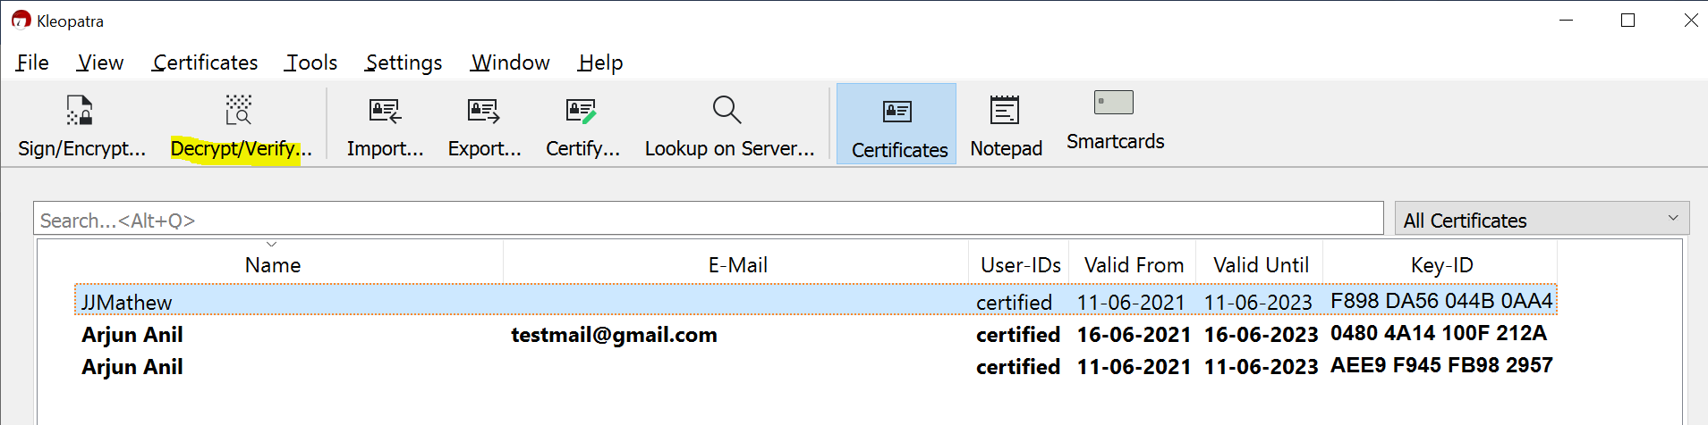

Figure 107: Decrypt 1

**Encrypt using GPG**

1. Install GPG.
2. Generate the key pair. Select RSA and RSA (default).

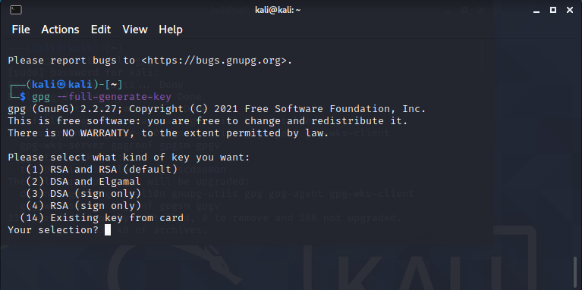

Figure 108: Key Generation

1. Give the necessary details to generate the key.
2. Provide the passphrase.

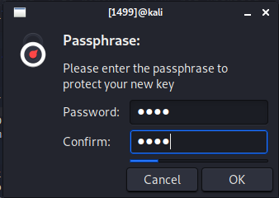

Figure 109: Passphrase

1. Public private key pair is generated.

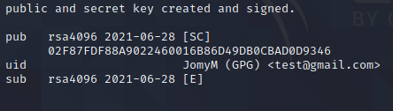

Figure 110: Generated Keypair

1. Encrypt the file.

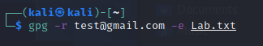

Figure 111: Encrypting the file.

1. Decrypt the file and enter the passphrase for completing the decryption.

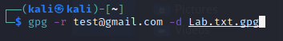

Figure 112: Decrypting and providing passkey.

1. Decrypted Message.

**Encryption/Decryption using Mailvelope**

1. Install Mailvelope extension in Microsoft Edge browser.
2. Go to key management & import the public key of the receiver.

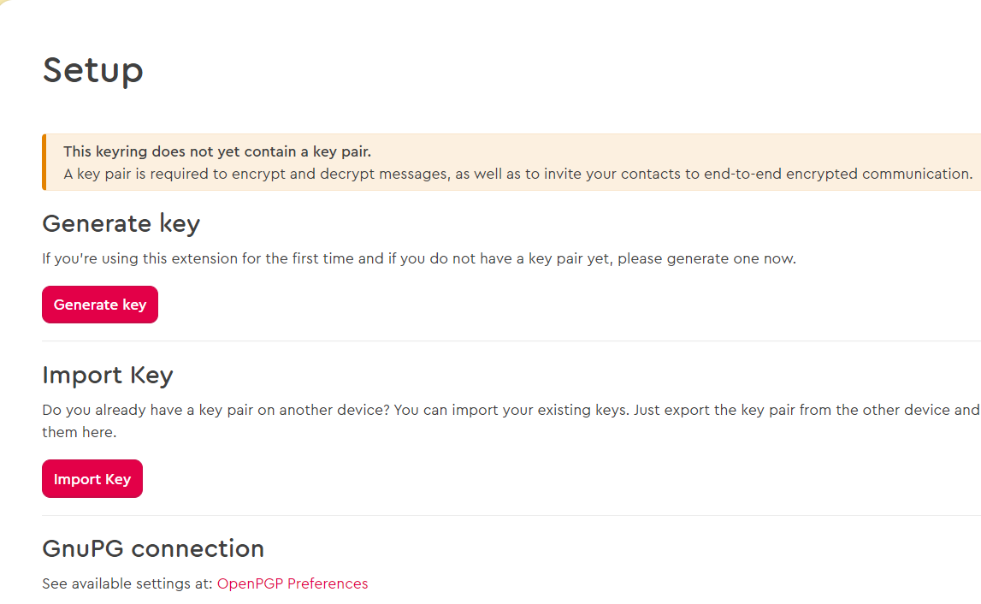

Figure 113: Setup

1. Click on Encrypt in Mailvelope and provide the details and press submit.
2. Encryption is successful.
3. Decrypting the generated text file.

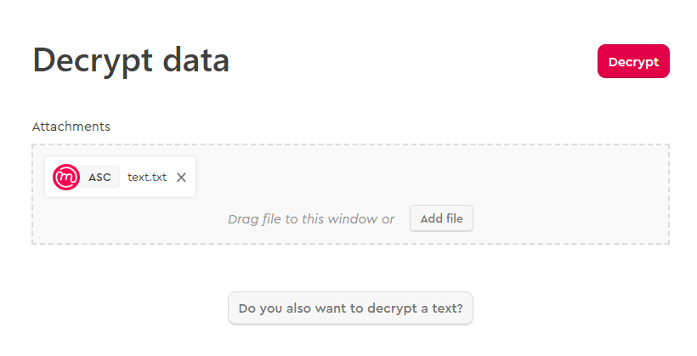

Figure 114: Decrypting text file

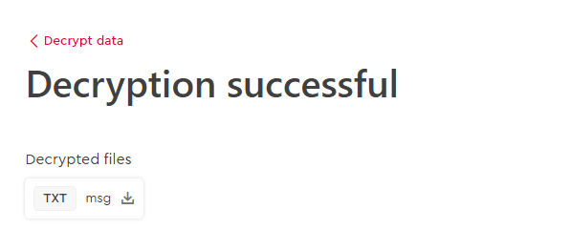

Figure 115: Success Message

## **Outcome of the Practical**

PGP has been successfully implemented using Kleopatra, command interface using GPG and sent secure email using Mailvelope.

# Capture Network Traffic Using Wireshark

## **Aim**

To demonstrate Packet capture using Wireshark.

## **Explanation**

Wireshark is the world’s foremost and widely used network protocol analyzer. It lets you see what’s happening on your network at a microscopic level and is the de facto standard across many commercial and non-profit enterprises, government agencies, and educational institutions. Wireshark development thrives thanks to the volunteer contributions of networking experts around the globe and is the continuation of a project started by Gerald Combs in 1998.

Wireshark has a rich feature set which includes the following:

* Deep inspection of hundreds of protocols, with more being added all the time.
* Live capture and offline analysis
* Standard three-pane packet browser
* Multi-platform: Runs on Windows, Linux, macOS, Solaris, FreeBSD, NetBSD, and many others
* Captured network data can be browsed via a GUI, or via the TTY-mode TShark utility
* The most powerful display filters in the industry
* Rich VoIP analysis
* Read/write many different capture file formats: tcpdump (libpcap), Pcap NG, Catapult DCT2000, Cisco Secure IDS iplog, Microsoft Network Monitor, Network General Sniffer® (compressed and uncompressed), Sniffer® Pro, and NetXray®, Network Instruments Observer, NetScreen snoop, Novell LANalyzer, RADCOM WAN/LAN Analyzer, Shomiti/Finisar Surveyor, Tektronix K12xx, Visual Networks Visual UpTime, WildPackets EtherPeek/TokenPeek/AiroPeek, and many others
* Capture files compressed with gzip can be decompressed on the fly
* Live data can be read from Ethernet, IEEE 802.11, PPP/HDLC, ATM, Bluetooth, USB, Token Ring, Frame Relay, FDDI, and others (depending on your platform)
* Decryption support for many protocols, including IPsec, ISAKMP, Kerberos, SNMPv3, SSL/TLS, WEP, and WPA/WPA2
* Coloring rules can be applied to the packet list for quick, intuitive analysis
* Output can be exported to XML, PostScript®, CSV, or plain text

## **Tools Used**

Wireshark is a free and open-source packet analyzer. It is used for network troubleshooting, analysis, software and communications protocol development, and education.

## **Procedure and Screenshots**

* 1. In the Wireshark home page, select the network interface we want to monitor.

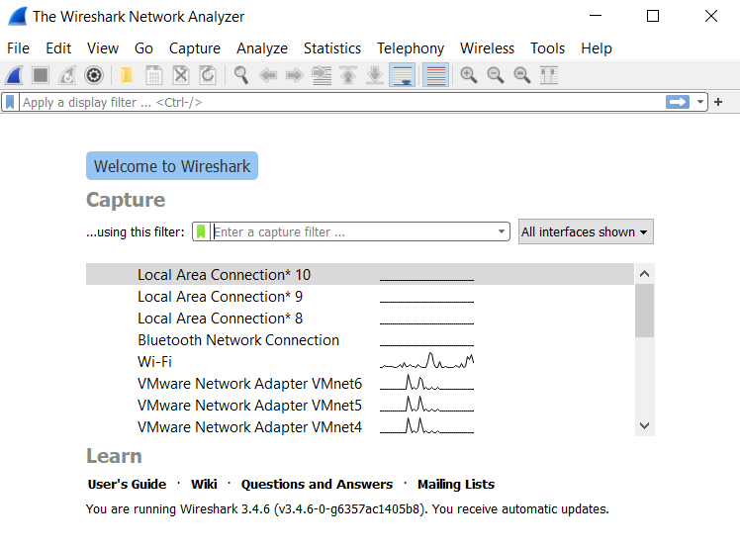

Figure 116: Wireshark Homepage

We can now view the packets which are captured by Wireshark.

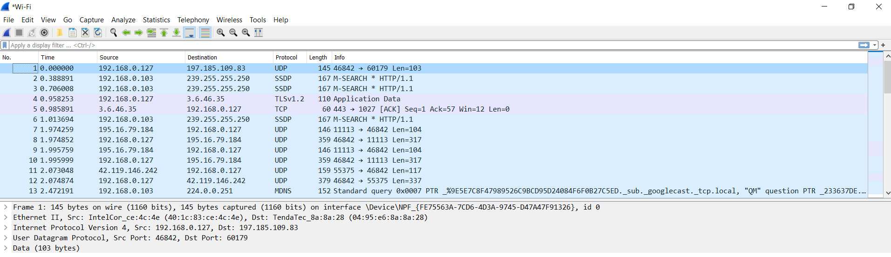

Figure 117: Packet capture using Wireshark.

* 1. Change coloring rules by go to view coloring rules. Select a color for HTTP.

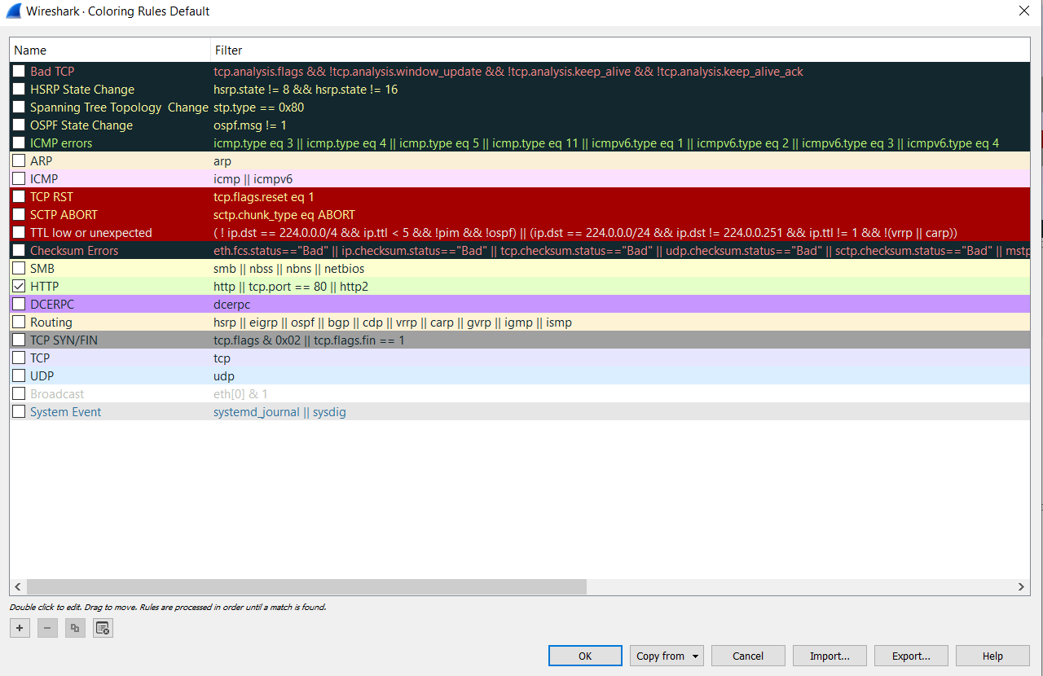

Figure 118: Selecting Colors for Different Rules

Now we can see the HTTP traffic are only colored and easy to identify.

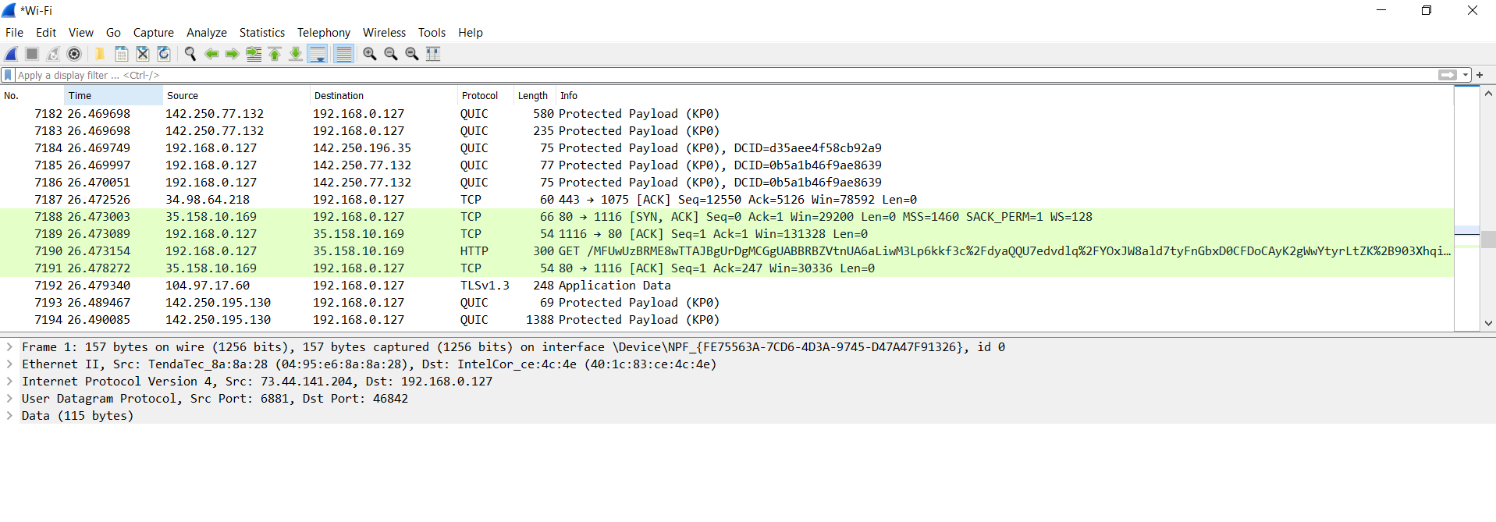

Figure 119: HTTP Packets

* 1. For further filtering commands we can go to Analyze and click display filtering options.

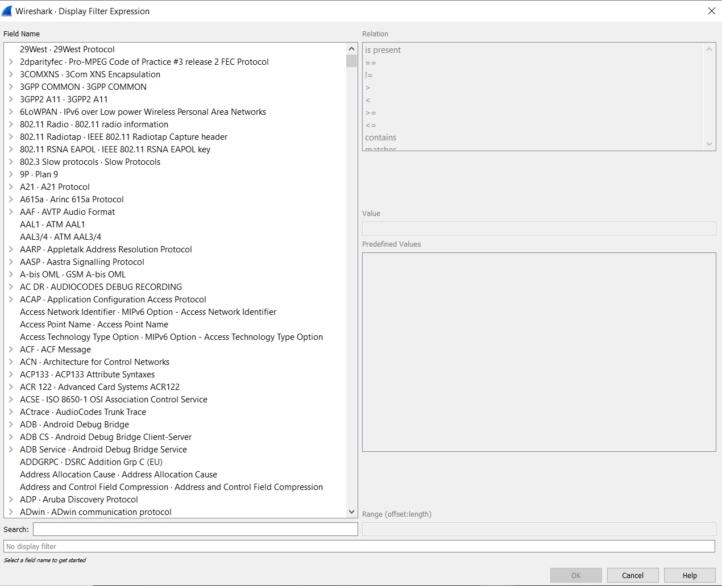

Figure 120: Filter Expression List

By expanding each packet we can get to know the details of each packet that is SYN packet or SYN/ACK packet, sequence no or RST packet.

Here we can see it is a HTTP packet running on protocol 80 and an acknowledgement coming from source address 35.150.10.160 and destination is 192.168.0.127

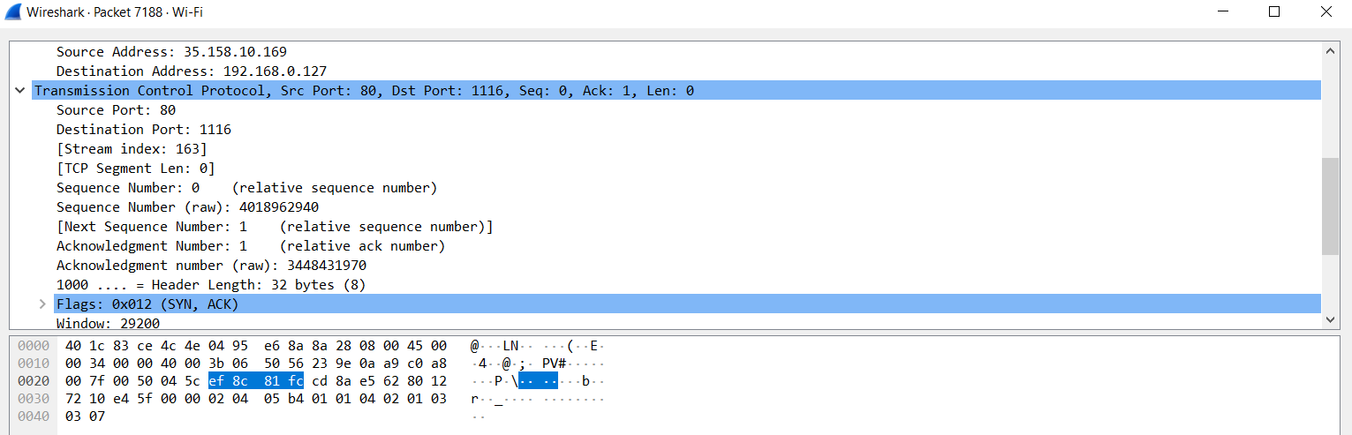

Figure 121: Packet Details

* 1. We can filter by source IP, port, destination IP, destination port, protocol etc. Here we filtered by source IP 192.168.0.127.

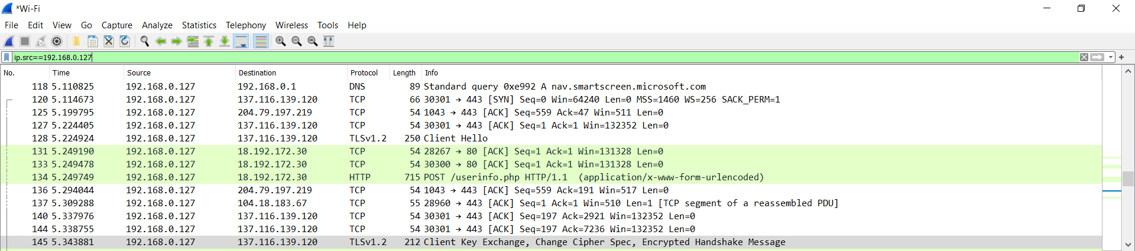

Figure 122: Filter Source by IP

Filtering with destination IP 192.168.0.127

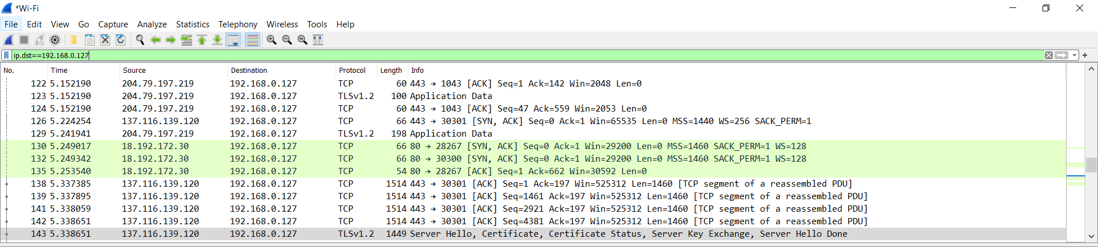

Figure 123: Filtering by Destination

Filtering by source and destination IP.

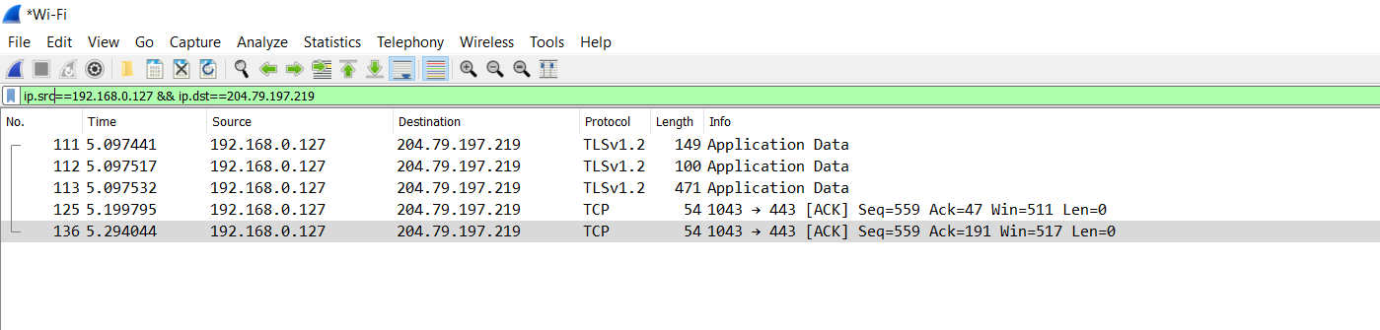

Figure 124: Filter by Source and Destination IP

Filtering by TCP port 80.

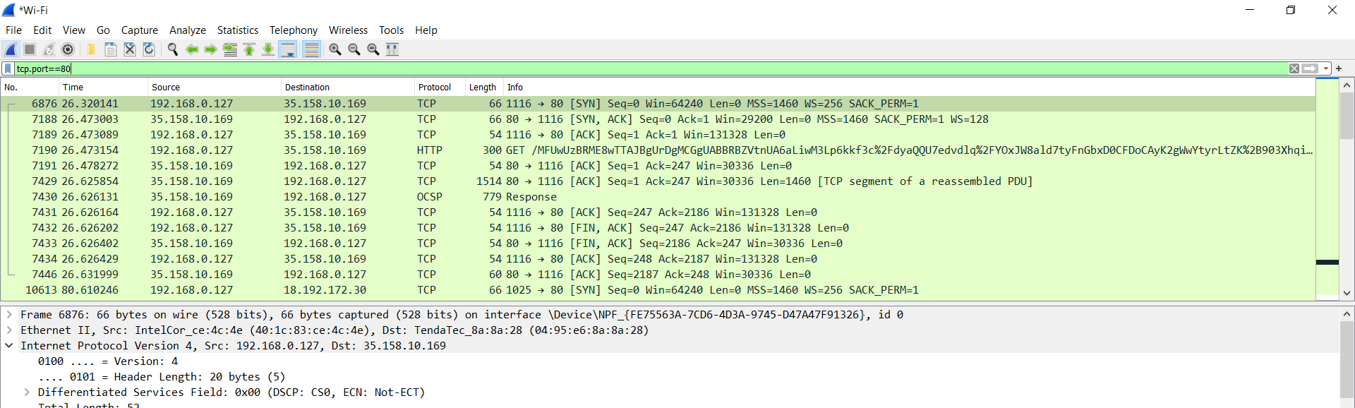

Figure 125: Filtering by TCP

Filtering by source port 1105.

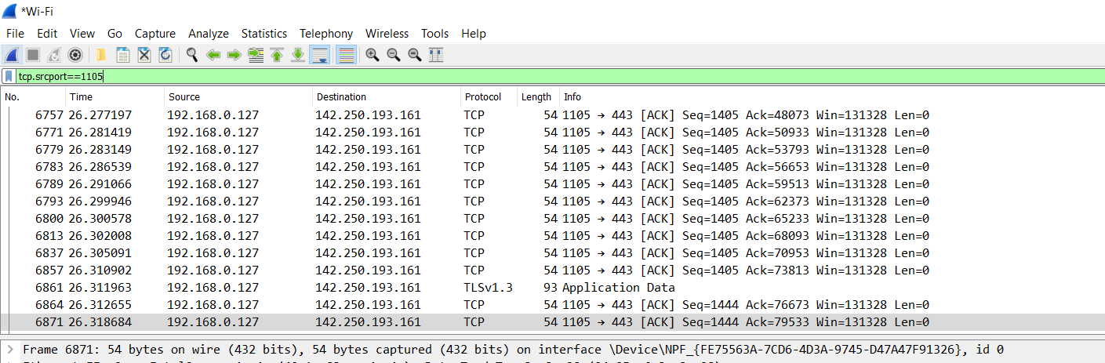

Figure 126: Filter by Source Port

Filtering by destination port 443.

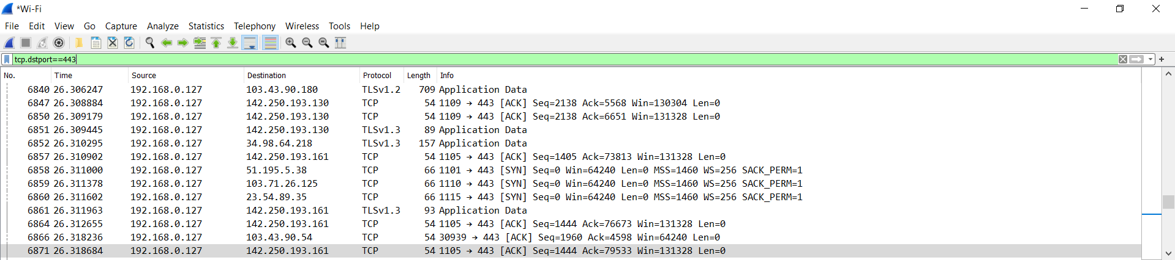

Figure 127: Filter by Destination Port

Search by protocol TLS.

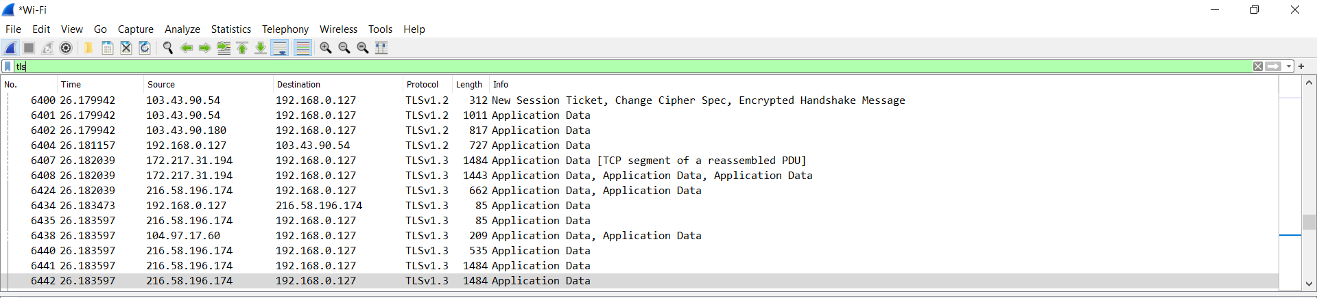

Figure 128: Filter by TLS

Login to a HTTP site.

Filtering by HTTP.

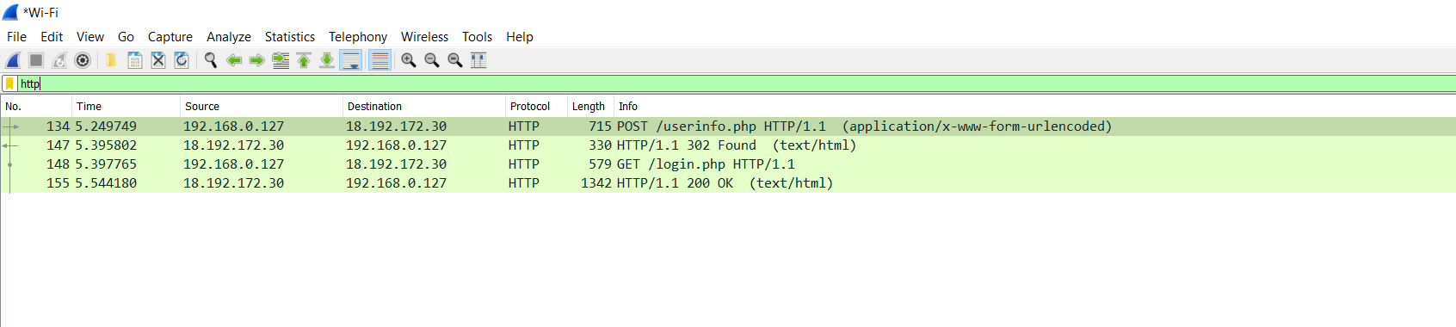

Figure 129: Filtering traffic by HTTP

We selected the desired packet and viewed the TCP stream data and we can get the username and password.

Capturing packets by enabling VPN.

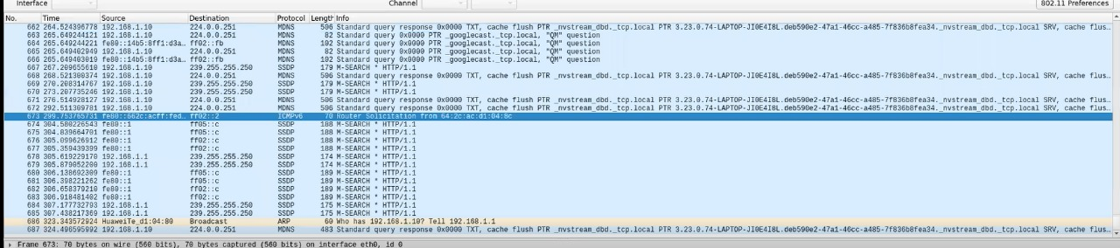

Figure 130: Scanning VPN Traffic

## **Outcome**

We have successfully demonstrated packet capture using Wireshark and shown how to catch user credentials for http websites.

# REFERENCES

1. [Traditional Ciphers - Tutorialspoint](https://www.tutorialspoint.com/cryptography/traditional_ciphers.htm)
2. [Difference between Monoalphabetic Cipher and Polyalphabetic Cipher - GeeksforGeeks](https://www.geeksforgeeks.org/difference-between-monoalphabetic-cipher-and-polyalphabetic-cipher/#:~:text=A%20monoalphabetic%20cipher%20is%20any,on%20a%20single%20alphabetic%20key.)
3. [CrypTool - Wikipedia](https://en.wikipedia.org/wiki/CrypTool)
4. [Diffie-Hellman Key Exchange explained (Python) | by Syed Sadat Nazrul | Medium](https://medium.com/@sadatnazrul/diffie-hellman-key-exchange-explained-python-8d67c378701c)
5. [VeraCrypt - Wikipedia](https://en.wikipedia.org/wiki/VeraCrypt)
6. [www.ciphershed.org/](http://www.ciphershed.org/)
7. [Advanced Encryption Standard - Tutorialspoint](https://www.tutorialspoint.com/cryptography/advanced_encryption_standard.htm)
8. [Data Encryption Standard - Tutorialspoint](https://www.tutorialspoint.com/cryptography/data_encryption_standard.htm)
9. [PGP - Authentication and Confidentiality - GeeksforGeeks](https://www.geeksforgeeks.org/pgp-authentication-and-confidentiality/)
10. [OpenPGP: Key generation (asecuritysite.com)](https://asecuritysite.com/encryption/openpgp)
11. [HMAC - Wikipedia](https://en.wikipedia.org/wiki/HMAC)
12. [login page (vulnweb.com)](http://testphp.vulnweb.com/login.php)
13. [Wireshark · Go Deep.](https://www.wireshark.org/)